Cambridgeshire ACRE

Housing Need Survey
Results Report for
Melbourn

Survey undertaken in October 2011

CONTENTS PAGE

CONTEXT AND METHODOLOGY 3
Background to Affordable Rural Housing 3
Context 3
Methodology 3
Melbourn Parish 4
Local Income Levels and Affordability 5

RESULTS FROM PART ONE: VIEWS ON AFFORDABLE HOUSING DEVELOPMETN AND IDENTIFYING THOSE IN HOUSING NEED 9
Views on Affordable Housing Development in Melbourn 9
Suitability of Current Home 11

RESULTS FROM PART TWO: IDENTIFYING CIRCUMSTANCES AND REQUIREMENTS 14
Local Connection to Melbourn 14
Household Composition 15
Property Type, Size and Tenure 16

SUMMARY AND RECOMMENDATION 17
Pre-Existing Evidence from the Housing Register 17
Findings from Housing Needs Survey 17
Conclusion 18
Recommendation 18

APPENDIX 1 – CHOICE BASED LETTINGS AND LOW COST HOME OWNERSHIP 19

CONTEXT AND METHODOLOGY

Background to Affordable Rural Housing

Affordable housing is housing made available for either rent or shared ownership, based on the evidence of need, to those unable to afford market prices. Affordable housing could be built on a rural exception site which is a site used specifically for affordable housing in a small rural community that would not normally be used for housing because it is subject to policies of restraint.

Rural exceptions sites can only be used for affordable housing in perpetuity and planning conditions and legal agreements are used to restrict the occupation of property to people falling within categories of need and to those who can prove a local connection through family, residence or work.

To be eligible for rental properties, applicants must complete an application form to join the local Housing Register and they would then be able to bid for properties through the choice based lettings scheme. To be eligible for low cost shared ownership properties, applicants must apply to the local Housing Register and then apply directly through the local Homebuy Agent. You can read more about choice based lettings and low cost home ownership in Appendix 1.

Context

In April 2011, Cambridgeshire ACRE was commissioned to carry out a Housing Needs Survey in Melbourn Parish. This survey was carried out on behalf of Jephson Housing Association, an affordable homes provider, in partnership with South Cambridgeshire District Council and Melbourn Parish Council.

The aim of the survey was to determine existing and future levels of affordable housing need in the parish and to gauge opinion on the value of developing affordable homes in the village.

Methodology

Survey packs were posted out to all 2,041 addresses in the Parish at the end of August 2011. The survey packs included a covering letter from Cambridgeshire ACRE, a letter of support from the Parish Council, a questionnaire and a postage paid envelope for returned forms. Copies of these documents are available upon request from Cambridgeshire ACRE.

The questionnaire was divided into two sections:
- Part One of the survey form contained questions to identify those who believe they have a housing need. Respondents were also asked if they supported the idea of building a small affordable housing development in the village. All households were asked to complete this section.
- Part Two of the survey form contained questions on household circumstances and housing requirements. This part was only completed by those households who are currently or expecting to be in need of housing.

The closing date for the survey was 17 October 2011. 369 completed forms were returned giving the survey an 18 per cent response rate.

Melbourn Parish

Melbourn is a large parish in south Cambridgeshire. It is located between Cambridge and Royston on the southern side of the A10. It has a population of about 4,500 with a relatively high proportion of pensionable age. Its location, general attractiveness and access to rail links means that it is a popular place to live for commuters. However, the science park, on the northern fringe of the village, means that commuter flows are two way.

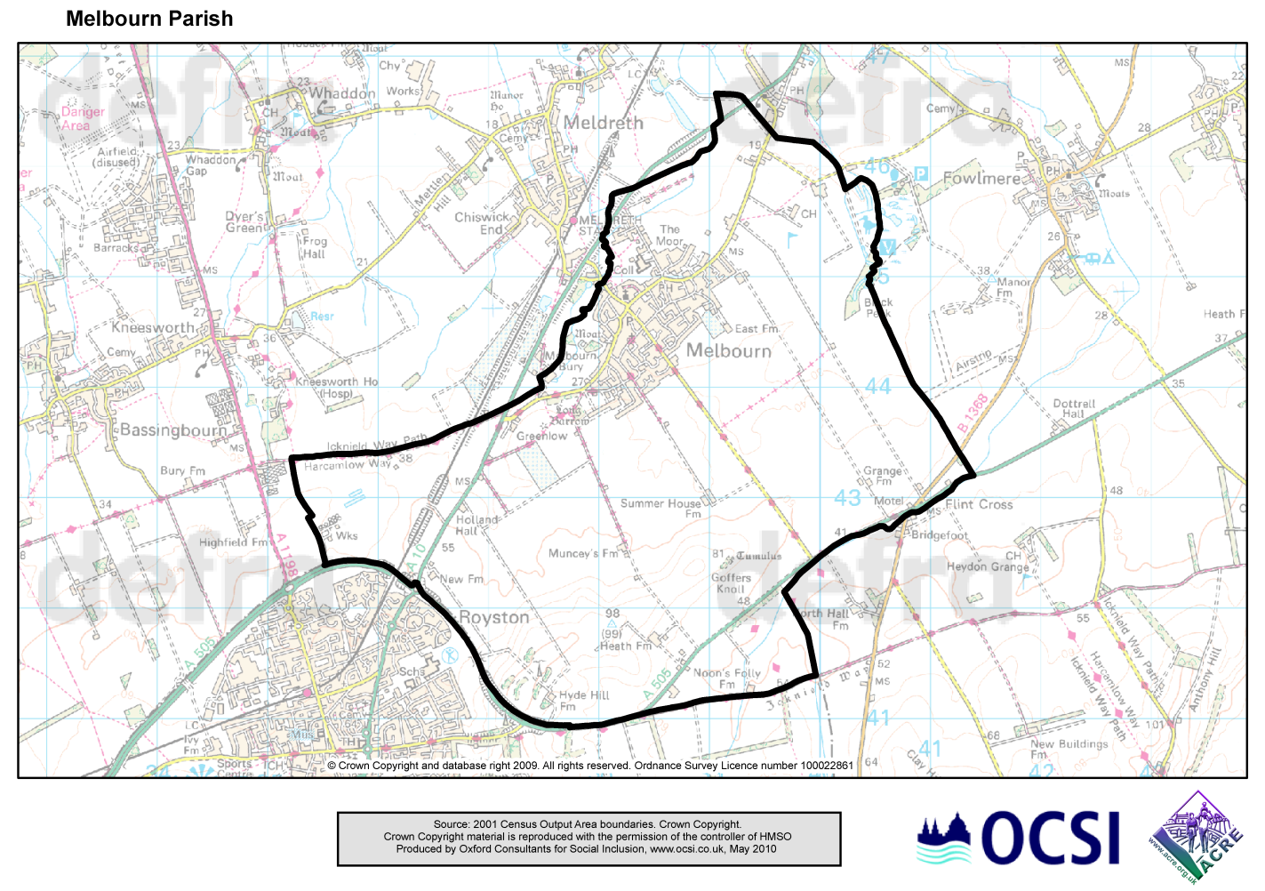
High employment levels are just one of the factors that contribute to Melbourn’s ‘sense of place’. A range of education provision (including the Village College), health services and community facilities also enhance Melbourn’s offer to residents and visitors.

Melbourn is relatively wealthy with household income levels above the county average - over 40 per cent of the resident workforce are employed in managerial, professional and associate professional roles. Unemployment is correspondingly low with relatively few people receiving work or income related benefits.

Both owner occupation and social renting are above average in Melbourn. There is a very small private rental market – less than half the average for Cambridgeshire. The dwelling stock is dominated by detached and semi-detached accommodation. Flats account for only two per cent of the dwelling stock compared to more than one in ten (12 per cent) in Cambridgeshire and 15 per cent in the East of England.

Local Income Levels and Affordability

Buying on the Open Market
The average asking price of property in Melbourn is broadly in line with South Cambridgeshire and North Hertfordshire although there are some variations by size of property. Table 1 compares the average asking price of properties for sale on the open market in Melbourn with those in surrounding areas. With the fluid house market situation prices are changing every month and the prices referred to in this report should be treated as illustrative only.

Table 1: Average Property Prices, November 2011

No. of bedrooms | Melbourn Parish | South Cambs | North Herts | Cambridge City
1 | £145,000 | £139,000 | £116,000 | £143,000
2 | £168,000 | £190,000 | £172,000 | £188,000
3 | £233,000 | £277,000 | £256,000 | £279,000
4 | £416,000 | £413,000 | £417,000 | £400,000

A review of properties currently for sale in Melbourn found 32 properties available on the open market; 4 two-bed properties, 17 three-bed properties, 5 four-bed properties and 6 five or six bed properties. No one-bed properties are currently for sale.

Table 2 (overleaf) takes the current property price data for the various sizes of dwelling currently available on the open market and estimates the annual income that would be required in order to be able to afford the mortgage on such a property.

For a household to be able to purchase a two bedroom house (at the price stated above) in Melbourn, a household income of £42,000 would be required. The most recently available Paycheck data reveals that 57% of Melbourn’s population earn less than £40,000. On this basis 48% of households in Melbourn earn insufficient to afford even a one-bed property. The median income in Melbourn Parish is £36,200 per annum.

It should be remembered that a household’s ability to buy is also dependent on them having saved an appropriate deposit. The calculations presented here assume a mortgage to house value of 75%. In other words, the purchaser can raise a deposit of 25%. It may be possible to secure a mortgage with a lower deposit but this will require even higher income levels.

Households with insufficient income and deposit saved to afford their desired property, may have to amend their expectations.

Table 2: Annual Income requirements for open market properties

No. of bedrooms | House Price | Deposit required (assume 25% required) | Annual income required (based on mortgage lending principle of 3 x income) | Monthly salary needed for purchasers
1 | £145,000 | £36,250 | £36,250 | £3,021
2 | £168,000 | £42,000 | £42,000 | £3,500
3 | £233,000 | £58,250 | £58,250 | £4,854
4 | £416,000 | £104,000 | £104,000 | £8,667

Buying in Shared Ownership
Shared ownership gives the opportunity to 'part buy' and 'part rent' a home. This means if a household can't afford to buy a property outright they may be able to afford to buy a share in a property, typically 25%, 50% or 75%. At a point when the household can afford to, they can choose to buy a further share of the property. Where a property has been built on a rural exception site, the maximum percentage that can be owned is 80% so that the property always remains available as affordable housing and can never be sold on the open market.

Shared ownership housing schemes are tailored for people who cannot afford to buy a suitable home by outright purchase, and who are in housing need. Priority will often be given to people on local authority or housing association waiting lists. When someone moves out of a shared ownership property, their property will either be offered to the housing association to find a buyer or it may be advertised in the local estate agents.

Shared ownership affordability can be estimated by assuming the householder will purchase a 25% share of the property. To buy this 25% share, the householder would need at least a 10% deposit. Rent would be paid on the unsold equity at a rate of 2.75%. It is likely that a small service charge would also be applicable. Table 3 estimates shared ownership affordability.

Table 3: Cost of purchasing a 25% share of a shared ownership property

Property Value | Deposit required  (Assume 10%) | Mortgage required  (Subsidy required shown below in brackets) | Mortgage cost pcm  (Assume rate of 5% for 25 yrs) | Rent / equity loan interest charge pcm | Total pcm | Household income required
£120,000 | £3,000 | £27,000  (£90,000) | £157.21 | £206.25 | £363.46 | £13,185
£180,000 | £4,500 | £40,500  (£135,000) | £235.81 | £309.38 | £545.19 | £19,788

Should a household not be able to afford shared ownership, then they could opt for a rental property.

Renting
Table 4 shows the typical cost for renting privately and compares this with the typical rental cost of a new Housing Association property. The Government has recently taken steps to bring social housing rents closer to private sector ones, with rents for new tenants set at up to 80% of the amount you would have to pay in the private sector. Recent estimates by Cambridgeshire County Council suggest that the Local Housing Allowance would be sufficient to cover the cost of a one-bed property in Melbourn ward at the maximum affordable rent but not the cost of a two or three-bed property.

Table 4: Comparison of property rental costs in Melbourn ward

No. of Beds | Private  Average rent per week | Housing Association  Maximum affordable rent per week  (80% of median market rent)
1 (or bedsit) | £125 - £149 | £100 - £124
2 | £150 - £174 | £125 - £149
3 | £175 - £199 | £150 - £199
RESULTS FROM PART ONE – VIEWS ON AFFORDABLE HOUSING DEVELOPMENT AND IDENTIFYING THOSE IN HOUSING NEED

Views on Affordable Housing Development in Melbourn

All respondents were given an opportunity to voice their opinion on the possibility of a small development of affordable homes for local people within the parish. 77% of respondents said they would be in favour; 16% stated that they would not be in favour; and 7% chose not to state their opinion. This is illustrated in Figure 1.

Figure 1: Attitude towards affordable housing development

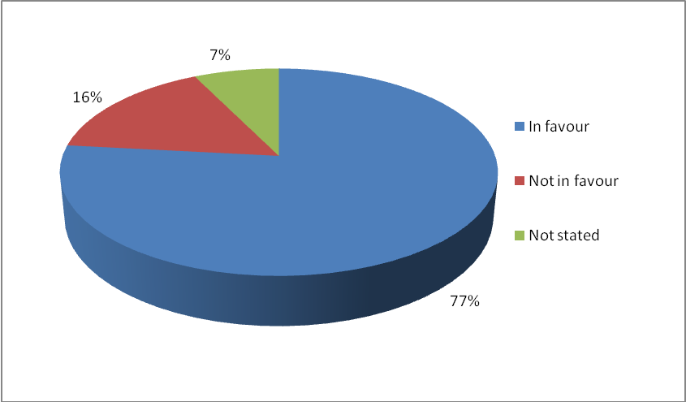

Respondents were also asked how they felt about the possibility of a small development that included both private housing and affordable homes so that the sale of the private homes could finance the affordable homes development. Here, the numbers fell somewhat with only 63% being in favour of this idea, 26% being against it and 11% not stating an opinion.

Many respondents chose to include additional comments to qualify their answers. A selection is presented here, grouped by theme.

Much support for affordable homes centred on the needs of young and elderly people:
- I have two sons aged 24, who desperately want their own homes with their partners
- My daughter has just moved back to Cambridgeshire and cannot find a house in Melbourn suitable for her needs
- Young professionals are in definite need and if encouraged to stay will be a valuable asset to community in future
- Young people nowadays need more affordable housing as it is very hard for them when starting out in life. Affordable housing also means families can stay closer in the village
- Need some more retirement flats as there are many older people in Melbourn who will need suitable housing in the future
- Should include provision for the elderley (adapted property)
- I personally would be interested in buying an affordable home in this local area. I have lived in Melbourn for 29 years. I work in Melbourn and my immediate family all live in Melbourn. I would like to purchase a property in this area but cannot obtain a mortgage (at present) to do so. Affordable homes for local people will be an ideal solution!!!
- Affordable housing is a "must" in the village. This is a very expensive area in which to live, and salaries are very low for the majority of people

A key concern for some was that affordable housing should be allocated to local people:
- So long as it is for local people
- Local homes should mean for the village people
- Any development of this nature should be strictly for the young families and residents of Melbourn
- Provided the homes remained as affordable and were not covered by 'right to buy'

Many respondents caveated their support for affordable housing with concerns about the location, scale and design of any development:
- Melbourn is a large village and great care would have to be taken on the choice of site. I cannot think of a suitable area. A brownfield site would be preferable to a green field
- I am in favour if the development does not expand the current village envelope
- Depending on where they are situated in the village and on your version of small
- This would need to be a very small development as I feel the village has about reached its expansion limits
- Yes, if this does not change the village too much. Must stay a village - not become a small town
- Shouldn't be architecturely bland like almost every development in the village over the past 30 years

There were also concerns about the ability of Melbourn’s infrastructure to cope with further development:
- Yes, but housing developments need to consider the needs of those who live there e.g. Off street parking as parked cars are a huge hazard in Melbourn, school spaces etc
- Not enough support for more housing in this area i.e. Schools, doctors, dentist, youth facilities etc
- Melbourn is already a large village. The school is already struggling to cope with too many children. More cars in the village means more congestion and there is already a problem

In fact, lack of infrastructure was one of the key reasons for some people being opposed to further affordable housing development in principle:
- Village is already "overgrown"
- We believe Melbourn has already outgrown it's own resources and could not effectively support any further development
- I do not believe that the existing social infrastructure can support an increase in population
- Too many homes being built now. Spoiling the countryside
- I think the village is large enough as it stands and would not wish to see any further expansion

Suitability of Current Home

Respondents were asked to indicate whether or not their current home was suitable for their household’s needs. Figure 2 shows that 89% of respondents felt their current home was suitable for their household needs, with 11% indicating that their current home is unsuitable for their needs.

Figure 2: Suitability of current home

The 11% of respondents who indicated that their current home is unsuitable for their needs equates to 42 households. Those stating their current home is unsuitable were asked to indicate the reasons why. Respondents were allowed to give more than one reason for unsuitability, so all responses are recorded. Figure 3 illustrates the reasons respondents gave for their current home being unsuitable. ‘Current home too small’ and ‘no more suitable homes available locally’ were the most commonly cited reasons in Melbourn.

Figure 3: Reasons why current home is unsuitable

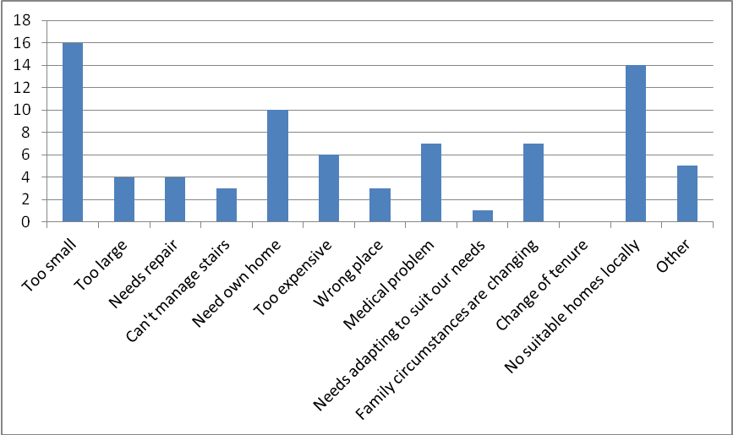

The most frequently quoted reasons for the household’s current home being unsuitable in general are:

The property is too small: If the family is getting larger through additional children, through blended families or through families merging to provide care and support, then the property may become too small for the family’s needs.

The property is too large: Large homes are expensive to heat and maintain.

The property needs repair: Older properties can require significant repairs that can be prohibitively expensive.

It needs a bathroom: This is usually a question of accessibility, with the bathroom being upstairs when the person can no longer use the stairs easily.

The property requires adaptations: To make the property more suitable for the occupants’ needs (which relates to people having medical problems).

The property is too expensive: As family circumstances change, people no longer require large properties and think about ‘downsizing’ to a more appropriate home.

It is in the wrong place: Where people indicate that their current property is in the wrong location; usually this is an accessibility problem as people can no longer get to the shops or to visit their friends and family.

Medical problems: This may mean that a previously ideal property becomes unsuitable, for example, if an occupant can no longer manage the stairs or if they need access to a ground floor bathroom and their home has no such facility. These people’s needs may be better met through a bungalow, but these properties are not always available within the same village.

The need to set up their own home: Usually people wishing to move away from the family home, for example young people living with their parents who wish to leave home.

Changing family circumstances: In this survey, this was the most popular reason given for households needing to move. Situations like divorce, a new baby or an elderly relative moving in could be factors in a home becoming unsuitable. These factors may dictate moving to a smaller, cheaper property or to a larger one to accommodate new members to the family.

Change tenure: This reason is usually given when people want to move from a privately rented property to a cheaper housing association property, or they may live in tied accommodation and are considering retirement or a change of employment which will oblige them to leave their current home.

No suitable homes available locally: People wish to stay in the area due to family reasons, schools or work but are unable to find a home more suited to their needs. Larger family homes and reasonably priced bungalows are the most commonly required properties and are often in short supply.

RESULTS FROM PART TWO – IDENTIFYING CIRCUMSTANCES AND REQUIREMENTS

Part Two of the Survey was only completed by those respondents who had indicated that their current home was unsuitable for their household’s needs and who were therefore potentially in housing need. Responses to Part Two were made on behalf of 42 households.

An assessment of each response has been undertaken by Cambridgeshire ACRE and a decision made regarding whether the household can be considered a potential candidate for affordable housing in Melbourn based upon:
- particular medical and welfare needs,
- proof of local connection,
- ability to gain access to and maintain suitable housing privately.

Following this assessment, 13 households were excluded leaving 29 households who were actually considered to be in need of affordable housing. The main reason for excluding households at this stage was that they planned to address their own housing needs through the private housing market.

The remainder of this section sets out the overall findings regarding those found to be in need of affordable housing in Melbourn.

Local Connection to Melbourn

Residence
Respondents were asked to indicate whether or not they currently lived in Melbourn. All bar one of the 29 households responding currently live within the parish of Melbourn.

Table 5 below shows how long these 28 households have resided there. Over half of the households have lived in the parish for over 15 years. Only six have lived in the parish for less than five years.

Table 5: Length of time living in the village

 | Frequency
Less than 1 year | 1
1-5 years | 5
5-10 years | 5
10-15 years | 2
More than 15 years | 15
Not stated | 0
Total | 28

Family
Respondents were asked to indicate whether or not they or another member of their household had family connections to Melbourn parish. Eighteen stated that they have a family connection to the parish. In most cases (13), this was their parent(s) already living in the village.

Household Composition

The survey sought to understand the gender, age and status of those who might potentially live in any affordable housing built as a result of this survey.

Number of people who will make up the household
Table 6 sets out the number of people making up each household. Of those seeking a new property, the majority would be smaller households of 1 – 2 people.

Table 6: Number of people in the household

 | Frequency | No of people
1 person | 9 | 9
2 people | 11 | 22
3 people | 4 | 12
4 people | 3 | 12
5 people | 2 | 10
6 people | 0 | 0
7 people | 0 | 0
Total | 29 households | 65 people

Gender
Respondents were asked to identify the gender of those people who would make up their household. Table 7 captures the results.

Table 7: Gender profile of residents

 | Frequency
Male | 33
Female | 32
Not stated | 0
Total | 65 people

Age
Respondents were asked to identify the ages of those people who would make up their household. Table 8 captures the results.

Table 8: Age profile of residents

 | Frequency
Under 16 | 19
16 - 24 years | 9
25 - 29 years | 5
30 - 39 years | 11
40 - 49 years | 8
50 - 54 years | 2
55 - 59 years | 4
60 - 64 years | 1
Over 65 years | 3
Not stated | 3
Total | 65 people

These results indicate that the new properties would be occupied by people from both genders and all age ranges, with the majority being classed as ‘young families’. Over 40 % of residents would be aged under 25. A good balance of genders and ages is vital for a sustainable community as local services, such as shops, schools, village halls and sports facilities; all rely on varied user groups.

Status
The survey sought to understand the employment status of those indicating a housing need. Table 9 outlines the results and shows that by far the largest proportion of those seeking a more affordable home are either in employment or are students/children (49 out of 65 people).

Table 9: Status of people in the household

 | Frequency
Employed | 26
Unemployed | 9
Student | 3
Child | 20
Retired | 4
Not stated | 3
Total | 65 people

Property Type, Size and Tenure

The survey allowed respondents to indicate the type (e.g. house, bungalow, flat, etc.), size (in terms of number of bedrooms) and tenure they would prefer. However, in concluding what type, size and tenure of properties should actually be built, this report’s recommendations are based on actual need rather than respondent aspirations. This analysis has been done by reference to South Cambridgeshire District Council’s Lettings Policy Document.

SUMMARY AND RECOMMENDATION

This report has been informed by primary data (people who responded to the survey stating that they have a housing need) and secondary data, such as the ratio of local house price to local income, the demographics of the local population and the local housing register.

It is this report’s conclusion that a significant affordable housing need has been found in Melbourn Parish.

Pre-Existing Evidence from the Housing Register

The local Housing Register was searched for households in need of affordable housing with a local connection to Melbourn. There are 183 households on the Register that meet this criterion. This data was been combined with the results of this survey in order to calculate overall need.

The properties that would need to be built and then let out through a Housing Association to accommodate these households are as follows:

1 bed |  |  | 2 bed |  |  | 3 bed |  |  | 4 bed |  |  | 5+ bed |  |  | Total
F | H | B | F | H | B | F | H | B | F | H | B | F | H | B | 183
 | 52 | 4 |  | 52 | 35 |  | 34 | 2 |  | 4

Findings from Housing Needs Survey

The Housing Needs Survey conducted in Melbourn found 29 households in need of affordable housing. 17 of these households were found to be already registered on the Housing Register and so were removed from the results, reducing the need identified through the survey to 12 additional households.

Nine of these households would require a property let out through a Housing Association. The properties that need to be built to accommodate these households are as follows:

1 bed |  |  | 2 bed |  |  | 3 bed |  |  | 4 bed |  |  | 5+ bed |  |  | Total
F | H | B | F | H | B | F | H | B | F | H | B | F | H | B | 9
 | 4 | 1 |  | 1 | 1 |  | 2

The remaining three households require a property available for Shared Ownership through a Housing Association. The properties that need to be built to accommodate these households are as follows:

1 bed |  |  | 2 bed |  |  | 3 bed |  |  | 4 bed |  |  | 5+ bed |  |  | Total
F | H | B | F | H | B | F | H | B | F | H | B | F | H | B | 3
 |  | 1 |  |  |  |  | 2

Conclusion

There are 195 households identified as being in need of affordable housing with a local connection to Melbourn:

1 bed |  |  | 2 bed |  |  | 3 bed |  |  | 4 bed |  |  | 5+ bed |  |  | Total
F | H | B | F | H | B | F | H | B | F | H | B | F | H | B | 195
 | 56 | 6 |  | 53 | 36 |  | 38 | 2 |  | 4

Recommendation

To fulfil all current and immediate housing need in Melbourn, 195 new affordable homes need to be built.

This scale of need is well above the typical scale of rural exception site developments. It is therefore recommended that the size of the development should adhere to the Planning Policy contained within the Local Development Framework for South Cambridgeshire District Council on rural exception sites. Ongoing consultation between the Parish Council and Jephson Housing Association should help to inform this decision.

Consideration also needs to be given to the Melbourn Village Plan. This plan is the result of extensive consultation and has a number of findings and agreed actions that could help shape any future affordable housing development in the village.
APPENDIX 1: CHOICE BASED LETTINGS AND LOW COST HOME OWNERSHIP

Most people access affordable housing through either the Choice Based Lettings or Low Cost Home Ownership schemes. These prioritise people with the greatest level of need. Rural exception sites differ in that they prioritise local connections to a parish over level of need.

Choice Based Lettings

Home-Link is the Choice Based Lettings scheme for the Cambridge sub-region. Choice Based Lettings aims to make the application process for affordable rented housing easier and to give people more choice about where they live.

Housing is allocated on a ‘needs basis’. In other words, those people that have the greatest level of need and have been in need for the longest time are given priority. Everybody on the Housing Register is assessed and placed into a band of need. Band A is the greatest level of need. Band D is the lowest.

The scheme means there is just one Housing Register for the Cambridge sub region with only one form to complete. When applicants are accepted onto the Register they are told what Band they have been assigned to, what size and types of property they can apply for and which areas they can apply in. Generally people can apply for properties within the Local Authority in which they reside. If the person has a local connection to other areas (through, for example, work) they may be able to apply in these areas as well. A small proportion of properties in every Local Authority are set aside for applicants living anywhere in the Cambridge sub region.

A distinctive feature of rural exception sites is that they have a ‘local connection’ condition attached to all affordable dwellings in perpetuity. This means that priority will always be given to people with a local connection to the parish even when their level of need is assessed to be lesser than other potential applicants.

Low Cost Home Ownership

Orbit HomeBuy Agent, the government-appointed HomeBuy Agent, responsible for marketing all low cost home ownership schemes in the Cambridge sub region, offers a Shared Ownership scheme called ‘New Build HomeBuy’.

People buy a share in a property built by a housing association and pay a subsidised rent on the part that they do not own. They can buy an initial share of between 25% and 75% of the property and pay rent on the remaining share.

In some shared ownership schemes, the householder can buy additional shares until they own the property outright. This is known as ‘staircasing’. However, on rural exception sites ownership is limited to 80% to ensure the dwellings remain ‘affordable’ in perpetuity. Again, priority is given to people with a local connection to the parish.

A more dtailed description of Melbourn can be found in the Melbourn Village Plan (http://melbourncambridge.co.uk/villageplan/plan2/)
Source: www.nestoria.co.uk
Source: www.rightmove.co.uk (as at 20-Dec-2011)
Source: CACI Paycheck 2009
Source: Figures used taken from Orbit Homebuy Agents Comparison Tables, July 2011
Source: http://atlas.cambridgeshire.gov.uk/Housing/LHA/atlas.html
Source: http://atlas.cambridgeshire.gov.uk/Housing/LHA/atlas.html (for electoral ward of Melbourn, which includes the parishes of Melbourn, Great & Little Chishill and Heydon)
Questions about housing and affordable housing development were also asked as part of the Melbourn Village Plan consultation process. See http://melbourncambridge.co.uk/villageplan/plan2/ for details. The results are broadly consistent with overall support for affordable homes for local people qualified by concerns over location, scale, facilities etc.
See http://www.scambs.gov.uk/documents/retrieve.htm?pk_document=906206
Codes used are F (Flat), H (House) and B (Bungalow)

