Cambridgeshire ACRE

Housing Needs Survey Results Report for
Landbeach Parish
Updated version September 2009

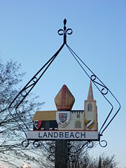

Local Homes for Local People

Contents Page Number

Context and Methodology 3
Landbeach Parish 4

Results from Part One: To ascertain those in housing need 6
Suitability of current home 6
Views on Affordable Housing development in Landbeach 7

Results from Part Two: To ascertain current household circumstances 9
Length of time living in Landbeach 9
Family connections to Landbeach 9
Household composition 10
Property type and size 12
Property tenure 13

Results from Part Three: To ascertain household requirements 15
Property type and size 15
Property adaptations 16
Property tenure 16
Household composition 17
Local income levels and affordability 19

Conclusion and Recommendations 24

Appendix 1 – Covering Letter 30

Appendix 2 – Housing Needs Survey Form 31

Appendix 3 – Tables showing the Full Results 38

Appendix 4 – Comments on the possibility of a small development of affordable homes in Landbeach parish 45

Context and Methodology

In March 2009 Cambridgeshire ACRE was commissioned to carry out a Housing Needs Survey in Landbeach Parish. This survey was carried out on behalf of Hundred Houses Society, an affordable homes provider in partnership with South Cambridgeshire District Council and Landbeach Parish Council.

The aim of this survey was to determine the existing and future levels of affordable housing need in the parish. Affordable housing is housing made available either for sale or rent, based on the evidence of need, to those sections of society unable to afford housing at market prices. Planning conditions and legal agreements can be used to restrict the occupation of property to people falling within categories of need. Under a traditional, generally points-based, allocation system, the local council will assess an applicant's housing needs, determine their priority, and make an offer of appropriate accommodation to the household with the highest number of points. On rural exception sites, applicants must prove a local connection through family or work.

Survey packs were posted out to all 379 addresses in the Parish on 27 February 2009. The survey packs included a covering letter (Appendix 1), a questionnaire (Appendix 2) and a postage paid envelope for returned forms.

The questionnaire was divided into three sections:
- Part 1 of the survey form contained questions to determine housing need. All households who returned the form completed this section.
- Part 2 of the survey form contained questions on household circumstances.
- Part 3 of the survey form contained questions on housing requirements.
- Parts 2 and 3 were completed by households who are currently or expecting to be in housing need of accommodation and who are either currently living in Landbeach Parish or who wish to return to the parish.

The closing date for the survey was 30 March 2009. 73 completed forms were returned giving the survey a 19% response rate. Appendix 3 contains tables showing the full results.

Landbeach Parish

Landbeach has two churches (Anglican and Baptist), a village hall and an Indian restaurant (formerly The Slap Up public house). The nearest railway station is Waterbeach, on the Fen Line. The village lies close to the A10 road that also links London to King's Lynn. Within the parish boundary, but outside the residential area, is Cambridge Research Park, on the site of the former Landbeach Marina, itself a flooded former gravel pit. It has limited services, although it has a post box, telephone box and mobile deliveries of milk etc. It has good community services such as a church, sports field, social club and village green.

According to the 2001 census, there were 825 people living in 359 dwellings within the Parish of Landbeach. Surveys were sent to 379 residential addresses, which appears to indicate that 20 additional dwellings have been built in the last 8 years.

Average property prices in Landbeach are slightly lower for smaller properties. With the fluid house market situation prices are changing every month. Table 1 compares average property prices across the county.

Table 1: Average Property Prices, March 2009

No. of bedrooms | Landbeach Parish | South Cambs | Cambridge City | East Cambs | Fenland | Hunts
1 | £109,000 | £143,000 | £136,000 | £136,000 | £118,000 | £123,000
2 | £168,000 | £180,000 | £199,000 | £151,000 | £137,000 | £168,000
3 | £240,000 | £238,000 | £251,000 | £202,000 | £183,000 | £216,000
4 | £323,000 | £354,000 | £374,000 | £282,000 | £264,000 | £317,000

This chart shows the average income across the parish. Landbeach has some people who earn a high level of income to match the house prices. Although there is a cluster of people around the £20,000 to £30,000 income level, it is significant that 33% of the population of Landbeach earn less than £27,250, the minimum needed to purchase a one bedroom flat. 61% earning less than £42,000 per annum to purchase a 2 bedroom house. 76% earn less than £60,000 which you need to earn to buy a 3 bedroom house. 16% earn enough to get a mortgage on a 4 bedroom house or larger. This assumes that they have the required deposit for first time buyers, which is 25% of the purchase price. The median income is £33,400 per annum.

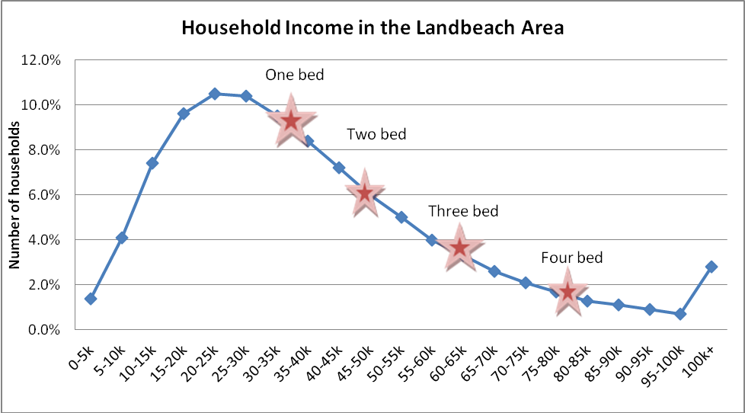

148 households have no-one in employment. 6 households had no-one in employment with dependent children and there are 7 lone parent households. There are 154 people with a limiting long term illness and 130 people providing unpaid care. 15% of the population are retired and 3% are students who are economically inactive.

RESULTS FROM PART ONE – TO ASCERTAIN THOSE IN HOUSING NEED

Suitability of current home

Respondents were asked to indicate whether or not their current home was suitable for their household’s needs. Figure 1 shows that 91% of respondents felt their current home was suitable for their household needs, with only 9% indicating that their current home is unsuitable for their needs.

Figure 1: Suitability of current home

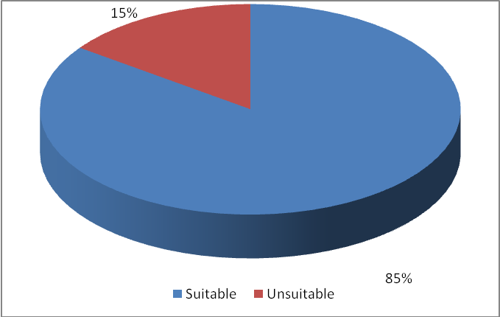

If respondents indicated that their current home was unsuitable for their needs, they were then asked to indicate the reasons why. Respondents were allowed to give more than one reason for unsuitability, so all responses are recorded. Figure 2 (overleaf) illustrates the reasons respondents gave for their current home being unsuitable.

The chart shows that the most popular reasons given for why the household’s current home is unsuitable is that they have a medical problem resulting in them needing a home better equipped to meet their needs. They also gave the reason that they wish to set up their own home.

Changing family circumstances (e.g. divorce, new baby on the way, or an elderly relative moving in), was also given as a reason for people wishing to move to larger premises. People stay in homes which are too large which they no longer require as they are difficult to maintain and expensive to run. This leads to a lack of larger houses for the young people in the village.

The results suggest there are at least three young people living in the Parish who wish to set up home for the first time but who are unable to do so due to a lack of housing they can afford.

Figure 2: Reasons why current home is unsuitable

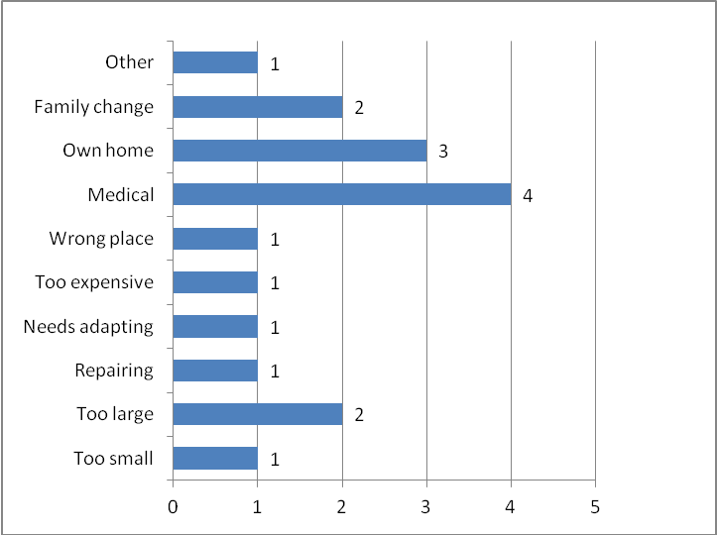

Views on Affordable Housing Development in Landbeach

All respondents to the survey were given an opportunity to voice their opinion on the possibility of a small development of affordable homes for local people within the parish. 64% of respondents said they would be in favour; 8% stated that they would not be in favour and 27% chose not to state their opinion. Figure 3, which illustrates these results pictorially, demonstrates that just under half of respondents would be in favour of a small affordable housing development in Landbeach.

Figure 3: Attitude towards affordable housing development

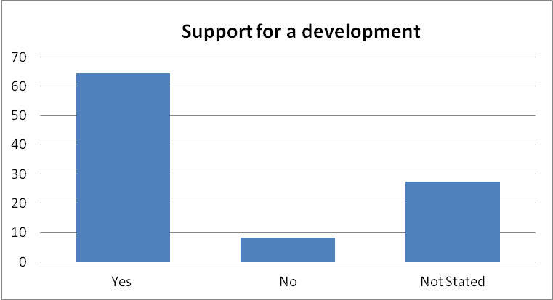

Many people chose to add comments to qualify their response and these have been shown in Appendix 4.

RESULTS FROM PART TWO – TO ASCERTAIN CURRENT HOUSEHOLD CIRCUMSTANCES

Part Two of the Survey was only completed by those respondents who had indicated that their current home was unsuitable for their households needs and who were therefore potentially in ‘housing need’. 14 respondents completed Part Two.

Length of time living in Landbeach

Respondents were asked to indicate whether or not they currently lived in Landbeach parish. 11 people responded that they do currently live within the parish of Landbeach. 3 live outside.

The parish of Landbeach has clearly been a popular location for many years. Only 1 household responding had lived in the parish for 51 – 70 years. A total of 4 of the households have lived there for 6 – 20 years. 3 households have lived there for 1-5 years. 3 households have lived there 21 -30 years. 8 households have been in the parish for over 5 years. Figure 4 demonstrates these results and shows the majority of those indicating a housing need are long-term residents of the parish.

Figure 4: Length of time in the village

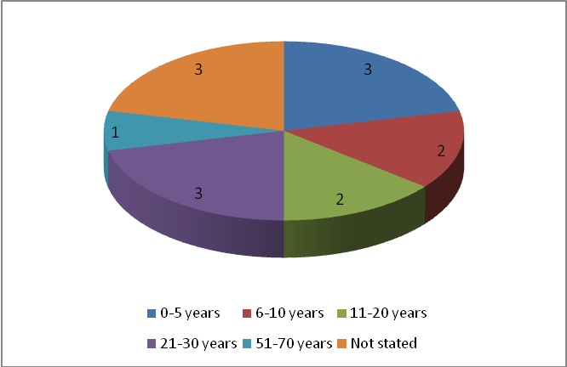

Family connections to Landbeach

Respondents were asked to indicate whether or not they or another member of their household had family connections to Landbeach parish. 9 stated that they have a family connection to the parish and in 4 cases this was that their parent(s) currently live within the parish. 4 of the households have family in Landbeach. The other 1 household has children living there. The rest, 4 have no other family connection to Landbeach although they live or work in the parish.

Household Composition

Number of people in the house

Respondents were asked about the number of people in their current household. The majority (3 households) are currently living in two, three and five person households.
2 households live in four person households. 2 households live in six person households. Only 1 respondent lives in a one person household.

Figure 5: Number of people in the household

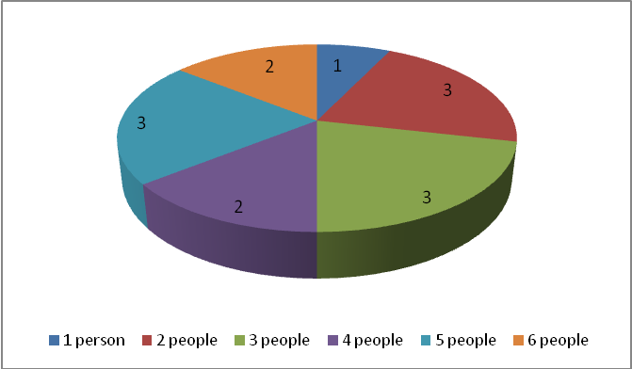

Age

Residents aged between 40 - 60 years old account for fourteen of the total residents indicated to be in housing need. There are 10 residents aged 40 – 60 years old. There are nine children aged under 16. Four are aged 16 – 25. Just 4 are aged over 60 years. Figure 7 shows that age profile of those in housing need is fairly evenly split over all stages of life, although middle aged families with children appear to be mostly like to have a housing need.

Figure 7: Age of people in the household

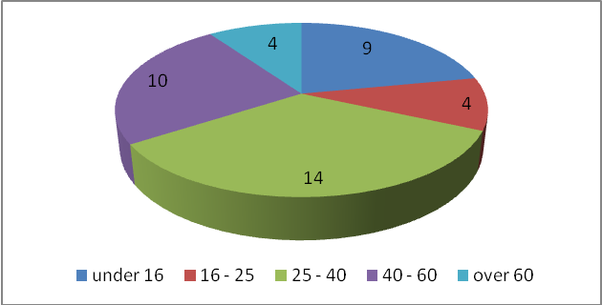

Status

25 of those who make up the household in housing need described themselves as employed; 6 as unemployed; 1 as a student and 9 as children. Figure 8 represents these figures and provides clear evidence that it is not just those who are unemployed or on benefits who are looking for affordable housing. There are people who are working for a living who are still unable to afford a home suitable for their needs. It is hoped that this evidence will allay some of the fears of people who are strongly against an affordable housing development because they feel it might attract an ‘undesirable’ element.

Figure 8: Status of people in the household

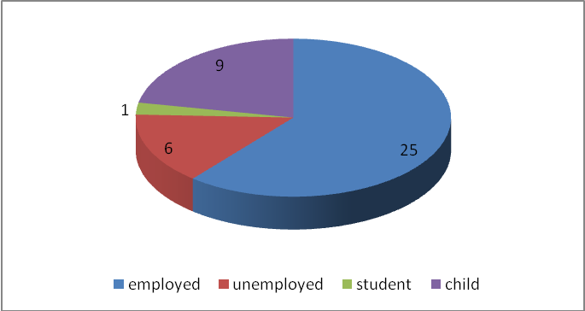

Property Type and Size

Respondents were asked to provide information on the type and size of property that they currently live in.

Out of the 14 households that responded, 10 indicated that they currently live in a house, 2 live in flats, 1 lives in a caravan and 1 household lives in a bungalow.

The majority of homes occupied by those who indicated a housing need are three bedroom or larger properties; these properties make up 5 of the survey results.

Figure 8: Current property type

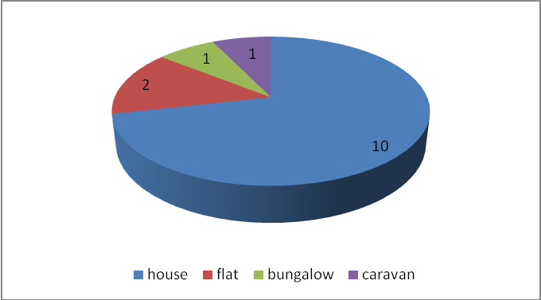

Figure 9: Current property size

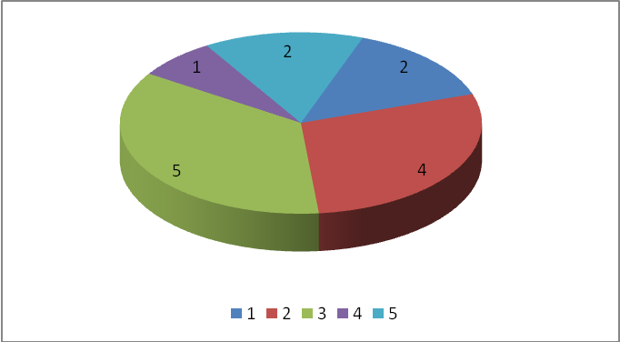

Property Tenure

Respondents were asked to indicate who owns their current home. A significant percentage of respondents (6 households) have properties owned by either the local authority or a housing association. 3 own their property themselves, either outright or with a mortgage.
2 of those responding are currently living with their parents. Another 2 households rent from a private landlord. One of the households responding has accommodation tied to their job.

Figure 10: Property Tenure

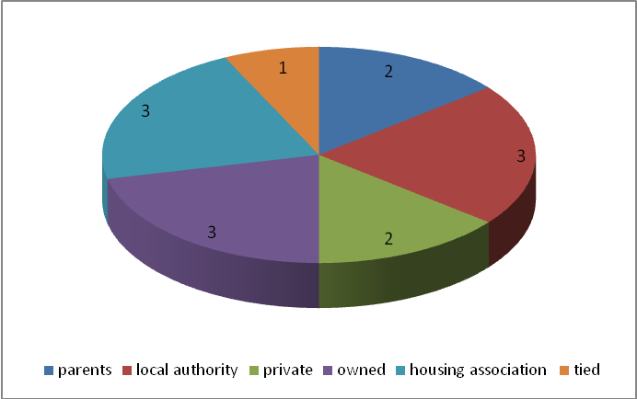

RESULTS FOR PART THREE: TO ASCERTAIN HOUSEHOLD REQUIREMENTS

14 households indicated that they are looking for a property better suited to their needs in Landbeach and completed Part 3 of the survey form.

Property Type and Size

The preferred type of property for 10 of the respondent households is a house. 4 households would prefer a bungalow.

Figure 11: Property type required

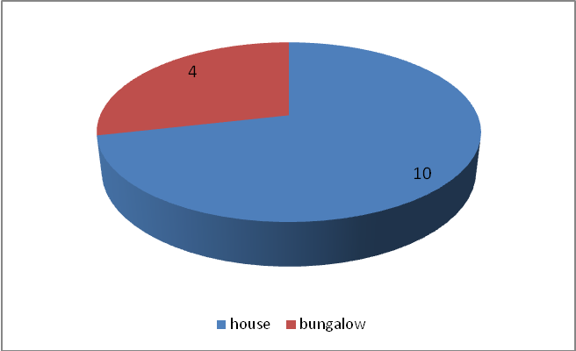

In terms of the size of property required, 9 households require a two-bedroom property, 3 households require a three-bedroom property. 3 require a four-bedroom property and 1 household requires a one bedroom property. 1 household requires a four bedroom property. Figure 12 shows this information on a pie-chart – and clear need for two/three bedroom properties can be easily seen.

A review of property search websites did not reveal any properties currently for sale in Landbeach. The households in need (even if they wish to buy and have the funds to do so) appear to be looking for properties that Landbeach currently cannot offer.

Figure 12: Property size required

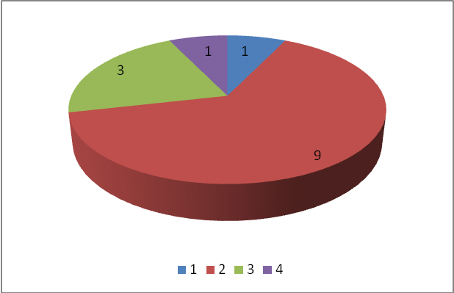

Property Adaptations

1 of the 14 households who responded indicated that they or a member of their household would require special adaptations to be made to their property in order to meet special needs.

Property Tenure

Respondents were asked to indicate their preferred tenure. 7 households would prefer to rent from a Housing Association. 3 households would prefer to buy on the open market.
4 households expressed an interest in buying in shared ownership, which is where the household can buy a percentage of the value of the property, e.g. from as little as 25%, and pay for this through a mortgage. The remaining percentage is owned by a Housing Association and a weekly rent is paid on the share not owned. The maximum percentage that can be owned is 80% so that the property always remains available as affordable housing and can never be sold on the open market.

Figure 13, over page, demonstrates the preferred tenures of those households in housing need.

Figure 13: Property tenure required

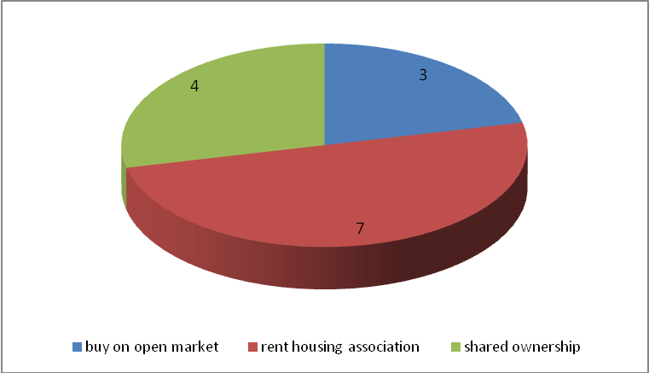

Household Composition

The survey sought to understand the gender, age and status on those who would live in the proposed households.

Number of people who will live in the house

Of the new households seeking a property, 6 would be two person households; 3 would be one person households and a further 2 would be four-person households. 2 would be three person households and 1 would be a five person household.

Figure 14: Number of people who will live in the household

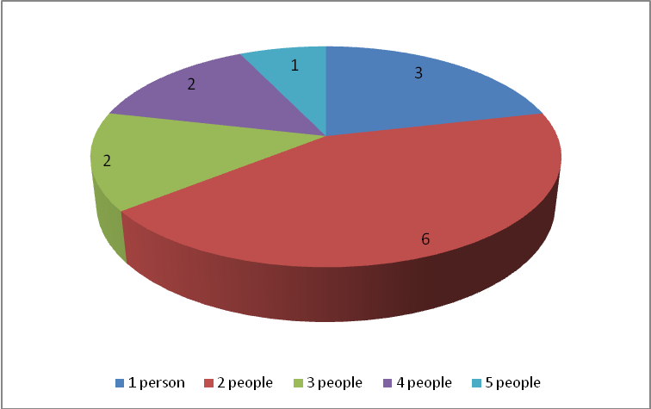

Age

Approximately 14 of the residents would be aged 16-40 years old, 9 would be under 16.
4 would be 17 – 25 and a further 4 would be 41 – 59.

These results indicate that the new properties would be occupied by people from all age ranges. A good balance of ages is vital for a sustainable community, as shops, schools, village halls, sports facilities, etc. all rely on varied user groups.

Figure 15: Age of people who will live in the household

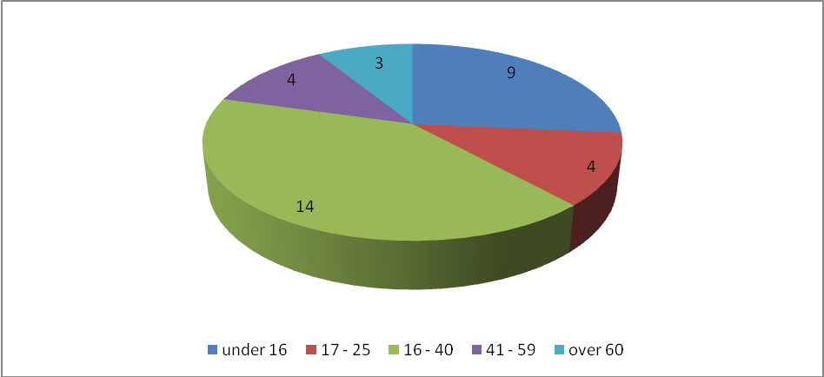

Status

19 of the people within the new households would be in employment; 9 would be children and 6 would be unemployed.

Figure 17 overleaf demonstrates that by far the largest proportion of those seeking a more affordable home are either in employment or are children (82% overall).

Figure 16: Status of people who will live in the household

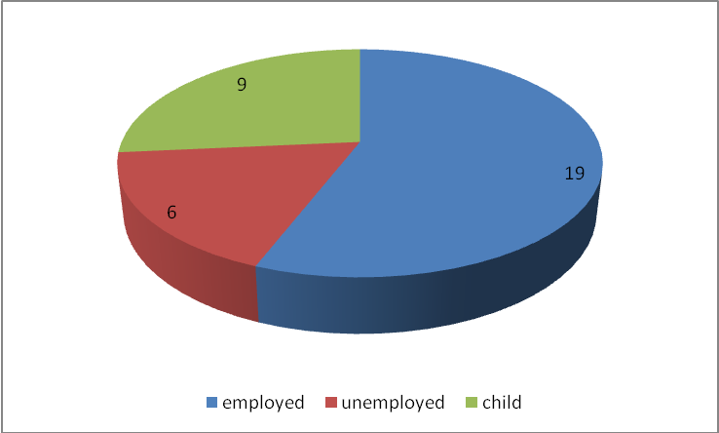

Local Income Levels and Affordability

When planning Affordable Housing schemes it is helpful to understand what people can afford. Respondents were therefore asked to include details on their proposed household’s annual gross household income.

Three households earn less than £20,000 a year. 5 households earn £20,001 to £30,000 a year. 3 households earn between £30,001 and £40,000 per year. One earns between £50,001 and £60,000 a year. Two households did not state their income.

Figure 17: Combined household income

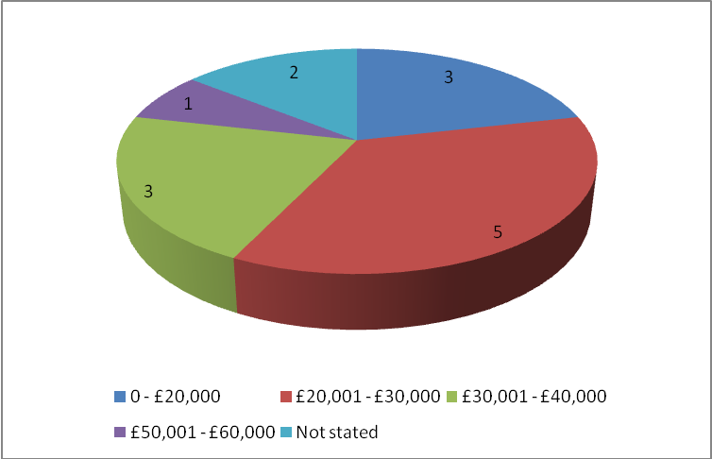
Respondents were also asked to indicate the maximum monthly payment their planned household could afford for housing. Figure 18 below shows that the majority of households (5) could afford to spend between £401 - £600 per month on housing. 4 could afford less than £400 a month. 2 could afford £601 to £800 a month. 3 did not state an amount.

Figure 18: Maximum monthly payment available for housing

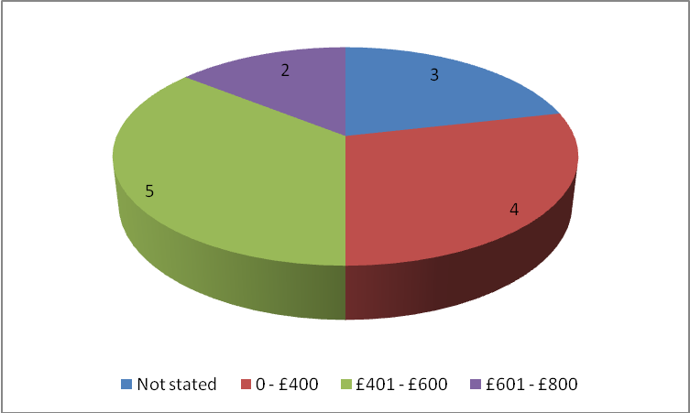

Buying on the Open Market

3 of the households who indicated a housing need stated that they would like to purchase a home on the open market.

Table 2 over the page shows most recent house price data for Landbeach for various sizes of dwelling and indicates the annual income that would be required in order to be able to afford the mortgage.

Table 2: House price data for Landbeach, March 2009

No. of bedrooms | House Price | Deposit required  (Assume 25% required) | Annual income required  (based on mortgage lending principle of 3 x income) | Monthly salary needed for purchasers
1 | £109,000 | £27,250 | £27,250 | £2,270
2 | £168,000 | £42,000 | £42,000 | £3,500
3 | £240,000 | £60,000 | £60,000 | £5,000
4 | £323,000 | £80,750 | £80,750 | £6,730

For a household to be able to obtain a 3 bedroom house (at the price stated above) in Landbeach, they would need a combined income of £60,000.

A household’s ability to buy is also dependent on them having saved an appropriate deposit, as most mortgage lenders will now only lend up to 75% of the property value. Each household who responded to the survey was also asked to state the maximum deposit they could afford to put down on a property and none could afford the required deposit to secure their desired property.

An assessment of whether those wishing to purchase a home on the open market are likely to be able to do so is given in Table 5 (Those in housing need who wish to buy a home on the open market) which can be found in the Conclusion section of this report.

Buying in Shared Ownership

If people can’t afford to buy on the open market, they might qualify for shared ownership. 4 of the households who indicated a housing need stated that they might be interested in buying a home in shared ownership.

Shared ownership affordability can be estimated by assuming the householder will purchase a 30% share of the property. To buy this 30% share, the householder would need at least a 10% - 20% deposit. Rent would be paid on the unsold equity at between 2.5% - 2.75%. A small service charge also needs to be added.

Table 3 over the page estimates shared ownership affordability using known Landbeach house price data.

Table 3: Shared ownership in Landbeach, March 2009

No. of bedrooms | House Price | 30% share | Deposit required  (assume 20% required) | Total Costs per Month | Annual joint household income required
1 | £109,000 | £32,700 | £6,540 | £420 | £15,100
2 | £168,000 | £50,400 | £10,080 | £632 | £22,800
3 | £240,000 | £72,000 | £14,400 | £890 | £32,100
4 | £323,000 | £96,900 | £19,400 | £1,200 | £42,485

An assessment of whether those wishing to purchase in shared ownership are likely to be able to do so is given in Table 6 (Those in housing need who wish to buy a home in shared ownership) which can be found in the Conclusion section of this report.

Should a household not be able to afford shared ownership, then they could opt / qualify for a rental property.

Renting

7 households said they would prefer to rent a property and all expressed a preference for rental through a Housing Association, rather than a private rental.

In terms of the rental payments that these households would be able to afford, two households could afford up to £200 per month; three could afford between £201 – 400; and two could afford between £401 - 600 per month.

Table 4 overleaf shows the typical monthly rental cost of a Housing Association property in 2008.

Table 4: Typical rental costs of Housing Association properties

 | No. of Beds | HA Monthly Rent | Private Monthly Rent
 | 1 (or bedsit) | £304 | £876
 | 2 | £348 | £1,089
 | 3 | £407 | £1,200
 | 4 | £496 | £1,446

More detail on those wishing to rent from a Housing Association can be found in Table 7 (Those in housing need who wish to rent from a Housing Association) which can be found in the Conclusion section of this report.

Conclusion and Recommendations

It is the conclusion of this report that a clear housing need has been found in Landbeach Parish.

This conclusion has been informed by primary data (people who responded to the survey stating that they have a housing need) and secondary data, such as the ratio of local house price to local income and the demographics of the local population.

Whilst there is a perception by many that affordable housing will lead to ‘problem families’ moving in, it should be noted that in Landbeach, there are many people already living with the parish who are in need, for example, young people wishing to leave home but who wish to remain in the village, older people wishing to ‘downsize’ and people with specific medical needs, e.g. accessible bathroom facilities, which are not being met by their current home.

The results of the survey suggest that there are 11 households in need of affordable housing.

SUMMARY AND RECOMMENDATIONS

It is therefore recommended that Hundred Houses Society consider building 11 affordable dwellings within the parish of Landbeach. The following list summarises the preferred accommodation type, tenure and minimum number of bedrooms needed:

Dwellings to be available to buy in shared ownership

Three households would be in a financial position to buy their preferred property in shared ownership.

- 2 x two-bed house
- 1 x two-bed bungalow

Dwellings to be available to rent from a Housing Association

Based on the information supplied by households responding to the survey, the remaining 8 households would be in a financial position to rent only and a variety of properties would be needed to satisfy this need:

- 3 x two-bed house
- 2 x three-bed house
- 1 x one-bed bungalow with adaptations
- 2 x two-bed bungalow

DEMAND FROM THE HOUSING REGISTER

This list has been compiled using information from the Housing Register for people with a local connection to Landbeach only. Where people have indicated that they have already registered their details on the Housing Register, 4 duplicate requests have been removed. This shows a total demand for 18 dwellings. This shows that the Housing Survey has picked up a total of a further 7 dwellings where people had not previously registered a need.

Dwellings to be available to buy in shared ownership

Three households would be in a financial position to buy their preferred property in shared ownership.

- 2 x two-bed house
- 1 x two-bed bungalow

Rent from a Housing Association
- 3 x one-bed flat
- 4 x two-bed house
- 2 x three-bed house
- 1 x one-bed bungalow
- 1 x one-bed bungalow with adaptations
- 4 x two-bed bungalow

Recommendation

To fulfil all current and immediate housing need in Landbeach, 18 new affordable homes would need to be built. It is recognised that this is likely to be unachievable and so it is therefore recommended that Hundred Houses aim to build between 8 and 12 affordable dwellings within the parish of Landbeach. Ongoing consultation with the Parish Council should help to inform this decision.

Appendix 1: Covering Letter

26 February 2009

The Householder

Dear Householder

Landbeach – Housing Needs Survey

Landbeach Parish Council has asked us to carry out an independent survey of housing need in the Parish. The aim of the survey is to identify whether there is a shortage of housing for local people, who cannot afford to rent or buy a suitable home at current prices. Examples are:

- People already living in the parish but who are living in unsuitable housing, for example, those who have a growing family or special needs.

- People wishing to remain in the village for reasons of social/family support networks.

- People whose work provides important services and who need to live close to the local community.

This survey is very important and will also give you an opportunity to tell us what you think about housing in your village.

If the survey finds there is a need for more affordable housing, then a small affordable housing development could be considered. This would provide low cost housing to rent or purchase through the shared ownership scheme. Priority for these homes would go to local people with a strong connection to the village. A full report on the survey findings will be shared with the Parish Council in due course.

In order to help us, please complete the enclosed questionnaire and return it in the pre-paid envelope provided by 30 March 2009. Additional copies of the survey can be sent to people who live elsewhere but who have a strong local connection the village and require housing – just let us know their contact details so we can send it to them.

Thank you in anticipation of your response.

Yours sincerely
Catherine Shilton
Rural Housing Enabler

Encs

Appendix 2: Housing Needs Survey

LOCAL HOMES FOR LOCAL PEOPLE
HOUSING NEEDS SURVEY FOR THE PARISH OF LANDBEACH

This survey is being carried out to assess housing need in the parish of Landbeach, encompassing Landbeach itself, Murrow, Guyhirn, Tholomas Drove and Thorney Toll. The Poor’s Allotments Charity is working with Cambridgeshire ACRE to co-ordinate and subsequently act upon the results. The results will help decide whether there is a need for affordable housing in the village and, if so, the type of affordable housing to be provided in the parish so it is important that as many people as possible complete the questionnaire and return it in the envelope provided.

It is important to note that the survey is intended to highlight all those current and future households who cannot afford to rent or buy a home in the open market and not just those in need in the traditional subsidised ‘social’ rented sector.

This survey should be completed by anyone living at your address that requires suitable alternative accommodation either now or in the immediate future. We also need to cover the requirements of those who no longer live in the survey area but who would like to return for family or work reasons. If you know of anyone in this category then please encourage them to complete this questionnaire. Further copies of the questionnaire can be obtained by calling Alison Brown on 01353 865029.

A copy of this form is being delivered to every household and business in the area and completed forms should be returned no later than 24 April 2009 in the enclosed pre-paid envelope.

All information provided will be treated in the strictest confidence and you do not have to provide your details if you do not wish. However, if you do complete the personal details below, we will contact you regarding any possible housing scheme that results from this survey.

PERSONAL DETAILS
NAME: (MR/MRS/MS/OTHER)
ADDRESS:
TELEPHONE:
EMAIL:

DATA PROTECTION
The organisation processing your data is Cambridgeshire ACRE, who is registered with the Information Commissioner’s Office, under the Data Protection Act 1998, for the purpose of processing personal data in the performance of its legitimate business. Any personal details collected will be held in accordance with Data Protection legislation. Further information relating to the Data Protection Act 1998 can be sent to you on request. If you have concerns about the processing of your personal data by Cambridgeshire ACRE you may contact the Information Commissioner’s Office at Wycliffe House, Water Lane, Wilmslow, Cheshire SK9 5AF.

The information you supply will be used to produce a statistical report identifying the level and type of housing need in your village. You do not have to identify yourself if you do not want to and we do not expect you to sign your form. Your answers will not be used for any other purpose.
PART ONE – HOUSING NEED

Please indicate whether you or a member of your household (e.g. older children or other dependents) are in housing need by answering either Question 1a or Question 1b.
 | Question 1a - My current home is unsuitable for my household. |  |  |  |  | Yes
 | If yes, please tick all boxes that apply to you:
 | It is too small (overcrowded) |  |  | It is too expensive
 | It is too large |  |  | It is in the wrong place
 | It needs repairing |  |  | I have a medical problem
 | It needs a bathroom |  |  | I need my own home
 | It needs adapting to suit our needs |  |  | I share with other households
 | Other: |  |  | We have changing family circumstances
 | Question 1b - My current home is suitable for my household. |  |  |  |  | Yes

 | Question 2 - Would you be in favour of a small development of affordable homes for local people? | Yes |  |  | No
 | Please add any comments you would like to make here:

If you answered ‘Yes’ to Question 1a, please complete Sections 2 and 3.

If you answered ‘Yes’ to Question 1b, please stop here and return the form to us in the pre-paid envelope which was enclosed alongside this survey.
PART TWO – HOUSEHOLD CIRCUMSTANCES
Please tick one box for each question unless otherwise indicated

 | Question 3a - Do you live in Landbeach Parish? | Yes |  |  | No
 | Question 3b - If yes, how long have you lived in Landbeach Parish? |  |  | yrs |  |  | months

 | Question 4a - Have you lived in Landbeach Parish in the past? | Yes |  |  | No
 | Question 4b - If yes to Q4a, how long did you live in Landbeach Parish? |  |  | yrs |  |  | months
 | Question 4c - If yes to Q4a, how long ago did you live in Landbeach Parish? |  |  | yrs |  |  | months

 | Question 5 - Do you or another member of your household have family connections to Landbeach Parish? | Yes |  |  | No
 |  | Please specify connection:

 | Question 6 - Do you or another member of your household work in Landbeach Parish but live elsewhere because you cannot afford to live locally? | Yes |  |  | No

 | Question 7 - Please provide details of everyone living in your home at present, including yourself.
 | Relationship to self, e.g. partner, son | Male  Female | Status: Employed / Unemployed / Student / Child / Retired | Under 16 | 16-25 | 26-40 | 41-59 | 60+
 | Self

 | Question 8 - What type of property do you currently live in?
 | Type | 1 bed | 2 bed | 3 bed | 4 bed | 5+ bed
 | House
 | Flat/maisonette/apartment/bedsit
 | Sheltered/retirement housing
 | Bungalow
 | Caravan/mobile home/temporary structure
 | Other (please specify)

 | Question 9 - Who owns the property you live in?
 | Live with parents |  |  | Rented from a Housing Association
 | Rented from Local Authority |  |  | Live in tied accommodation
 | Rented from a private landlord |  |  | Shared ownership (part owned/rented)
 | Owned with or without a mortgage |  |  | Other (please specify below)

PART THREE – HOUSING REQUIREMENTS

Question 10 - What type of property are you looking for?
(Please tick any that you feel are appropriate for your needs)

 | Type | 1 bed | 2 bed | 3 bed | 4 bed | 5+ bed
 | House
 | Flat/maisonette/apartment/bedsit
 | Sheltered/retirement housing
 | Bungalow
 | Caravan/mobile home/temporary structure
 | Other (please specify)

 | Question 11 - Do you or another member of your household require special adaptations to be made to your property in order to meet special needs? | Yes |  |  | No
 |  | If Yes, please specify:

 | Question 12 - Are you looking to:
 | Rent from a private landlord |  |  | Rent from a Housing Association
 | Buy on the open market |  |  | Buy in shared ownership ^{Note 1}
 | Note 1: Shared ownership is where the household can buy a percentage of the value of the property, e.g. from as little as 25%, and pay this through a mortgage. The remaining percentage is owned by a Housing Association and a small weekly rent is paid on this part. The maximum percentage that can be owned is 80% so that the housing always remains available as Affordable Housing.

 | Question 13 - Who would be in the new household?
 | Relationship to self, e.g. partner, son | Male  Female | Status: Employed / Unemployed / Student / Child / Retired | Under 16 | 16-25 | 26-40 | 41-59 | 60+
 | Self

 | Question 14 - When planning Affordable Housing schemes it is helpful to understand local income levels. Please indicate annual salary (before tax) in the table below.
 |  | Zero | Under £10,000 | £10,000 - £14,999 | £15,000 - £19,999 | £20,000 - £24,999 | £25,000 - £29,999 | £30,000+
 | Self
 | Partner
 | Other

 | Question 15 - What is the maximum monthly payment your planned household can afford for housing?
 | Up to £200 per month |  |  | £201 - £400 per month
 | £401 - £600 per month |  |  | £601 - £800 per month
 | £801 - £1,000 per month |  |  | Other (please specify below)

 | Question 16 - What is the maximum initial payment you can afford as a deposit on a property? | £

 | Question 17 - Which of the following actions, if any, have you already taken?
 | Completed a housing register application form with a local authority? | Yes |  |  | No
 | If no, please note that to be eligible for housing resulting from any local scheme, you must be registered with the local authority. The Local Authority for Landbeach is Fenland District Council. They can be contacted at Fenland Hall, County Road, March, PE15 8NQ and 01354 654321.
 | Looked at privately rented accommodation in the area. | Yes |  |  | No
 | Looked at open market housing in the area. | Yes |  |  | No
 | Investigated whether you could obtain a mortgage. | Yes |  |  | No

Thank you for taking the time to complete this survey.
Please return it in the pre-paid envelope provided by 30 March 2009.

Appendix 3: Tables showing the Full Results

Part 1 - Housing Need

Q1a: My current home is unsuitable for my household | Frequency | Valid Percentage
Yes | 62 | 85
No | 11 | 15
Not stated | 0 | 0
Total | 73 | 100

Q1a: Reasons for unsuitability | Frequency
It is too small (overcrowded) | 1
It is too large | 2
It needs repairing | 1
It needs a bathroom | 0
It needs adapting to suit our needs | 1
It is too expensive | 1
It is in the wrong place | 1
I have a medical problem | 4
I need my own home | 3
I share with other householders | 2
We have changing family circumstances | 1
Other | 0
Total | 17

Q2: Would you be in favour of a small development of affordable homes for local people? | Frequency | Valid Percentage
Yes | 47 | 64
No | 6 | 8
Not stated | 20 | 27
Total | 73 | 100

Part 2 - Household Circumstances

Q3: Do you live in Landbeach Parish? | Frequency | Valid Percentage
Yes | 11 | 79
No | 3 | 21
Not stated | 0 | 0
Total | 14 | 100

Q4: If yes, how long have you lived in Landbeach Parish? | Frequency | Valid Percentage
0-5 years | 3 | 21
6-10 years | 2 | 14
11-20 years | 2 | 14
21-30 years | 3 | 21
31-50 years | 0 | 0
51-70 years | 1 | 7
Over 70 | 0 | 0
Not stated | 3 | 21
Total | 14 | 100

Q5: Do you or another member of your household have family connections to Landbeach Parish? | Frequency | Valid Percentage
Yes | 10 | 71
No | 3 | 21
Not stated | 1 | 7
Total | 14 | 100

Q6: Do you or another member of your household work in Landbeach Parish but live elsewhere because you cannot afford to live locally? | Frequency | Valid Percentage
Yes | 1 | 7
No | 12 | 86
Not stated | 1 | 7
Total | 14 | 100

Q7(i): Please provide details of everyone living in your home at present, including yourself. [Gender] | Frequency | Valid Percentage
Male | 19 | 46
Female | 22 | 54
Not stated | 0 | 0
Total | 41 | 100

Q7(ii): Please provide details of everyone living in your home at present, including yourself. [Status] | Frequency | Valid Percentage
Employed | 25 | 61
Unemployed | 6 | 15
Student | 1 | 2
Child | 9 | 22
Retired | 0 | 0
Not stated | 0 | 0
Total | 41 | 100

Q7(iii): Please provide details of everyone living in your home at present, including yourself. [Age] | Frequency | Valid Percentage
Under 16 | 9 | 22
16 – 25 | 4 | 10
26 – 40 | 14 | 34
41 – 59 | 10 | 24
60+ | 4 | 10
Not stated | 0 | 0
Total | 41 | 100

Q8(i): What type of property do you currently live in? [Type] | Frequency | Valid Percentage
House | 10 | 71
Flat/maisonette/apartment/bedsit | 2 | 14
Sheltered/retirement housing | 0 | 0
Bungalow | 1 | 7
Caravan/mobile home/temporary structure | 1 | 7
Other | 0 | 0
Not stated | 0 | 0
Total | 14 | 100

Q8(ii): What type of property do you currently live in? [Number of bedrooms] | Frequency | Valid Percentage
1 bed | 2 | 2
2 bed | 4 | 4
3 bed | 5 | 5
4 bed | 1 | 1
5+ bed | 2 | 2
Not stated | 0 | 0
Total | 14 | 14

Q9: Who owns the property you live in? | Frequency | Valid Percentage
Live with parents | 2 | 14
Rented from Local Authority | 3 | 21
Rented from a private landlord | 2 | 14
Owned with or without a mortgage | 3 | 21
Rented from a Housing Association | 3 | 21
Live in tied accommodation | 1 | 7
Shared ownership (part owned/rented) | 0 | 0
Other | 0 | 0
Not stated | 0 | 0
Total | 14 | 100

Part 3 – Housing Requirements

Q10(i): What type of property are you looking for? [Type] | Frequency | Valid Percentage
House | 10 | 71
Flat/maisonette/apartment/bedsit | 0 | 0
Sheltered/retirement housing | 0 | 0
Bungalow | 4 | 29
Caravan/mobile home/temporary structure | 0 | 0
Other | 0 | 0
Not stated | 0 | 0
Total | 14 | 100

Q10(ii): What type of property are you looking for? [Number of bedrooms] | Frequency | Valid Percentage
1 bed | 1 | 7
2 bed | 9 | 64
3 bed | 3 | 21
4 bed | 1 | 7
5+ bed | 0 | 0
Not stated | 0 | 0
Total | 14 | 100

Q11: Do you or another member of your household require special adaptations to be made to your property in order to meet special needs? | Frequency | Valid Percentage
Yes | 1 | 7
No | 13 | 93
Not stated | 0 | 0
Total | 14 | 100

Q12: Are you looking to: | Frequency | Valid Percentage
Rent from a private landlord | 0 | 0
Rent from a housing association | 3 | 21
Buy on the open market | 7 | 50
Buy in shared ownership | 4 | 29
Not stated | 0 | 0
Total | 14 | 100

Q13(i): Who would be in the new household? [Gender] | Frequency | Valid Percentage
Male | 15 | 44
Female | 19 | 56
Not stated | 0 | 0
Total | 34 | 100

Q13(ii): Who would be in the new household? [Status] | Frequency | Valid Percentage
Employed | 19 | 56
Unemployed | 6 | 18
Student | 0 | 0
Child | 9 | 26
Retired | 0 | 0
Not stated | 0 | 0
Total | 34 | 100

Q13(iii): Who would be in the new household? [Age] | Frequency | Valid Percentage
Under 16 | 9 | 26
16 – 25 | 4 | 12
26 – 40 | 14 | 41
41 – 59 | 4 | 12
60+ | 3 | 9
Not stated | 0 | 0
Total | 34 | 100

Q14: When planning Affordable Housing schemes it is helpful to understand local income levels. Please state combined household income (before tax). | Frequency | Valid Percentage
0 - £20,000 | 3 | 21
£20,001 - £30,000 | 5 | 36
£30,001 - £40,000 | 3 | 21
£40,001 - £50,000 | 0 | 0
£50,001 - £60,000 | 1 | 7
Not stated | 2 | 14
 | 14 | 100

Q15: What is the maximum monthly payment your planned household can afford for housing? | Frequency | Valid Percentage
Not stated | 3 | 21
0 - £400 | 4 | 29
£401 - £600 | 5 | 36
£601 - £800 | 2 | 14
 | 14 | 100

Q16: What is the maximum initial payment you can afford as a deposit on a property?
Analysed manually, as free format response allowed.

Q17(i): Actions taken – completed a housing register application form | Frequency | Valid Percentage
Yes | 7 | 50
No | 4 | 29
Not stated | 3 | 21
Total | 14 | 100

Q17(ii): Actions taken – looked at privately rented accommodation in the area | Frequency | Valid Percentage
Yes | 5 | 36
No | 5 | 36
Not stated | 4 | 29
Total | 14 | 100

Q17(iii): Actions taken – looked at open market housing in the area | Frequency | Valid Percentage
Yes | 8 | 57
No | 3 | 21
Not stated | 3 | 21
Total | 14 | 100

Q17(iv): Actions taken – investigated whether you could obtain a mortgage | Frequency | Valid Percentage
Yes | 7 | 50
No | 3 | 21
Not stated | 4 | 29
Total | 14 | 100

Appendix 4 – Comments on the possibility of a small development of affordable homes in Landbeach parish

The following list shows all the comments made in response to the question “Would you be in favour of a small development of affordable homes for local people?”

We would welcome a new development
- It is essential to have affordable houses in our village so children of people living in the village have affordable living, otherwise we will become a village of over 60's instead of a proper village with families and people of all ages.
- More 2 bed bungalows would be nice as 60+ like myself would give up 3 bed houses, but I don't want 1 bedroom.
- This is greatly needed. However, any development needs to be within the area suitable, and of a style in keeping with the rest of the main part of the village.
- Especially I would like 2 bed starter homes. 1 brother lives elsewhere due to lack of affordable housing.
- A mixture of private and rented accommodation.
- I think this is essential if the pleasant atmosphere of the village is to be maintained.
- Yes if this survey demonstrates a need.
- As a former SCDC Councillor, I am well aware of the need that exists to build affordable homes for local people - particularly for the children of Landbeach families, who wish to remain in the village.
- There are not enough houses for people to rent. Not everyone can afford to buy, what is affordable for one person, is too much for another.

Issues about location, style, size and allocation of housing
- Providing they are all for local people and that other L.A. Housing is only let to local people. There is also room for about 4 flats or small bungalows, warden (or local community workers) controlled accommodation.
- Yes. Subject to
1) That it is a small development. (Remember that Chapman's Close was built as a small affordable homes development)
2) That occupancy on completion is strictly verified as local people.
3) Remember also the need to keep any development small must be related to the facilities available in the village, and also to the continued expansion of Cambridge itself. (E.g. The Arbury Park development and the proposed Cowley Road development, both of which, as the crow flies, are relatively near Landbeach.)
- We might be (in favour) would like to know more about how they will be allocated. How will they be restricted not only for original sale but for future use?
- If the location is suitable.
- Don't know. Affordable homes - these are cheaply built to lowish standards - are small - or part owned by an association who will charge rent for evermore.
- Depends on location. How do you establish 'local people'? Is this an attempt to exclude immigrants?

- I live in Chapman's Close and I have seen plans for building directly behind my house - there is meant to be no 'back-building' in Landbeach & with the gardens being very small, it would be very intrusive to have houses directly behind - when there are other sites in Landbeach which wouldn't cause that problem.
- Maximum of 6.
- Depends how small 1-10 yes.
- But depending on where and what sort. Not beyond building line or on current 'green' land.
- This depends on genuinely affordable homes for local people or not. I would not support any development of 'affordable homes' that was 'cover' for more rampant and inappropriate speculative development.

No need in Landbeach
- Landbeach has almost nothing in the way of amenities. Public transport is patchy in provision. A modern development would not fit in with the old fashioned, rural feel of the village.
- Any development would spoil the village. Plus the village is not suitable for expansion due to the lack of facilities e.g. Schools, shops, doctors in the village.
- The proposed affordable homes at Walnut Farm, High Street, Landbeach were completely inappropriate and had a huge impact on the surrounding houses. I have no confidence that any proposals can be developed that have little import on neighbouring houses. Suggesting flats in a small village astounds me.

Perspectives
- Not bothered either way
- No opinions.

Source: www.nestoria.co.uk
Source: www.nestoria.co.uk
Source: www.nestoria.co.uk
Source: Figures used have been calculated using Hastoe East’s Affordability Schedule
Source: Figures used are from Hastoe Housing Association, 2008

