What we do,
and how we spend your money
doing it

449 employees,
57 Councillors
and £51 million,
all working for you

for the year ending 31st March 2015

www.scambs.gov.uk

A. Introduction
South Cambridgeshire District Council (SCDC) is an area of mainly rural countryside, surrounding the City of Cambridge like a doughnut. There are 102 villages and parish councils, and approximately 151,400 people in this area.
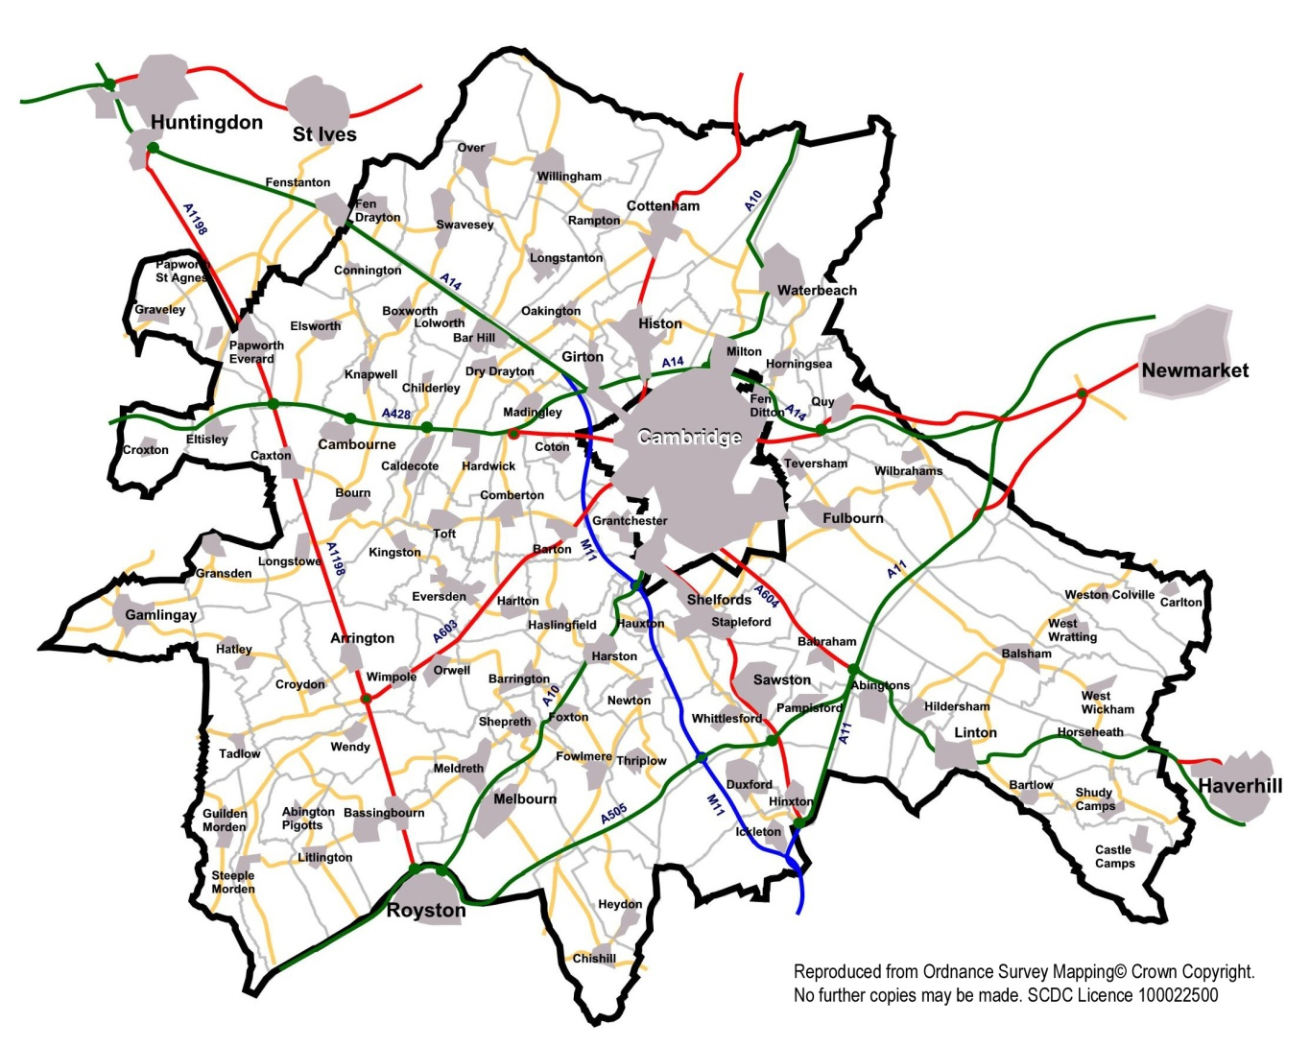

SCDC is one of six areas of local government in Cambridgeshire, the others being Huntingdonshire District Council, East Cambridgeshire District Council, Fenland District Council and Cambridge City Council. All of these councils are within the region of Cambridgeshire County Council, with the sixth area being Peterborough Unitary Authority.
Very broadly, County Councils are responsible for the big areas of expenditure such as children’s services (mainly schools), support for the elderly and disabled, roads and public transport and waste disposal, Cambridgeshire’s annual budget is around £770 million. A district council’s main areas of responsibility are housing (including for some, like South Cambridgeshire, council housing), waste and recycling collection (‘dustbin men and women’), planning (including consideration of applications) and licensing (pubs, etc.), but there are hundreds of other things that the Government requires district councils to do. In total, SCDC’s annual expenditure is about £51 million.

SCDC has 57 elected councillors, about one councillor per 2,656 district population. Their job is to represent the views of you, the electorate and the council tax payers, and to take decisions at full council meetings – these are mainly strategic or policy decisions. There are also a number of committees (planning, licensing etc.) which make specific and individual decisions on applications, etc.
These councillors are paid various allowances and details can be found on our website at:
https://www.scambs.gov.uk/content/senior-staff-salaries-and-members-allowances
To carry out its work, SCDC has around 449 employees (usually called “Officers”): however, many of these work part time hours. It also works with partner organisations and through outsourced contracts and contractors. Our own employees are located either at our offices in Cambourne (about 329 people) or at our depot in Waterbeach (about 85 people) and there are 35 Supported Housing officers working across the district managing our sheltered housing schemes.
The vast majority of SCDC’s expenditure is on people, because that is the nature of its work. We have to pay for vehicles (mainly refuse vehicles), utilities, information technology, etc., but about 50% of our running costs are people-related. Therefore, in the accounts that follow, you should not be surprised to find that employee costs are amongst the most significant.
The purpose of this report is to help you understand where SCDC’s money comes from and how we spend it, and thereby to show you what we do – from the major items of headline-grabbing expenditure, to the scores of smaller things that we do, either because the Government requires us to do them, or because we choose to do so. We draw up our accounts to 31 March in each year, and this report looks at the year 2014/15 which ran to 31 March 2015.
This report was initiated by the Chairman of the Corporate Governance Committee of SCDC and the Committee offers its grateful thanks to the Chairman and Officers.

B. Income
SCDC has three major sources of income:
- Council tax
There are about 64,436 domestic properties in South Cambridgeshire. Under Government rules, they are split into 9 bands (-A to H) based on the value of the property in 1991– if it seems strange to you that we have to use such out-dated property valuations, it’s probably because council tax is such a “hot topic” that the politicians at Westminster have not dared to go near it since! We are required to set a council tax for a middle-sized property (band D) and then the Government rules are that bigger or smaller properties pay a multiple/fraction of that. In 2014/15, the SCDC band D council tax was £125.31 per property; it was £120.46 in 2013/14. The full figures for 2014/15 were:
 |  |  |  | SCDC
 |  | No. of |  | Council | Total
Band | Value in 1991 | properties | Proportion | Tax per | Council tax
 |  | in SCDC | of Band D | property | raised
-A (disability) | Less than £40,000 | 4 | 5/9^{ths} | £68.26 | not material
A | Less than £40,000 | 2,414 | 6/9^{ths} | £81.91 | £0.19m
B | £40 - £52k | 6,967 | 7/9^{ths} | £95.56 | £0.66m
C | £52 - £68k | 18,874 | 8/9^{ths} | £109.21 | £2.06m
D | £68 - £88k | 12,267 | 9/9^{ths} | £122.86 | £1.51m
E | £88 - £120k | 8,564 | 11/9^{ths} | £150.16 | £1.29m
F | £120 - £160k | 5,020 | 13/9^{ths} | £177.46 | £0.89m
G | £160 - £320k | 2,485 | 15/9^{ths} | £204.77 | £0.51m
H | More than £320k | 184 | 18/9^{ths} | £245.72 | £0.05m
TOTAL |  | 56,779 |  |  | £7.16m

*property numbers after adjustments for single person discounts and other reductions

SCDC’s council tax is very low. Throughout England there are 201 shire districts (large towns and cities are measured differently) whose council taxes range from £70.46 to £322.11 (average £170.69) and SCDC is the 17th lowest of these. You may think that is a good or a bad thing, on the one hand our council tax is low, on the other hand that gives us less income to spend on good works in our area.

When you get your council tax bill through the post, it is a single bill for the County Council, SCDC, your parish council, the police force and the fire brigade combined. SCDC is responsible for sending out this bill and passing the amounts on to the other authorities. In 2014/15 for a Band D property, the make-up was
County | £1,121.94
SCDC | £122.86 | i.e. 8% of the total
Parish Council | £75.64 | average (ranging from nil to £123.47)
Police | £181.35
Fire Brigade | £64.26
Total | £1,566.05

SCDC employs 15 officers to send out the bills and collect payment. The overall cost of collecting is £0.610 million (see later for how we calculate costs) which is a cost met by SCDC. Nationally, 97.0% of bills were collected, but SCDC is more efficient than this and its 2014/15 collection rate was one of the best in the country at 99.3%.
- Council house rents
SCDC has 5,357 council houses, bungalows and flats, including around 1,081 units of sheltered accommodation. This means that SCDC is directly responsible for about 8% of the residential property in its area. Rental income is protected and can only be used for repairs and maintenance, etc., on the council properties themselves. Rents vary, of course, according to the value of and number of bedrooms in a property. SCDC sets its rents in line with Government guidance. In essence, the Government has expected us to set our rents in a way that has been gradually moving council rents towards rents charged by housing associations for similar properties. From April 2015 the government guidelines have changed so that rents will only increase each year by an amount linked to inflation, with the move towards the level of other registered housing providers only happening when a property is empty. Our council house rents are substantially below open-market levels. We have:
Type | Number | Average rent per week | Total rent collected p.a.
1 bed | 1,077 | £88.16 | £27.976m
2 bed | 2,307 | £101.44
3 bed | 1,896 | £107.66
4 or more beds | 77 | £121.08
Non-dwelling properties, e.g. garages |  |  | £0.381m
Charges for services and facilities including service charges in sheltered accommodation |  |  | £1.403m
TOTAL | 5,357 |  | £29.760m

We employ 5 people to manage the collection of this rent, at a cost of £0.205 million (see later for how we calculate costs) and our collection rate is good at 98.83%.

- Income from Central Government
SCDC’s council tax only covers very roughly half of the services that SCDC provides (excluding council houses), and the other half comes from a grant from central Government called the “Revenue Support Grant”, which in 2014/15 was £2.608 million. In addition there is a new homes bonus of £3.201 million, to cover the initial costs of providing services to occupants of newly built houses. Also, from 1 April 2013 the Government introduced a change to how councils treat business rate income: SCDC can now keep a proportion of an increase in income that results from business growth in the district.

Summary of major sources of income
Before summarising the three major sources of income we should mention that SCDC, like all district councils which still manage their own council houses, is required to divide itself into two accounts:
- the General Fund, which receives the council tax and formula grant, and does everything apart from on-going general repairs and maintenance on council houses
- the Housing Revenue Account, which receives rents, and pays for on-going general repairs and maintenance on council houses.

The summary for 2014/15 is:
General Fund |  |  | Housing Revenue Account
Council tax | £7.16m |  | Council house rents and charges | £29.76m
Revenue support grant, business rates and other grants from Government | £6.93m |  | Interest payment on loan* | -£7.19m
Available to be spent by SCDC | £14.09m |  | Available to be spent by SCDC | £22.57m

*Our accounts for 2011/12 included a payment of £205.123 million to Central Government; this was a lump sum payable instead of annual payments to the Government. The Council can now use all its rent income and currently benefits the Council and its tenants. The payment was financed by a series of loans from the Public Works Loan Board, a Government agency.

On the General Fund, the amount of revenue support grant and retained business rates has fallen by 28% compared to the previous year; this is reduced to a 20% reduction in cash terms in overall funding when the new homes bonus grant is included.
C. Accounting for people costs
When we look at what SCDC spends your money on, we could say “we spend £X million on this” and “we spend £Y million on that”, but in fact such a large proportion of SCDC’s costs are people-related, that it is probably easier to understand what we do if we say “we employ X number of people doing this” and “we employ Y number of people doing that”. That is the way in which the rest of this report is presented.
However, we first need to explain how we account for people costs. We have 449 employees (or 396 on a full-time-equivalent basis) and their gross pay, employer’s national insurance and pension contributions, and overheads come to £18.852 million. The ‘cost’ of a person is made up of four parts:
  - Their gross pay (wages/salaries) before deductions for income tax, national insurance, etc.
All SCDC staff are graded for salary purposes, and the following table gives an illustration of staff gross pay (wages/salaries). It is done on the basis of full-time equivalent (“FTE”) i.e. if someone only works 1 day a week, then that person is counted as one-fifth for the purposes of the table below, to show a true comparison.
Annual salary/wage | No. of FTEs | Total cost £m
Less than £10,000 | 0 | 0
£10,000 - £19,999 | 50 | -0.863
£20,000 - £29,999 | 210 | -5.033
£30,000 - £39,999 | 96 | -3.315
£40,000 - £49,999 | 25 | -1.135
£50,000 - £59,999 | 9 | -0.466
£60,000 - £69,999 | 1 | -0.061
£70,000 - £79,999 | 0 | 0
£80,000 - £89,999 | 3 | -0.240
£90,000 - £99,999 | 0 | 0
£100,000 - £109,999 | 1 | -0.104
£110,000 - £119,999 | 0 | 0
£120,000 - £129,999 | 1 | -0.122
Sub total | 396 | -11.339
Overtime and allowances |  | -0.275
TOTAL |  | -11.614

  - National Insurance costs
This added £0.863 million or 7.4% of the total wage/salary bill. (The lower contracted-out rate is payable in respect of most employees who are in the pension scheme).
  - Pension contribution
Under Government rules, all district council staff are enrolled in a defined benefit pension fund (but staff may subsequently decide to opt out of the scheme). In SCDC’s case, the fund is part of a huge scheme covering all councils and many other bodies in Cambridgeshire. The scheme is administered by Cambridgeshire County Council and the investments are managed by external fund managers.
The pension fund is currently heavily in deficit. It has assets of £86.5 million, mainly bonds, stocks and shares; but the actuary’s estimate of the present value of its liabilities – i.e. the cost of paying out all the pensions in the future – is £148 million. SCDC paid £2.098 million in annual and special employer contributions to the pension fund in 2014/15, or 20.2% of basic wages/salaries. A further 4.8% pension contribution has been added to a reserve in anticipation of increased future costs. Employees in the scheme also contribute between 5.5% and 11.4% of their salary.
  - Overheads
In the accounts that follow, you will see reference to “allocated overheads”. Our staff need to work in the Cambourne offices or Waterbeach depot, and they need heat, light, travel expenses, insurance, etc. - all the normal costs of employing and managing people. These overheads are allocated to each person and, therefore, to the area in which they work.
In 2014/15, these overheads accounted to £2.85 million and arose from:

£ million | Departments | Cambourne offices | Waterbeach depot | Central costs | Total
Employee related |  |  |  | -0.269 | -0.269
Premises | -0.004 | -0.602 | -0.133 |  | -0.738
Transport | -0.177 |  |  |  | -0.177
Supplies and services | -1.248 | -0.107 | -0.014 | -0.089 | -1.458
Depreciation | -0.280 | -0.225 | -0.007 |  | -0.512
Income from:
Fees and charges | 0.084 | 0.068 |  | 0.010 | 0.162
Government grants | 0.139 |  |  |  | 0.139
Total | -1.485 | -0.866 | -0.154 | -0.348 | -2.853

D. Expenditure
We shall now look at what SCDC does, and shall express it in terms of what our people do, as well as the financial cost of that. In organisational terms, SCDC is arranged in four areas:

- Affordable Homes
115 people look after the 5,357 council house properties including sheltered accommodation that SCDC owns and runs:
- 14 people (two job share) manage the process of allocating houses to applicants: they advise people on how to apply for a council house, manage the choice-based lettings process by which people are allocated their homes and provide housing advice and support to residents who need housing assistance or who are facing homelessness.
- 12 people work with housing association partners and with the Council’s planning section to facilitate the building of new affordable homes in the district; keep abreast of policy changes and work closely with housing staff in other councils to ensure that the Council has the right strategies and policies in place to meet national requirements and to ensure best practice is being followed; work with tenants to help them participate in consultation exercises and other ways of working with the Council in the delivery of housing services. This team also included the home improvement agency which provides services to the private sector residents administering disabled facilities grants and assisting them to maintain their quality of life in their own homes. This agency is now part of a shared service with Cambridge City and Huntingdonshire councils.
- 15 people located in Cambourne manage the process of keeping the houses in good repair. We split this into ‘responsive repairs’ (where a tenant contacts us needing a repair, and we respond to that request) and ‘planned maintenance’, where we plan a programme of, for example, up-grading old heating systems in a number of houses. This involves responding to requests from residents, making regular surveys, planning the maintenance cycle, dealing with contractors and so on.
- 13 people work in housing services. This team assists with the letting of new properties; deals with requests for repairs and grounds maintenance, responds to reports of anti-social behaviour and supports tenants to maintain their tenancies.
- 45 people look after our sheltered housing. This team comprises a manager, 5 specialist staff and 23 officers who provide housing support to elderly residents, carry out support needs assessments and ensure that the services needed are in place to maintain independent living. There are also 16 cleaners for the 42 sheltered housing communal rooms.
- 6 people look after the asset management database; keep track of our £11 million of repair and maintenance works, process invoices and help plan future works.
- 2 people look after the travellers sites in our area that are owned by the County Council, collecting rents, organising repairs and dealing with lettings.
- 3 people look after the Council’s leasehold properties, including handling land and property sales.
- 2 people work on developing new housing initiatives.
- 1 Director and 2 senior managers look after the whole function.

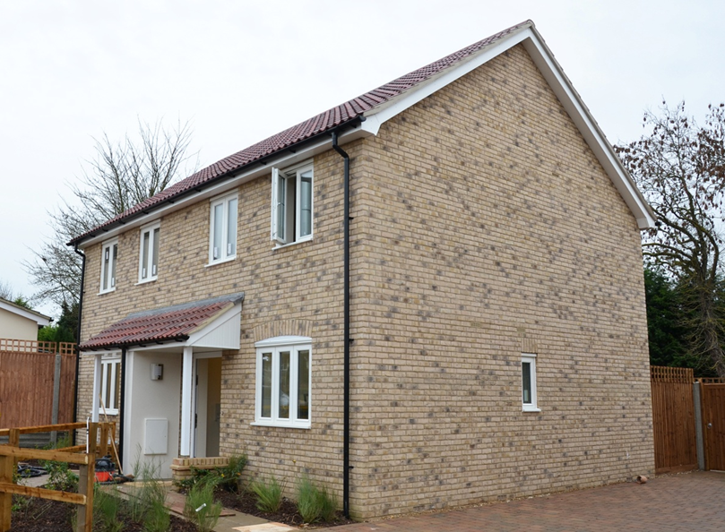

Who pays for these 115 people? The answer is: mostly, the tenants themselves. Most of this area falls within the “Housing Revenue Account” and this is paid for by the rents that the tenants pay. However, the Council’s work providing housing and homeless advice, its work with housing associations and some aspects of the lettings system are paid for by council tax. In addition some of work of the sheltered housing service is paid for by money from the County Council’s supporting people budget.

For every £1 collected in rent, 53p is spent on repairs and maintenance, 26p is spent on interest payments and around 21p on other costs such as staffing, administration and accommodation costs.

 |  |  |  |  | Charged to Housing Revenue Account | Charged to General Fund
The accounts for this area are (£ million):
*Costs of the officers at Cambourne and Waterbeach |  |  |  |  |  | -2.931
**Overheads |  |  |  |  |  | -0.905
 |  |  |  |  |  | -3.836
Of which: recharged to Housing Revenue Account |  |  |  |  | -0.626 | 0.626
*Costs of other staff providing services |  |  |  |  | -0.665 | 0
Direct costs, e.g. property, transport, supplies & services |  |  |  |  | -5.142 | -0.875
Depreciation/ financing |  |  |  |  | -18.469 | -0.084
Fees, charges and other income |  |  |  |  | 1.569 | 0.728
Government Grant |  |  |  |  | 0 | 0.058
 |  |  |  |  | -23.333 | -3.383
* | Salaries, wages, national insurance, pensions, as discussed earlier in this document
** | See discussion of 'overheads' earlier in this document

- Planning & New Communities
72 people work in Planning and New Communities:
- 7 people work in planning policy. It is Government policy – and sensible − that planning applications should not be considered randomly, but instead against a policy framework. Much policy is handed-down by central Government, but SCDC is required to, and wants to, draw up its own policies at a local level. These range from major “local plans” which govern how thousands of houses will be built over the next few decades, to other more specific and localised policies. Because this is a complicated area and because we consult extensively, it involves a lot of people.
- 2 people work in urban design working on major developments, including fringe sites around the edge of Cambridge city, and developing design guides with developers to ensure these developments have high quality design of buildings, street scene and open spaces.
- 13 people work in New Communities. They process the planning applications from developers building huge developments like Cambourne, Northstowe, Orchard Park and Trumpington Meadows where it is not just a question of a few new houses, but the creation of a whole new community. These planning applications are initially very complicated and can take many years to process. This section also provides district-wide services such as economic development and support for businesses.
- 2 people look after “section 106 agreements”, which are named after a section in an Act of Parliament, and involve a developer promising to make a contribution. For example, if a developer builds hundreds of new houses, it must also perhaps build a primary school, put in playing facilities, contribute to new roads etc. All these promises need to be agreed and legally written down before the planning permission is given, and involve extensive negotiation and monitoring.
- 22 people work in the Planning Service and process all the planning applications other than those going to New Communities. This is a huge area for us: each year, there are about 3,022 planning applications within SCDC’s area. Most of these are relatively clear-cut or un-contentious, and can be agreed (or are refused) by these 22 officers. The remainder are reported to the Planning Committee, which consists of elected councillors, for them to consider.
- 6 people work in building control checking applications for new buildings and alterations to existing buildings to ensure they will for example be structurally sound, weather resistant, insulated for heat and sound. They then carry out site inspections to check on compliance;
- 3 people work in the Conservation Service, which is allied to Planning. If your planning application is to a listed property or in a conservation area, these 3 people will comment on it as part of the planning process. They cover 86 conservation areas and 2,670 listed buildings, together with 5 redundant churches/churchyards.

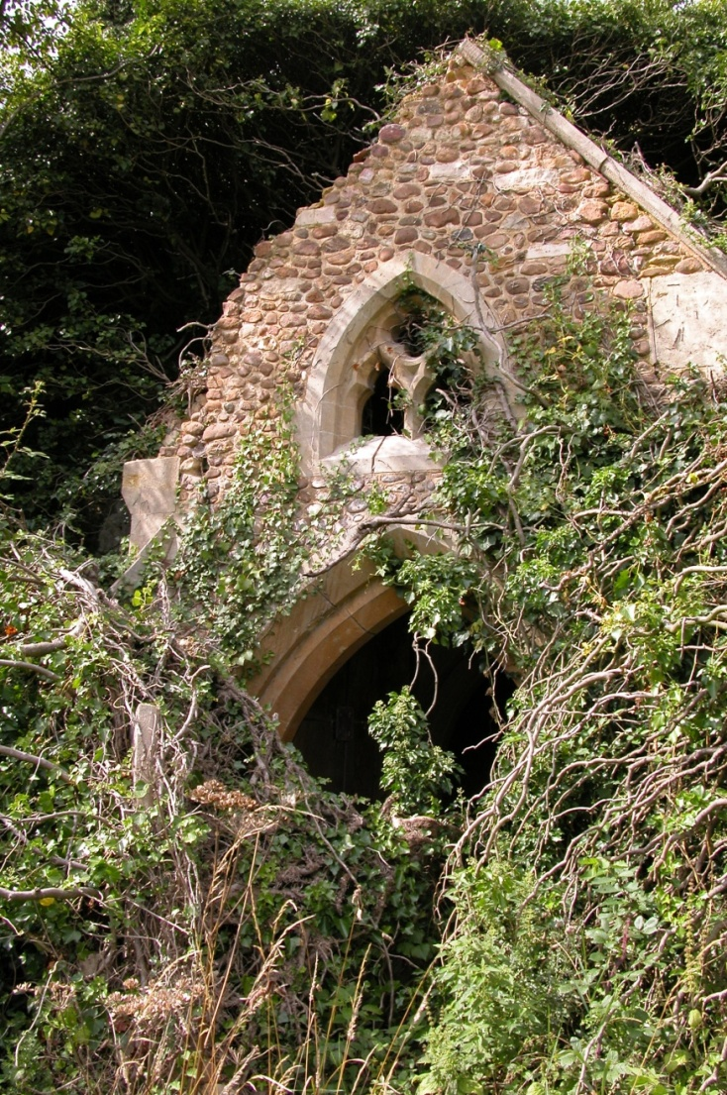
St Denis Church, East Hatley
- 5 more people come under the Conservation Service mentioned previously, with specific roles:
3 tree and landscape officers deal with new tree protection orders and process applications to prune and cut down trees that have protection orders or are in conservation areas; 1 landscape officer ensures high quality landscaping and open spaces in new developments, including care homes; and 1 ecology officer ensures proper account is taken of wildlife and nature conservation in new developments and conversions. Examples are the swifts at Fulbourn and the new country park at Trumpington Meadows which incorporates the award-winning River Cam project. They also support community projects, including planting new orchards.

- 1 person works on planning appeals in an administrative and co-ordinating role to ensure we meet all our deadlines in responding to appeals and hearings, because some of SCDC’s planning decisions are disputed and taken up to an external appeal by the applicant.
- 3 people work on planning enforcement, which is where house-owners or builders do work without permission, and the work needs reversing or the person taken to court. They also ensure that authorised work is carried out in accordance with the planning consent.
- The whole department has 1 Director, 1 head of service, 1 lawyer and 5 administrative assistants.
 | The accounts for this area are (£ million): |  |  |  |  | Charged to Housing Revenue Account | Charged to General Fund
* | Costs of the officers at Cambourne and Waterbeach |  |  |  |  |  | -3.035
** | Overheads |  |  |  |  |  | -0.851
 |  |  |  |  |  |  | -3.886
 | Of which: recharged to Housing Revenue Account |  |  |  |  | -0.312 | 0.312
 | Direct costs, e.g. property, transport, supplies & services |  |  |  |  |  | -1.082
 | Depreciation/ financing |  |  |  |  |  | -0.019
 | Fees, charges and other income |  |  |  |  |  | 2.773
 |  |  |  |  |  |  | -1.902
* | Salaries, wages, national insurance, pensions, as discussed earlier in this document
** | See discussion of 'overheads' earlier in this document
- Health and Environmental Services
120 people look after waste collection (principally black, green and blue bin collection) and other aspects of the environment of South Cambridgeshire. Note that whilst SCDC is responsible for collecting waste (for example dustcarts collecting from your home or from offices, etc.) we are not responsible for processing or disposing of it: instead, we take the waste to a facility at Waterbeach that is managed by the County Council and a private sector operator, and they look after the processing and disposal.
- 61 dustbin men (we welcome job applications from women when a vacancy arises) are based at SCDC’s depot at Waterbeach and empty the green and black and blue wheeled bins, including specialised collections of commercial and clinical waste.
- 13 people clean the streets and empty the litter and dog bins.
- 4 people plus 3 supervisors and 1 operations manager support the refuse, recycling and street cleaning services.
- 3 people work in Licensing. SCDC is responsible for the licensing of taxis and private hire vehicles, premises, events, pubs, social clubs and restaurants and other establishments. The licensing of alcoholic premises was transferred from the Magistrate Courts to district councils in 2005. The team is involved in advising applicants and dealing with enforcement issues across all areas of licensing.
- 15 people work in health protection. SCDC has responsibility for ensuring that its residents’ health is protected. Of the 15 people:
- 7 people work in Environmental Protection: they investigate statutory nuisances such as noise, odour and dust; and enforce standards in private-sector housing, including houses in multiple occupation
- 3 people work in Food Control and Health and Safety: they advise and check on food hygiene in, and cleanliness of, catering and food premises, and deal with enforcement issues for all areas of food, health and safety.
- 5 people work in specialist roles: they monitor air quality; identify and remediate contaminated land; respond to planning consultations, to mitigate the health and environmental impacts of new development; and support the new public health agenda.
- 4 people look after Drainage and Watercourses. This is a wonderful hang-over from the distant past, but still important today! In the late 18th and early 19th centuries, when the Enclosure Acts resulted in open land being enclosed by hedges and ditches to form field boundaries, the then council was awarded statutory responsibility for keeping certain ditches clear to avoid flooding. Today, three centuries later, SCDC still has this responsibility! We are obliged to look after about 175 miles of ditches in 45 parishes and 1 manager (in our Cambourne offices) and 3 operatives (based at our Waterbeach depot) do this.
- 6 people and 2 managers support all the partnerships that SCDC has with other authorities, agencies, communities and voluntary sector groups across the district. This includes running a number of our grant schemes; working with and supporting our parish councils; and leading work on projects such as community transport and parish energy projects to reduce carbon emissions
- 5 administrative assistants maintain the records and databases supporting operational services.
- 1 Director, 1 head of services and 1 manager look after the whole function.
The accounts for this area are |  | Charged to Housing Revenue Account | Charged to General Fund
(£ million):
*Costs of the officers at Cambourne and Waterbeach |  |  | -2.005
**Overheads/recharges |  |  | -0.681
 |  |  | -2.686
Of which: recharged to Housing Revenue Account |  | -0.015 | 0.015
*Cost of other staff providing services |  |  | -2.358
Direct costs, e.g. property, transport, supplies and services |  |  | -3.044
Depreciation / financing |  |  | -0.370
Fees and charges and other income |  |  | 2.240
 |  |  | -6.203
* Salaries, wages, national insurance, pensions, as discussed earlier in this document
** See discussion of ‘overheads’ earlier in this document

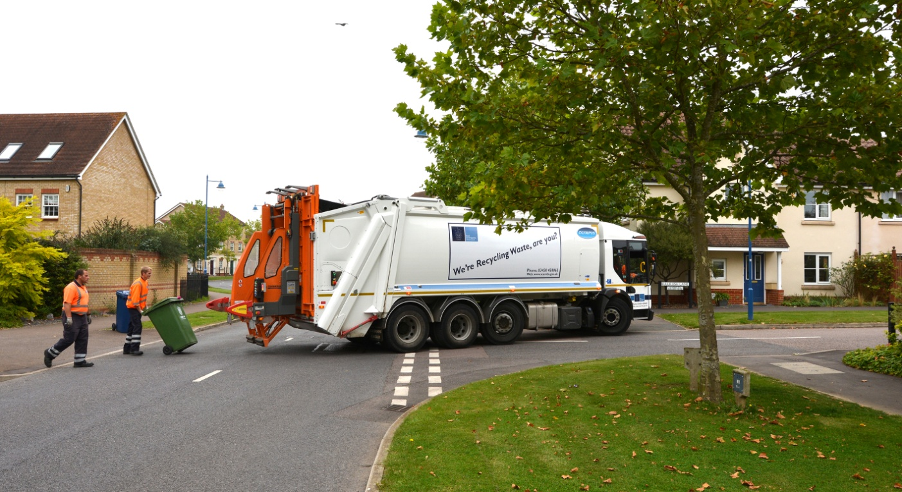

(4) Corporate Services
142 people look after the financial and administrative back-up that you would expect of any major organisation.
- 1 benefits manager in charge of:
- 18 people who look after council tax support and housing benefits. SCDC is responsible for processing applications for benefits and making the payments. In 2014/15, around 11,840 claims in South Cambridgeshire totalled approximately £27 million in benefits. A large proportion of the money that is paid out comes from the Government, so it just passes through SCDC’s hands and does not come out of the council tax, etc. In the accounts that follow, you will therefore see the housing benefit itself, on a pass-through basis as expenditure and income, and you will see the costs of our employees who process the claims. We receive a grant from the Government but this only covers just over half of our costs. We have:
- 16 people who process housing benefit claims; and
- 2 senior staff.
- 19 people in business efficiency, financial and management accounting, treasury management, procurement, payment of suppliers, insurance and risk management, internal audit and a head of service.
- 5 people in human resources. Payroll services are provided by Cambridge City Council.
- 12 people and a head of service in IT provide the internal computer infrastructure vital to all organisations and the public face of the Council in terms of its website.
- 6 people in our legal services team.
- 3 people who maintain the land charges register of planning approvals, planning notices, general and specific financial charges, etc., and deal with search requests from solicitors and agents.
- 5 people in Democratic Services who organise the council meetings and committees, publish agendas and take minutes.
- 1 revenues manager in charge of:
- 9 people who collect our rents, mainly council house rent and deal with debt recovery.
- 15 people who administer council tax and business rates, check premises and send out bills.
- 5 people who administer the allocation of income and the collection of sundry fees and charges, including service charges and supporting people income.
- 1 person dealing with the computer systems for council tax, benefits, rents and business rates.
- 6 people deal with catering and office facilities which include a team of 3 catering staff, and 2 caretakers and a facilities manager who look after the Cambourne offices.
- 5 people who provide web and graphic design and printing for the Council’s many documents and websites.
- 17 people who deal with customer service, complaints and compliments for the Council.
- 3 people administer all elections in the district including district council, county council and European elections, as well as one-off elections and elections for a Police and Crime Commissioner.
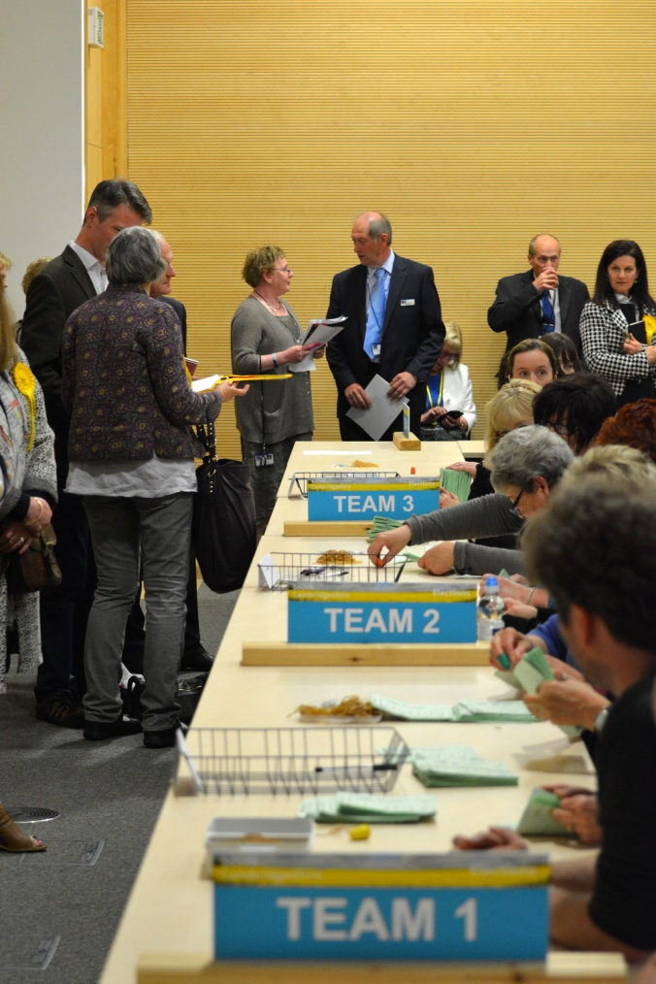
Election count 2015
- 3 people look after our corporate Planning Committee (the Council’s annual plan setting out its priorities) to ensure that residents are consulted on both the work we do and their satisfaction with it; collect performance information (so we can ensure we are giving the best service we can to our residents); and co-ordinate projects across the authority (to ensure that they are on time and providing the outcomes for residents they were intended to).
- 3 people (two job share) manage all internal and external communications, including the highly regarded South Cambs magazine; on-going communication support to key council projects and proactive information-giving and sharing our services.
- 1 Executive Director looks after the whole function, with 2 Personal Assistants to support all directors and the Chief Executive, and 1 Chief Executive who oversees everything.

The accounts for this area are |  |  | Charged to Housing Revenue Account | Charged to General Fund
(£ million):
 | *Costs of the officers at Cambourne and Waterbeach |  |  | -5.087
 | **Overheads/recharges |  |  | 1.223
 |  |  |  | -3.864
 | Of which: recharged to Housing Revenue Account |  | -0.586 | 0.586
 | *Cost of other staff providing services |  |  | -0.711
 | Direct costs, e.g. property, transport, supplies and services |  |  | -1.155
 | Benefits |  |  | -27.211
 | Fees and charges and other income |  |  | 0.957
 | Government grant |  |  | 0.334
 | Government grant - Benefits |  |  | 27.785
 |  |  |  | -3.279
 | * Salaries, wages, national insurance, pensions, as discussed earlier in this document
 | ** See discussion of ‘overheads’ earlier in this document

E. Summary accounts
We can summarise SCDC's 2014/15 accounts as (£ million): |  |  | Charged to Housing Revenue Account | Charged to General Fund
MAJOR SOURCES OF INCOME
 | Council tax |  |  | 7.156
 | Retained Business Rates |  |  | 3.286
 | Revenue Support Grant from the Government |  |  | 2.608
 | New homes bonus |  |  | 3.201
 | Council house rents |  | 27.976
 | Less interest on self-financing debt |  | -7.193
 |  |  | 20.783 | 16.251
EXPENDITURE AND OTHER INCOME
 | All Departments
 | *Costs of the officers at Cambourne and Waterbeach |  | -1.839 | -11.313
 | **Overheads |  | -0.673 | -1.999
 |  |  | -2.512 | -13.312
 | Of which: recharged to/from Housing Revenue Account |  | -0.990 | 0.990
 | Direct costs, e.g. property, transport, supplies and services |  | -4.760 | -2.542
 | Capital Expenditure |  | -5.617
 | Transfer to Reserves |  | -1.000
 | Depreciation / financing |  | -5.659 | -0.638
 | In year movement on business rate and council tax collection |  |  | -2.166
 |  |  | -20.537 | -17.669
 | INCOME
 | Fees and charges and other income |  | 0.439
 | Financing, operating and other adjustments |  |  | 0.374
 | Housing and Council Tax Benefit
 | Paid to residents | -27.211
 | Received from Government | 27.322
 |  |  | 0 | 0.111
 |  |  | -20.098 | -17.184
 | * Salaries, wages, National Insurance, pensions, as discussed earlier in this document
 | ** See discussion of ‘overheads’ earlier in this document
MAJOR SOURCES OF INCOME (as above) |  |  | 20.783 | 16.251
EXPENDITURE AND OTHER INCOME (as above) |  |  | -20.098 | -17.184
SURPLUS / DEFICIT ( - ) FOR THE YEAR |  |  | 0.685 | -0.934

The full Statement of Accounts is a technical 105 page document complying with international financial reporting standards, awaiting an audit opinion to be issued at the end of September, and is available on the Council’s website:
https://www.scambs.gov.uk/content/statement-accounts-and-annual-governance-statement

