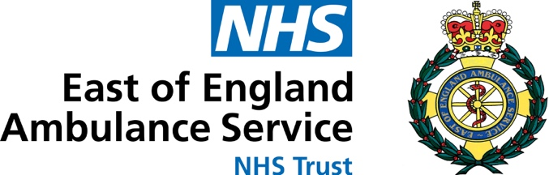

By Email Only
East of England Ambulance Service NHS Trust
Hammond Road
Bedford
MK41 0RG
Fiona Bradley
Planning Services
Interim Support Team Leader South Cambridgeshire District Council

Date: 25 November 2022
Our Ref: 22/02771/OUT/ZM
Your Ref: 22/02771/OUT

Planning Application: 22/02771/OUT
Location: Land North Of Cambridge North Station Milton Avenue Cambridge Cambridgeshire

A hybrid planning application for:
- An outline application (all matters reserved apart from access and landscaping) for the construction of: three new residential blocks providing for up to 425 residential units and providing flexible Class E and Class F uses on the ground floor (excluding Class E (g) (iii)); and two commercial buildings for Use Classes E(g) i(offices), ii (research and development) providing flexible Class E and Class F uses on the ground floor (excluding Class E (g) (iii)),together with the construction of basements for parking and building services, car and cycle parking and infrastructure works.
- A full application for the construction of three commercial buildings for Use Classes E(g) i (offices) ii (research and development), providing flexible Class E and Class F uses on the ground floor (excluding Class E (g) (iii)) with associated car and cycle parking, the construction of a multi storey car and cycle park building, together with the construction of basements for parking and building services, car and cycle parking and associated landscaping, infrastructure works and demolition of existing structures.

Dear Ms Bradley
Further to the meeting on 21st October 2022, please find attached the revised calculation based on 1.72 person per dwelling as the refurbishment is designed for 1-2 bedroom apartments.

Table 1 shows the population likely to be generated from the proposed development. The capital required to create additional ambulance services to support the population arising from the proposed development is calculated to be £108,554.

Table 1 Capital Cost calculation of additional health services arising from the development proposal
Additional Population Growth | ICS Activity  Rate² | Ambulance Cost³ | Total
1,190 (425 dwellings)¹ | 0.22 | £675 | £108,554
- Calculated assuming 1.72 persons for each dwelling average household as agreed with South Cambridgeshire District Council
- Calculated Cambridgeshire and Peterborough Census 2020 population (894,300) and 2021-22 EEAST emergency activity volume (193,898)
- EEAST ambulance callout cost (2021)

EEAST looks forward to receiving the s106 agreement in due course to support one or more of the following elements:
- Increasing the number of ambulances required to meet the expanded demand in order to maintain contractual response times to prevent the application of contractual fines
- Extending/refurbishment of existing ambulance station(s) within the locality to meet the increased demand or in certain instances support relocation to a more suitable location
- Provision of additional medical equipment to manage the increased number of incidents from the growing population in order to maintain mandated ambulance response times and treatment outcomes
- Recruiting, training and providing new equipment for additional Community First Responders (CFRs) to support the proposed development and the community as a whole
- Use of digital solutions.

Yours sincerely
Zoë May
Head of Business Relationships

cc: Lucy MacLeod, Strategic Premises & Estates Manager for Primary Care,
Cambridgeshire & Peterborough Integrated Care System
Jake Lambert, Bidwells

