Fulbourn Neighbourhood Plan

Strategic Environmental Assessment (SEA)and Habitat Regulations Assessment Screening Determination Statement

November 2020

Executive Summary

This statement sets out the reasons for the determination that the draft Fulbourn Neighbourhood Plan is not likely to require a Strategic Environmental Assessment. In addition, this statement determines that the making of the Fulbourn Neighbourhood Plan is not likely to have a significant effect on a European site.

This determination statement is intended to demonstrate that the Fulbourn Neighbourhood Plan is compatible with certain European Union obligations as required by the basic conditions, namely:

- Directive 2001/42/EC of the European Parliament and of the Council of 27 June 2001 on the assessment of the effects of certain plans and programmes on the environment; and
- Article 6(3) and (4) of the EU Habitats Directive and with Regulation 61 of the Conservation of Habitats and Species Regulations 2010 (as amended).

Fulbourn Parish Council and South Cambridgeshire District Council will publish this determination statement in accordance with the regulatory requirements.

Determination Statement

This statement has been produced to ensure the Neighbourhood Plan will, when examined, comply with the Neighbourhood Planning (General) Regulations 2012 (as amended) in particular Regulation 32 and Regulation 15(1)e(ii) of the Neighbourhood Planning (General) (Amendment) Regulations 2015.

A neighbourhood plan is required to meet a number of basic conditions (which are set out in the Town and Country Planning Act 1990), one of which being it must not breach and must be otherwise compatible with EU and Human Rights obligations. This requires neighbourhood plans to fully consider the requirements of the SEA regulations which transpose the EU’s SEA Directive into law and which requires those making plans that could impact on the environment to consider whether they are likely to have a significant effect or not.

Regulation 32 in the Neighbourhood Planning (General) Regulations 2012 (as amended) sets out an additional basic condition to those set out in primary legislation. Regulation 32 states: “The making of the neighbourhood plan is not likely to have a significant effect on a European site (as defined in the Conservation of Habitats and Species Regulations 2010 (d)) or a European offshore marine site (as defined in the Offshore Marine Conservation (Natural Habitats, &c.) Regulations 2007 (e) ) (either alone or in combination with other plans or projects).

A Strategic Environmental Assessment (SEA) and Habitat Regulations Assessment (HRA) Screening Opinion was prepared by Place Services on behalf of South Cambridgeshire District Council (SCDC) for the Fulbourn Neighbourhood Plan. (See Appendix 1).

SCDC has consulted the statutory consultees (Historic England/Natural England/Environment Agency) on the Screening Report prepared by Essex Place Services and asked for their views on whether a SEA is required.

Consultation responses were received from the three statutory consultees. Their conclusions are summarised below, and their detailed comments are included in Appendix 2.

- Historic England: The Screening Report indicates that the Council considers that the plan will not have any significant effects on the historic environment. Historic England notes that the plan does not propose to allocate any sites for development.

On the basis of the information supplied, and in the context of the criteria set out in Schedule 1 of the Environmental Assessment Regulations [Annex II of ‘SEA’ Directive], Historic England concurs with the Council that the preparation of a Strategic Environmental Assessment is not required.. (November 2020)

- Natural England: It is Natural England’s advice, on the basis of the material supplied with the consultation, that, in so far as their strategic environmental interests (including but not limited to statutory designated sites, landscapes and protected species, geology and soils) are concerned, that there are unlikely to be significant environmental effects from the proposed plan.

Natural England agrees with the report’s conclusions that the Fulbourn Neighbourhood Plan would not be likely to result in a significant effect on any European Site, either alone or in combination and therefore no further assessment work would be required (November 2020)

- Environment Agency: Due to resource pressures they are no longer able to provide Local Planning Authorities with comprehensive bespoke advice on screening opinions. (October 2020)

The Neighbourhood Plan has been prepared for town and country planning purposes and sets a framework for future development consent. The policies of the Neighbourhood Plan can be considered to determine the use of small areas at local level commensurate with their status in determining local planning applications.
The Plan does not allocate any land for development purposes and does not include any content that could give rise to significant negative effects on the environment, or any social or economic tenets of sustainability.
The Fulbourn Neighbourhood Plan can therefore be screened out for its requirement of Strategic Environmental Assessment in line with the requirements of Directive 2001/42/EC.
The HRA screening report indicates that the Fulbourn Neighbourhood Plan is not predicted to have likely significant effects on any Habitats site, either alone or in combination with other plans and projects. Natural England agreed that there are unlikely to be significant environmental effects from the proposed plan. The requirement for the Plan to undertake further assessment under the Conservation of Habitats and Regulations 2017 (as amended) is therefore screened out.

Appendix 1: Strategic Environmental Assessment Screening for Fulbourn Neighbourhood Plan

As part of the process of making a Neighbourhood Plan, Fulbourn Parish Council has requested a screening opinion to see whether a Strategic Environmental Assessment is required. Such a requirement can be screened out if it is felt, based on the information available, that the Neighbourhood Plan would not have a likely significant environmental affect.

A Strategic Environmental Assessment (SEA) and Habitat Regulations Assessment (HRA) Screening Opinion was prepared by Place Services on behalf of South Cambridgeshire District Council for the Fulbourn Neighbourhood Plan.

  - Fulbourn Neighbourhood Plan 2019 – 2031 Pre-Submission Draft
  - Strategic Environmental Assessment (SEA) & Habitat Regulations Assessment (HRA)
  - Screening Report – October 2020

Contents
1. Introduction 1
1.1 The Purpose of this Report 1
1.2 The Fulbourn Neighbourhood Plan 2019 to 2031 1
1.3 The South Cambridgeshire Local Plan 3
2. Legislative Background 10
2.1 Strategic Environmental Assessment (SEA) 10
2.2 Habitats Regulations Assessment (HRA) 11
3. SEA Screening 12
3.1 When is SEA Required? 12
3.2 Criteria for Assessing the Effects of the Neighbourhood Plan 15
3.3 Likely Significant Effects resulting from the Neighbourhood Plan 16
4. HRA Screening 27
4.1 Habitat Regulations Assessment of Development Plans 27
4.2 Court Judgements and their consideration in this Report 28
4.3 Habitats (European) Sites 29
4.4 Method and Approach 30
4.5 Results from HRA Screening of Neighbourhood Plan Policies 34
4.6 Other Plans and Projects: In-combination Effects 54
5. Conclusions 59
5.1 Strategic Environmental Assessment (SEA) 59
5.2 Habitats Regulations Assessment (HRA) 59
Appendix 1 60
The Fulbourn Neighbourhood Plan area 60
Appendix 2 61
The Plan Area and Locations of the Habitats sites within 20 km 61

List of Tables
Table 1: Exploring whether the Principle of the Plan would warrant SEA 13
Table 2: Assessment of Likely Significant Effects on the Environment 16
Table 3: Habitats Sites within 20km to be considered in this assessment 30
Table 4: Assessment of potential impacts 34

Introduction

1.1 The Purpose of this Report
This screening report is an assessment of whether or not the contents of the Fulbourn Neighbourhood Plan (Pre-Submission Draft) requires a Strategic Environmental Assessment (SEA) in accordance with the European Directive 2001/42/ EC and associated Environmental Assessment of Plans and Programmes Regulations. A SEA is required if the Neighbourhood Plan is deemed to have a likely significant effect on the environment.
This report will also screen to determine whether the Neighbourhood Plan requires a Habitats Regulations Assessment (HRA) in accordance with Article 6(3) and (4) of the EU Habitats Directive and with Regulation 61 of the Conservation of Habitats and Species Regulations 2017 (as amended). An HRA screening report is required when it is deemed that likely adverse significant effects may occur on protected Habitats (European) Sites as a result of the implementation of a plan/project.

1.2 The Fulbourn Neighbourhood Plan 2019 to 2031
The Neighbourhood Plan will set out planning policies for the Fulbourn Neighbourhood Plan area. Once formally adopted, a Neighbourhood Plan carries the same legal weight as Local Development Plans adopted by the Local Planning Authority (LPA), in this case South Cambridgeshire District Council.
The Neighbourhood Plan states that the Neighbourhood Plan has given the community of Fulbourn the opportunity to define the key characteristics of their village and to guide future development and change up to 2031: preserving what is important to local people and indicating how the village should evolve in future in the context of the growth of Cambridge and South Cambridgeshire. The Plan’s Vision Statement is as follows:
“In the period to 2031 Fulbourn village will continue to be a vibrant, sustainable and thriving local community with its own distinctive characteristics, separate from Cambridge yet complementary and benefiting from its proximity. It will have a locally distinctive built and natural environment and a wide provision of local services, strongly supported by the local community. New developments will ensure the ongoing success of Fulbourn providing suitable housing, employment, leisure facilities and local services whilst protecting and enhancing its natural and built assets for future generations.”
Additionally, a number of Planning Objectives are devised for the Neighbourhood Plan. These are:

Planning Objectives
1. Retain the character of Fulbourn as an individual village, separate from Cambridge
It is important for Fulbourn to continue to be a sustainable village retaining its key characteristics, separate from Cambridge, but recognizing the benefits of its proximity. This means that Fulbourn should retain its individuality as a village set within its rural landscape and that the Green Belt surrounding the parish should be sustained.
2. Enhance the rural environment surrounding the village
The rural environment of the Parish surrounding the village should be enhanced through encouraging further development of biodiversity and amenities both within the village and in the surrounding fields. This will include providing greater natural and human connectivity between village and countryside and increased protection and biodiversity within the green spaces of the village.
3. Maintain and improve the character and distinctiveness of the village
This will mean prioritising local distinctiveness in every element of change and growth and favouring sensitive development which enriches the landscape and enhances the character of the locality. As part of this effort, it will be important to support the conservation of our natural and built environmental assets for future generations, strengthen the character of the green spaces and also resist inappropriate development.
4. Have a mix of housing that is affordable, available and suitable for all ages
Within the village, it will be important to secure a range of housing to meet the needs of all ages to ensure that local residents and their families could continue to live in the village. The environmental sustainability of new and existing buildings should be optimised, encouraging high levels of energy efficiency, and other sustainable measures to mitigate the impacts of climate change.
5. Support business development and employment opportunities
The community is keen to continue to support and accommodate businesses within the village so that the local economy can continue to provide a suitable range of employment opportunities and essential services to the villagers and make a contribution to the wider economy of the region.
6. Improve amenities and community facilities
The community recognises the need to safeguard our existing local community assets and seek provision of complementary new or enhanced community facilities to meet all future needs and reduce the need to travel to access services
7. Increase the safety of local streets and lanes and enhance access to public transport services
Walking and cycling through the winding lanes and narrow streets of the village are part of the life and experience of Fulbourn and need to be supported through all measures that increase safety and comfort, while respecting local character. This is also essential to reduce carbon emissions and respond to the climate crisis. Future development should also be accompanied by strong support for walking, cycling and improvement of public transportation for the village as a whole.
8. Recognise the challenges of climate change and promote the application of appropriate measures through all aspects of development
The community of Fulbourn recognises the challenges posed by climate change and fully supports the application of the specific policies of the Local Plan. Locally specific measures are included in the various policies as appropriate.

1.3 The South Cambridgeshire Local Plan
The South Cambridgeshire Local Plan sets out the planning policies and land allocations to guide the future development of the District up to 2031. It includes policies on a wide range of topics such as housing, employment, services and facilities, and the natural environment.

1.3.1 Content regarding the Neighbourhood Plan area within the Local Plan

1.3.1.1 The Settlement Hierarchy and Principle of Development
The Local Plan identifies Fulbourn as a ‘Minor Rural Centre’ within Policy S/9. Minor Rural Centres are generally less sustainable locations for new development than ‘Rural Centres’ however are identified as more sustainable than ‘Group Villages’ and ‘Infill Villages’ in the strategy for the rural area as they often perform a role in terms of providing services and facilities for a small rural hinterland. The Local Plan states that,
‘Within Minor Rural Centres there is scope in principle for larger scale windfall development within the village framework. This would allow larger villages with a reasonable level of services to provide services and facilities for surrounding smaller villages to achieve more development. However, the overall scale of development should be restricted in recognition of their more limited services compared to Rural Centres. A maximum scheme size of 30 dwellings is used as a guideline figure to indicate the upper limit of housing development likely to be suitable. Development will not be permitted on sites capable of accommodating scheme sizes significantly larger than 30 dwellings in Minor Rural Centres.’
Policy S/7 of the Local Plan covers policy regarding ‘Development Frameworks’. Development Frameworks define where policies for the built-up areas of settlements give way to policies for the countryside. The Policy supports development within such frameworks (including that of Fulbourn), and includes further information on proposals outside development frameworks for Neighbourhood Plans, stating that,
‘(2) Outside development frameworks, only allocations within Neighbourhood Plans that have come into force and development for agriculture, horticulture, forestry, outdoor recreation and other uses which need to be located in the countryside or where supported by other policies in this plan will be permitted.’

1.3.1.2 Local Plan Development Allocations in Fulbourn
The Local Plan allocates land for development purposes within the Fulbourn Neighbourhood Plan area within Policy H/3. Additionally, part of the land allocated within Policy E/3 of the Local Plan is within the Neighbourhood Plan area.
Policy H/3 allocates the Fulbourn and Ida Darwin Hospitals for redevelopment, representing previously developed land in the Green Belt and also within the Fulbourn Hospital Conservation Area, to which enhancements are sought. The Policy states that redevelopment will comprise of the existing built footprint of the Ida Darwin Hospital into a different configuration, comprising residential redevelopment on the eastern part of the Ida Darwin site and the transfer of part of the building footprint to the Fulbourn Hospital site for new mental health facilities.
It is anticipated that the Ida Darwin site could deliver 250 to 275 dwellings, although the total would depend on any buildings that would remain on the Ida Darwin site, and the amount of additional healthcare development required on the Fulbourn Hospital site. The Policy also states that redevelopment will create a green wedge on the western part of the Ida Darwin site to provide a compensatory enhancement to the openness of the Green Belt in this location. The site allocation is considered ‘strategic to the delivery of homes’ in the District and therefore is outside the influence of the Fulbourn Neighbourhood Plan.
Local Plan Policy E/3: Fulbourn Road East (Fulbourn) allocates 6.9 hectares of land adjoining Peterhouse Technology Park, again within the Green Belt, for employment use. Eastern parts of this allocation are located within the Fulbourn Neighbourhood Plan area. The Inner Green Belt Review 2012, and the independent Inner Green Belt Review 2015, undertaken jointly with Cambridge City Council, examined the Green Belt in detail and concluded that the area pertaining to this site, on the edge of Cambridge, is not considered of long term importance to Green Belt purposes. Given the level of need for jobs, it was considered that exceptional circumstances exist to justify its release. The allocation is also considered ‘strategic to the delivery of jobs’ in the District and outside the influence of the Fulbourn Neighbourhood Plan.
The following maps, taken from the Local Plan, show the location and boundary of the proposed allocations that are located within the Fulbourn Neighbourhood Plan area. For a key to the map, visit the Local Plan Policies Map on the South Cambridgeshire District Council website.

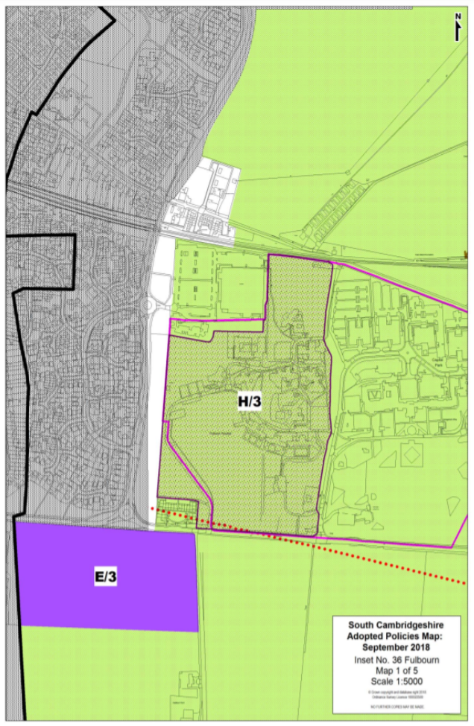
Figure 1: Map of Local Plan allocations within Fulbourn Neighbourhood Plan area (H/3 west and E/3)

Source: South Cambridgeshire Local Plan, 2018
Figure 2: Map of Local Plan allocations within Fulbourn Neighbourhood Plan area (H/3 east)

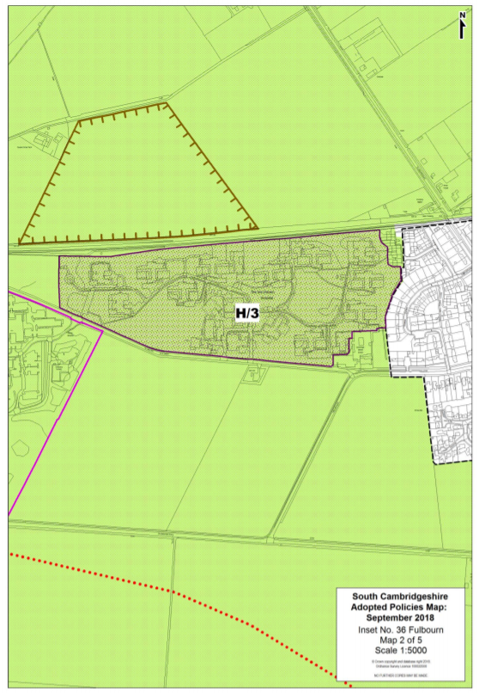
Source: South Cambridgeshire Local Plan, 2018

1.3.1.3 Protected Village Amenity Areas (PVAAs) and Local Green Space Sites

1) Protected Village Amenity Areas (PVAAs)
The Local Plan also designates sites within village frameworks for the purpose of safeguarding areas of undeveloped land which are important to retain. Some of the PVAAs may have important functions for the village such as allotments, recreation grounds and playing fields whilst others have an important amenity role in providing a setting for buildings or offer tranquil areas where there is minimum activity. Not all PVAAs have public access as some undeveloped areas which are important may be private gardens. They also vary from those which are very open to visual penetration to those which may be enclosed or semi-enclosed.
PVAAs are safeguarded within ‘Policy NH/11: Protected Village Amenity Areas’ and are identified on the Local Plan Policies Map. The Policy states that development will not be permitted within or adjacent to these areas if it would have an adverse impact on the character, amenity, tranquillity or function of the village.
The Fulbourn Neighbourhood Plan area contains three PVAAs surrounding Fulbourn Primary School, St Vigor’s Church and Poorwell Water / The Horse Pond.

2) Local Green Space Sites
The National Planning Policy Framework (NPPF) introduces a new designation of Local Green Space, to identify and protect green areas of particular importance to a local community. The NPPF outlines that such designations should only be identified where the green space is in reasonably close proximity to the community it serves; where the green area is demonstrably special to a local community and holds a particular local significance (for example because of its beauty, historic significance, recreational value (including as a playing field), tranquillity or richness of its wildlife); and where the green area concerned is local in character and is not an extensive tract of land. The Local Plan identifies ‘Victorian garden, Fulbourn’ as a Local Green Space site (reference NH/12-031), with protection under Policy NH/12: Local Green Space. This Policy states,
‘Local Green Space identified on the Policies Map will be protected from development that would adversely impact on the character and particular local significance placed on such green areas which make them valued by their local community. Inappropriate development, as defined in the National Planning Policy Framework, would not be approved except in very special circumstances and in discussion with the local community.’
The following map, taken from the Local Plan, shows the location of the Local Green Space site and the three PVAAs in Fulbourn. For a key to the maps, visit the Local Plan Policies Map on the South Cambridgeshire District Council website.
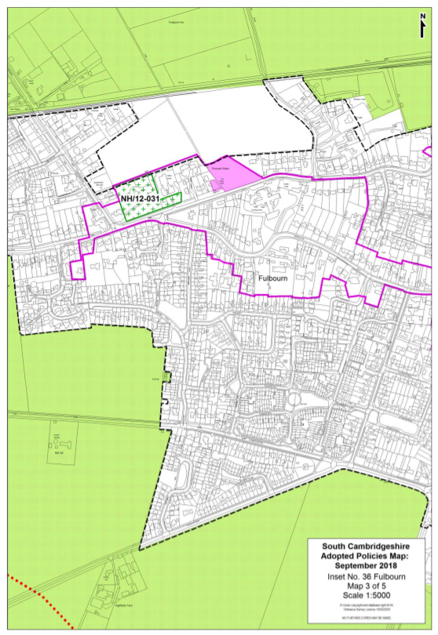
Figure 3: Map of the Local Green Space site, and PVAA ‘Poorwell Water / The Horse Pond’ in Fulbourn

Source: South Cambridgeshire Local Plan, 2018
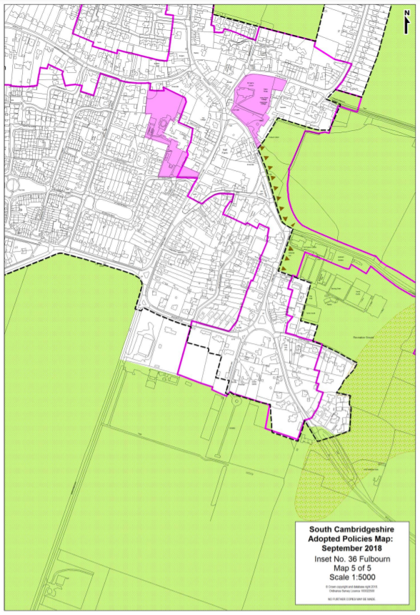
Figure 4: Map of the PVAAs surrounding ‘Fulbourn Primary School’ and ‘St Vigor’s Church’ in Fulbourn

Source: South Cambridgeshire Local Plan, 2018

Legislative Background

2.1 Strategic Environmental Assessment (SEA)
Directive 2001/42/EC of the European Parliament and of the Council of 27 June 2001 on the assessment of the effects of certain plans and programmes on the environment states that,
‘Environmental assessment is an important tool for integrating environmental considerations into the preparation and adoption of certain plans and programmes which are likely to have significant effects on the environment.
(10) All plans and programmes which are prepared for a number of sectors and which set a framework for future development consent of projects listed in Annexes I and II to Council Directive 85/337/EEC of 27 June 1985 on the assessment of the effects of certain public and private projects on the environment(7), and all plans and programmes which have been determined to require assessment pursuant to Council Directive 92/43/EEC of 21 May 1992 on the conservation of natural habitats and of wild flora and fauna(8), are likely to have significant effects on the environment, and should as a rule be made subject to systematic environmental assessment. When they determine the use of small areas at local level or are minor modifications to the above plans or programmes, they should be assessed only where Member States determine that they are likely to have significant effects on the environment.
(11) Other plans and programmes which set the framework for future development consent of projects may not have significant effects on the environment in all cases and should be assessed only where Member States determine that they are likely to have such effects.’
The Fulbourn Neighbourhood Plan may influence frameworks for future development or become used ancillary to those plans and programmes that do set such a framework, and as such it has been determined that the principle of the Neighbourhood Plan should be screened for the necessary application of the SEA Directive.
The Report from the Commission to The Council, The European Parliament, The European Economic and Social Committee and the Committee of the Regions states, on the application and effectiveness of the Directive on Strategic Environmental Assessment (Directive 2001/42/EC), that
‘the following Plan & Programme (P&P), and modifications to them, are covered when prepared and/or adopted by an authority and required pursuant to legislative, regulatory or administrative provisions:
- P&P prepared for certain sectors and which set the framework for future development consent in respect of projects under the Environmental Impact Assessment-EIA-Directive.
- P&P requiring an assessment under the Habitats Directive (92/43/EEC).
- P&P setting the framework for development consent in respect of projects (not limited to those listed in the EIA Directive; see above) and determined by "screening" as being likely to have significant environmental effects.’
This report represents this screening process in regard to the content and influence of the Fulbourn Neighbourhood Plan.

2.2 Habitats Regulations Assessment (HRA)
Under the provisions of the EU Habitats Directive and translated into English law by the Habitats Regulations (The Conservation of Habitats and Species Regulations 2017, as amended), a competent authority must carry out an assessment of whether a plan or project will significantly affect the integrity of any European Site (also referred to as Habitats Sites in the National Planning Policy Framework), in terms of impacting the site’s conservation objectives.
HRA screening is the initial assessment of the impacts of a land use proposal against the conservation objectives of Habitats sites. Specifically, it is to ascertain whether or not a proposal (either alone or in combination with other proposals) would potentially damage the internationally designated features of that site. European sites are also known as Natura 2000 sites.
This HRA Screening Report has been undertaken in order to accompany the Fulbourn Neighbourhood Plan which is being produced by Fulbourn Parish Council in accordance with the Neighbourhood Planning (General) Regulations 2012.
The Neighbourhood Planning (General) Regulations 2012, state that submitted Plans need to be accompanied by a statement explaining how the proposed Plan meets the ‘basic conditions’ set out in Schedule 4B of the 1990 Town and Country Planning Act. These basic conditions include a requirement to demonstrate how the Plan is compatible with EU obligations, which includes the need to undertake an HRA.
In line with the Court judgement (CJEU People Over Wind v Coillte Teoranta C-323/17), mitigation measures cannot be taken into account when carrying out a screening assessment to decide whether a plan or project is likely to result in significant effects on a Habitats Site.

SEA Screening

3.1 When is SEA Required?
Planning Practice Guidance – Strategic environmental assessment requirements for neighbourhood plans (Paragraph: 026 Reference ID: 11-026-20140306) states that,
‘In some limited circumstances, where a neighbourhood plan is likely to have significant environmental effects, it may require a strategic environmental assessment. Draft neighbourhood plan proposals should be assessed to determine whether the plan is likely to have significant environmental effects. This process is commonly referred to as a “screening” assessment and the requirements are set out in regulation 9 of the Environmental Assessment of Plans and Programmes Regulations 2004.
If likely significant environmental effects are identified, an environmental report must be prepared in accordance with paragraphs (2) and (3) of regulation 12 of those Regulations.
One of the basic conditions that will be tested by the independent examiner is whether the making of the neighbourhood plan is compatible with European Union obligations (including under the Strategic Environmental Assessment Directive).
To decide whether a draft neighbourhood plan might have significant environmental effects, it must be assessed (screened) at an early stage of the plan’s preparation according to the requirements set out in regulation 9 of the Environmental Assessment of Plans and Programmes Regulations 2004. These include a requirement to consult the environmental assessment consultation bodies.
Each consultation body will be able to advise on particular topics relevant to its specific area of expertise and responsibility, and the specific information that it holds.
Where it is determined that the plan is unlikely to have significant environmental effects (and, accordingly, does not require an environmental assessment), a statement of reasons for the determination should be prepared. A copy of the statement must be submitted with the neighbourhood plan proposal and made available to the independent examiner.’
Articles 2 and 3 of the SEA Directive set out the circumstances in which a SEA is required. Table 1 sets out the assessment of whether the principle of the Fulbourn Neighbourhood Plan will require a full SEA.
Table 1: Exploring whether the Principle of the Plan would warrant SEA

Question 1: Is the Plan subject to preparation and/or adoption by a national, regional or local authority OR prepared by an authority for adoption through legislative procedure by Parliament or Government?
Yes - The Neighbourhood Plan has been prepared for adoption through legislative procedure.

Question 2: Is the Plan required by legislative, regulatory or administrative provision? (Typical characteristics of "administrative provisions" are that they are publicly available, prepared in a formal way, probably involving consultation with interested parties. The administrative provision must have sufficient formality such that it counts as a "provision" and it must also use language that plainly requires rather than just encourages a Plan to be prepared.)
Yes - The Neighbourhood Plan would be considered as falling within the category of an ‘administrative provision’.

Question 3: Is the Plan prepared for agriculture, forestry, fisheries, energy, industry, transport, waste management, water management, telecommunications, tourism, town and country planning or land use AND does it set a framework for future development consent of projects in Annexes I and II to the EIA Directive?
Yes to both criteria - The Neighbourhood Plan has been prepared for town and country planning and sets a framework for future development consent.

Question 4: Will the Plan, in view of its likely effect on sites, require an assessment under Article 6 or 7 of the Habitats Directive?
The Neighbourhood Plan’s likely effect on sites and requirement for an assessment under Article 6 or 7 of the Habitats Directive is explored in Section 4 of this Report.

Question 5: Does the Plan determine the use of small areas at local level, OR is it a minor modification of a Plan likely to require assessment under the Habitats Directive?
Yes to one of the criteria - The policies of the Neighbourhood Plan can be considered to determine the use of small areas at local level commensurate with their status in determining local planning applications.

Question 6: Does the Plan set the framework for future development consent of projects (not just projects in the Annexes of the EIA Directive)?
Yes - The Neighbourhood Plan has been prepared for town and country planning and sets a framework for future development consent.

Question 7: Is the Plans sole purpose to serve national defence or civil emergency, or is it a financial or budget Plan, or is it co -financed by structural funds or European Agricultural Guidance and Guarantee Fund (EAGGF) programmes 2000 to 2006/7?
The Neighbourhood Plan does not serve a purpose related to national defence or civil emergency, a financial or budget Plan. The Neighbourhood Plan is not co-financed by structural funds or EAGGF programmes 2000 to 2006/7.

Question 8: Is it likely to have a significant effect on the environment?
Likely significant effects are explored in more detail in Section 3.3 of this Screening Report. The ‘conclusions’ section of the Report outlines whether the Neighbourhood Plan requires SEA or not due in regard to its effects on the environment.
The following section looks at the criteria for assessing the effects of the Neighbourhood Plan and the identified effects of the Neighbourhood Plan in line with the criteria. Crucially, it will determine whether there are any likely significant effects on the environment.

3.2 Criteria for Assessing the Effects of the Neighbourhood Plan
Criteria for determining the likely significant effects on the environment, referred to in Article 3(5) of Directive 2001/42/EC are set out below.

Annex II of SEA Directive 2001/42/EC – Significant Effects
1. The characteristics of plans and programmes, having regard, in particular, to
 | - | the degree to which the plan or programme sets a framework for projects and other activities, either with regard to the location, nature, size and operating conditions or by allocating resources,
 | - | the degree to which the plan or programme influences other plans and programmes including those in a hierarchy,
 | - | the relevance of the plan or programme for the integration of environmental considerations in particular with a view to promoting sustainable development,
 | - | environmental problems relevant to the plan or programme,
 | - | the relevance of the plan or programme for the implementation of Community legislation on the environment (e.g. plans and programmes linked to waste-management or water protection).
2. Characteristics of the effects and of the area likely to be affected, having regard, in particular, to
 | - | the probability, duration, frequency and reversibility of the effects,
 | - | the cumulative nature of the effects,
 | - | the transboundary nature of the effects,
 | - | the risks to human health or the environment (e.g. due to accidents),
 | - | the magnitude and spatial extent of the effects (geographical area and size of the population likely to be affected),
 | - | the value and vulnerability of the area likely to be affected due to:
 |  | * | special natural characteristics or cultural heritage,
 |  | * | exceeded environmental quality standards or limit values,
 |  | * | intensive land-use,
 |  | * | the effects on areas or landscapes which have a recognised national, Community or international protection status.

3.3 Likely Significant Effects resulting from the Neighbourhood Plan
The following assessment will consider the likelihood of the Fulbourn Neighbourhood Plan (at the time of writing) to have significant effects on the environment. The table below will explore the likelihood of effects on the following required themes, as included within Annex I of the SEA Directive (2001/42/EC):
- Biodiversity;
- Population;
- Human health;
- Fauna;
- Flora;
- Soil;
- Water;
- Air;
- Climatic factors;
- Material assets;
- Cultural heritage including architectural and archaeological heritage;
- Landscape; and
- The interrelationship between the above factors.
Table 2: Assessment of Likely Significant Effects on the Environment
Criteria for determining the likely significance of effects (Annex II SEA Directive) | Likelihood and summary of significant effects
The degree to which the plan or programme sets a framework for projects and other activities, either with regard to the location, nature, size and operating conditions or by allocating resources. | The Plan sets out relevant policies which will be used to determine proposals for development within the Neighbourhood Plan area once adopted. The Plan does not include any allocations for development; instead housing needs will be met through the ‘strategic’ development of the Ida Darwin hospital site as identified for allocation within Policy H/3 of the adopted South Cambridgeshire Local Plan. The Neighbourhood Plan states that, ‘Fulbourn has no need to propose further housing allocations but should encourage sustainable and high-quality development on the sites already allocated and within the Village Development Framework.’  Policy FUL/10 of the Neighbourhood Plan, entitled ‘Housing Development and Local Need’ seeks to ensure that new housing development proposals of 10 or more units will be expected to take account of and demonstrate that they respond to identified local need. Various criteria are included within the Policy related to housing mix, a percentage of yields being affordable, net density and infrastructure obligations.  A Neighbourhood Plan must demonstrate conformity with the strategic policies of the Local Plan and once brought into force, the policies it contains take precedence over existing non-strategic policies only in the Local Plan for that Neighbourhood Plan area. The degree to which the Plan sets a framework for projects through allocating resources is considered relatively low as Policy FUL/10 reiterates affordable housing thresholds and ‘per hectare’ net density requirements of Local Plan policies H/10 and H/8 respectively.  The extent to which any conflicts exist between Policy FUL/10 and District level policies within the Local Plan will be considered between the Parish Council and the Local Planning Authority in finalising the Neighbourhood Plan, or otherwise through the independent examination of the Neighbourhood Plan.
The degree to which the plan or programme influences other plans or programmes including those in a hierarchy. | The Neighbourhood Plan provides policies for the Plan area, relevant to a local level only. The Neighbourhood Plan does not allocate any land for development purposes and its policies are considered to be in general conformity to that of the adopted South Cambridgeshire Local Plan. The Neighbourhood Plan, when/if ‘made’, will have weight in all planning decisions within the Plan area, however it should be acknowledged that issues identified as ‘strategic’ within the Local Plan will have priority over any of the Neighbourhood Plan policies. The degree to which the plan or programme influences other plans or programmes, including any development brief at the Ida Darwin hospital site, is therefore relatively low in the context of the Plan area.
The relevance of the plan or programme for the integration of environmental considerations in particular with a view to promoting sustainable development. | Neighbourhood Plans are required to contribute to the achievement of sustainable development. The Neighbourhood Plan policies seek to ensure environmental considerations are taken into account. The Neighbourhood Plan includes policies related (directly / indirectly) to ensuring environmental considerations will be integrated into any forthcoming development within the Plan area. These are:  - FUL/01: Respect for Local Character and Local Setting;  - FUL/02: Protecting Setting of Fulbourn; and  - FUL/04: Protection and Enhancement of Natural Features’  Irrespective of the adequacy of the above policies, adopted Local Plan policies apply within the Neighbourhood Plan area, which have been subject to thorough assessment within the Local Plan Sustainability Appraisal and Habitats Regulations Assessment. This ensures that environmental considerations, in particular with a view to promoting sustainable development, will be considered for all development proposals within the Neighbourhood Plan area.
Environmental problems relevant to the plan. | The Neighbourhood Plan reflects a small area and the Plan’s policy content seeks to address environmental issues. The policy content of the adopted Local Plan will additionally apply to any proposals within the Neighbourhood Plan area. Local Plan policies have been subject to Sustainability Appraisal (SA) within the context of the Local Plan. The Neighbourhood Plan and this Screening Report identify the following potential (direct / indirect) environmental problems or sources of potential problems relevant to the Neighbourhood Plan area:  - The Plan area is within various SSSI Impact Risk Zones (IRZs). Development proposals within IRZs are required to be consulted on with Natural England, should they be of a type or size that could warrant negative effects on the relevant SSSI.  - The Plan area contains the Fulbourn Fen SSSI to the east, which is in an ‘unfavourable recovering’ condition; as a result, all planning applications in the IRZ require consultation with Natural England.  - Additionally the Wilbraham Fens SSSI borders the Neighbourhood Plan boundary to the north, the Great Wilbraham Common SSSI borders the Neighbourhood Plan boundary to the north east, the Fleam Dyke SSSI borders the boundary to the south east, the Roman Road SSSI borders the boundary to the south and the Gog Magog Golf Course SSSI borders the boundary to the south west.  - Although the village of Fulbourn is within a Development Framework (as defined within the South Cambs Local Plan), the entirety of the land surrounding the built up area is located within the Cambridge Greenbelt.  - A number of Priority Habitats (from the Priority Habitat Inventory) are scattered throughout the Plan area, with some adjacent to the existing development framework boundary. These include good quality semi-improved grassland, lowland meadows, deciduous woodland, young trees woodland, traditional orchard, and lowland calcareous grassland.  - The Plan area contains three Scheduled Monuments:  - Settlement site by Caudle Corner Farm;  - Iron Age ritual enclosure containing a Bronze Age barrow, and Roman cemetery; and  - Fleam Dyke.  - There are approximately 53 Listed Buildings within the Plan area; the majority of these are associated with the Fulbourn Conservation Area forming the historic core of the village.  - Of these Listed Buildings, there exists the Grade II* listed Church of St Vigor and the Grade II* listed Highfield House. Both of these listed buildings are located within the Conservation Area.  - The majority of the Neighbourhood Plan area is within various Source Protection Zones (SPZs). SPZs are defined around large and public potable groundwater abstraction sites. The purpose of SPZs is to provide additional protection to safeguard drinking water quality through constraining the proximity of an activity that may impact upon a drinking water abstraction. Within the Neighbourhood Plan area, there lie areas of Zone I (Inner Protection Zone), Zone II (Outer Protection Zone) and Zone III (Total Catchment).  - The majority of chalk streams suffer from low summer flow, which has been increasing in recent years due to over-abstraction from the aquifer and surface water sources.  - Land within Flood Risk Zones 3 and 2 exist at the Neighbourhood Plan boundary’s eastern boundary associated with the Cam Valley river system, and the Little Wilbraham River (also a County Wildlife Site).  - The non-developed areas of the Plan area consist of Grade 2 (‘very good’) and Grade 3 (‘good to moderate’) soils. The Neighbourhood Plan area does not contain any Grade 1 (‘excellent’) soil, which represents the best and most versatile soil within the wider District context and also the country.  - The Plan area is located within the East Anglian Chalk National Character Area (NCA).  - The East Anglian Chalk NCA is characterised as a visually simple and uninterrupted landscape of smooth, rolling chalkland hills with large regular fields enclosed by low hawthorn hedges, with few trees, straight roads and expansive views to the north. The Chalk produces water that is naturally mineral rich, sediment free and of a stable temperature and as such supports specialised chalk stream ecology. A series of important nature reserves are located along the springline at the base of the chalk scarp, notably at Chippenham, Fulbourn and Fowlmere.  - Medieval moated sites, park lands and nucleated villages are distinctive features of medieval settlement on the Chalk, many of which are preserved in the grounds of later country estates (for example Barrington, Sawston and Fulbourn), and many are also Scheduled Monuments.  - The Plan area contains areas of land which are identified as Minerals Safeguarding Areas for sand and gravel within the Adopted Cambridgeshire County Council Minerals Core Strategy (2011).
The relevance of the plan or programme for the implementation of Community legislation on the environment (e.g. plans and programmes linked to waste management or water protection). | The content of the Neighbourhood Plan is not in conflict with those relevant planning documents within the wider district and county area related to waste management or water protection.
The probability, duration, frequency and reversibility of the effects on the following factors: | The following impacts have been identified within this Screening Assessment:
- Biodiversity | The Plan includes Policy FUL/04 – Protection and Enhancement of Natural Features, which seeks to ensure that new development of any size shall incorporate measures to protect, enhance and extend existing natural features in the Plan area.  The Plan area lies outside the Impact Risk Zone (IRZ) of the Devils Dyke SAC, Wicken Fen Ramsar site and Fenland Special Area of Conservation (SAC). The HRA Screening element of this Report concludes that there would be no likely significant effects resulting from the Plan alone or in-combination with other plans and projects. This is due to the Plan not introducing any new residential or employment development proposals which would result in any direct impacts.  The Plan area is within the IRZs of numerous SSSIs within the Plan area however, or those that are otherwise in close proximity to the Neighbourhood Plan area. The implications of this are that all new non-Plan-led housing developments within the Plan area will require an assessment of recreational pressure on relevant SSSIs and measures to mitigate adverse impacts e.g. alternative open space provision (as espoused by Natural England).  Consultation with Natural England is considered a development management issue (in so far as consultation is required at that stage), and relevant policies exist within the adopted South Cambridgeshire Local Plan.  In consideration of all of the above, effects on biodiversity resulting from the Plan can therefore be ruled out at the time of writing.
- Population | It is considered that there would be no significant effects on population resulting from the Neighbourhood Plan. This is due to the small scale of the Plan area.
- Health | The Neighbourhood Plan includes Policy FUL/17 – Recreational and Healthcare Facilities, which includes criteria related to infrastructure provision / contributions, the expansion of the current Recreation Ground, and support for any new multi-purpose healthcare, social and lifestyle support centre proposals that may come forward in the Plan period.  There are no other significant effects resulting from the Neighbourhood Plan regarding human health that would warrant a strategic assessment through SEA. The Plan includes policies for the protection of open spaces and the enhancement of Green Infrastructure that contribute to healthy lifestyles.
- Fauna | There are no direct impacts resulting from the Neighbourhood Plan on fauna that are considered significant at the Plan level. The Plan seeks the protection and enhancement of biodiversity at key sites and does not propose any development that could lead to any deterioration of habitats. It is possible that any number of speculative developments could be forthcoming within the Plan area that could have negative impacts on protected species, however these cannot be considered strategically significant to the extent that Strategic Environmental Assessment would be warranted. Such issues are more appropriate to be considered on a case-by-case ‘project level’ basis at the development management stage and in accordance with relevant development management policies contained within the LPA’s adopted Local Plan.
- Flora | Numerous and various areas of Priority Habitat exist within the Plan Area. The Plan includes Policy FUL/04 – Protection and Enhancement of Natural Features, which seeks to protect and enhance existing biodiversity assets in the Neighbourhood Plan area. This Policy seeks to ensure that development proposals consider opportunities for biodiversity gain through species rich planting, the protection of existing mature trees and succession planting, and the integration of native species. In addition to this Policy’s protection and enhancement of flora, South Cambridgeshire Local Plan policies apply. As a result, no effects are expected to result from the Neighbourhood Plan regarding flora.
- Soil | The non-developed areas of the Neighbourhood Plan area consist of Grade 2 (‘very good’) and Grade 3 (‘good to moderate’) soils. The Neighbourhood Plan does not propose any development within this or any greenfield land within the Neighbourhood Plan area. There are no identified negative implications surrounding soil quality as a result of the Neighbourhood Plan.
- Water | The Plan area is within a groundwater Source Protection Zone (Zones I, II and III). The Neighbourhood Plan does not allocate land for any development purposes that could give rise to ground water pollutants (e.g. give rise to hazardous substances such as pesticides, oils, petrol and diesel, solvents, arsenic, mercury or chromium VI; or non-hazardous substances such as ammonia or nitrates). Pollution control policies at the LPA level apply within the Neighbourhood Plan area to ensure that no negative effects on water quality should be experienced within Fulbourn.  The HRA element of this Report concludes that although water quality is a major issue of concern for the Wicken Fen Ramsar site, and thereby Fenland SAC, the Plan does not contain any policies or proposals that would give rise to any deterioration of water quality given that the Neighbourhood Plan area lies outside the Impact Risk Zone for this Ramsar site.
- Air | There are no identified air quality issues within the Plan area. Although consultation with Natural England is required for any development that could cause air pollution (regarding industrial/agricultural development) in association with the IRZs of SSSIs in the eastern parts of the Plan area, consultation would be required at the planning application stage and is not considered a matter would warrant SEA, as a strategic process, to be undertaken.
- Climatic factors | No policies exist within the Plan that address flood risk issues, although it should be acknowledged that existing adopted Local Plan policies regarding flood risk apply in the Plan area.  The Neighbourhood Plan area contains a relatively large area of Flood Risk Zone 3 to the east of the development framework however no development allocations area proposed within the Plan that would lead to any incompatibilities in any such areas. It is therefore considered that SEA would not be required and any speculative development coming forward within Fulbourn in the Plan period can be considered at the planning application stage.
- Material assets | The Plan area contains land within a Minerals Safeguarding Area (MSA) for sand and gravel within the County Council’s adopted Minerals and Waste Core Strategy (Proposals Map C) (2011). The Plan does not include any policies that conflict with the MSA or include any site allocations.  Regarding other material assets, the content of the Neighbourhood Plan is not considered to have any significant effects due to the extent / size of the Plan area. Such issues are more appropriate to be considered on a case-by-case basis at the development management stage and in accordance with relevant development management policies contained within the LPA’s adopted Local Plan.
- Cultural heritage | The Plan area contains multiple Scheduled Monuments and numerous Listed Buildings, as well as the Fulbourn Conservation Area. The Plan does not allocate any land for development purposes that could have any negative effect on any of these assets but does include some proposals for improved connectivity that may have effects on heritage that would need further exploration at the appropriate stage.  The Plan includes polices that directly or indirectly regard heritage and the historic environment that will apply to all proposals in the plan area over the Plan period. These are:  - Policy FUL/01 – Respect for Local Character and Local Setting;  - Policy FUL/02 – Protected Setting of Fulbourn;  - Policy FUL/06 – Securing Village Character; and  - Policy FUL/08 – Building and Landscape Design  Irrespective of the robustness of these policies in ensuring the protection and enhancement of heritage assets, policy also exists at the LPA level which additionally applies in the Plan area. The effects on heritage are, as a result, considered a development management issue in the context of the Plan and its content. There are not considered to be any elements of the Plan that would give rise to significant effects on the historic environment at the strategic level that would require the full application of the SEA Directive.
- Landscape | The Plan area is within a sensitive landscape, both in regard to the protection objectives of the East Anglian Chalk National Character Area (NCA) and also the Cambridge Greenbelt. Nevertheless, the Plan does not allocate land for development purposes and includes policies relevant to landscape character and its preservation.  In light of the Plan’s policy stance regarding landscape character, and in consideration also of the requirements of development proposals in accordance with the South Cambridgeshire Local Plan, there are no significant strategic landscape effects identified within this Report that would warrant the requirement for the application of the SEA Directive and the formulation of a SEA Environmental Report.
The cumulative nature of the effects. | In line with the above considerations that explore the possible individual effects of the Plan’s content, no significant effects have been highlighted as possible that could lead to any cumulative impact.
The trans boundary nature of the effects. | The adopted South Cambridgeshire Local Plan can be seen to support the protection and improvement of conditions relevant to those sustainability factors listed within the SEA Directive. The Neighbourhood Plan is not in conflict with these wider thematic policies. The HRA Screening element of this Report, which explores in-combination effects with other relevant plans and projects, also identifies no in-combination effects regarding Habitats (European) Sites.
The risks to human health or the environment (e.g. due to accidents). | It is considered that there is no risk to human health or the environment as a result of the Neighbourhood Plan. This is in consideration of the above screening requirements related to sustainability themes. The Neighbourhood Plan is unlikely to give rise to any accidents that can be considered to have a significant risk to human health or the environment.
The magnitude spatial extent of the effects (geographical area and size of the population likely to be affected). | The Neighbourhood Plan relates to the local level only. No allocations are included within the Plan and the magnitude and spatial extent of the Plan’s content is unlikely to be significant in a wider District context. Effects are not expected to be realised over a wide geographic area.
The value and vulnerability of the area likely to be affected due to:  - special natural characteristics or cultural heritage  - exceeded environmental quality standards  - intensive land use | As highlighted above in the screening of the Neighbourhood Plan per sustainability theme, the Neighbourhood Plan has not been assessed as having any possible negative effect associated with environmental themes.
The effects on areas or landscapes which have a recognised national, community or international protection status. | As highlighted above in the screening of the Plan per sustainability theme, the Neighbourhood Plan has not been assessed as having any significant effects on areas or landscapes which have a recognised national, community or international protection status.

HRA Screening

4.1 Habitat Regulations Assessment of Development Plans
This section forms a plan level Habitats Regulations Assessment (HRA) as required by Regulation 63 of The Conservation of Habitats and Species Regulations 2017 (as amended).
Under the provisions of the EU Habitats Directive and translated into English law by the Habitats Regulations (The Conservation of Habitats and Species Regulations 2017 (as amended)), a competent authority must carry out an assessment of whether a plan or project will significantly affect the integrity of any Habitats Site, in terms of impacting the site’s conservation objectives.
The first stage of HRA is the screening assessment of the impacts of a land use proposal against the conservation objectives of Habitats (European) sites. Specifically, it is to ascertain whether or not a proposal (either alone or in combination with other proposals) would potentially damage the internationally designated features of that site. Habitats (European) sites are also known as Natura 2000 sites and Habitats sites in the NPPF.
In line with the Court judgement (CJEU People Over Wind v Coillte Teoranta C-323/17), mitigation measures cannot be taken into account when carrying out a screening assessment to decide whether a plan or project is likely to result in significant effects on a Habitats Site.
This HRA Screening Report has been undertaken in order to support the Fulbourn Neighbourhood Plan which is being produced by Fulbourn Parish Council in accordance with the Neighbourhood Planning (General) Regulations 2012. The area covered by the Neighbourhood Plan is shown in Appendix 1.
The Neighbourhood Planning (General) Regulations 2012, state that submitted Neighbourhood Plans need to be accompanied by a statement explaining how the proposed Neighbourhood Plan meets the ‘basic conditions’ set out in Schedule 4B of the 1990 Town and Country Planning Act. These basic conditions include a requirement to demonstrate how the Plan is compatible with EU obligations, which includes the need to undertake HRA.
This section of this Report aims to:
- Identify the Habitats sites within 20km of Fulbourn Neighbourhood Plan area.
- Summarise the reasons for designation and Conservation Objectives for each site to be considered in this assessment.
- Screen the Fulbourn Neighbourhood Plan for its potential to impact upon a Habitats site.
- Assess the potential for in combination effects from other projects and plans in the area.
- Identify if there are any outstanding issues that need further investigation.
On 23 June 2016, the United Kingdom (UK) held a referendum and voted to leave the European Union (EU). On 29 March 2017 the Prime Minister triggered Article 50 of the Treaty on European Union, which commenced a period of negotiations regarding the UK’s exit from the EU. On 26 June 2018 The European Union (Withdrawal) Act 2018 received Royal Assent and work to prepare the UK statute book for Brexit has begun. The European Union (Withdrawal) Act 2018 will make sure that UK laws continue to operate following the UK’s exit. There is no immediate change to legislation or policy affecting national infrastructure. Relevant EU Directives have been transposed into UK law and those are unchanged until amended by Parliament. There the requirements for HRA under the Conservation of Habitats and Species Regulations 2017 (as amended) remain in place.

4.2 Court Judgements and their consideration in this Report

4.2.1 CJEU People Over Wind v Coillte Teoranta C-323/17
As previously mentioned, in line with the Court judgement (CJEU People Over Wind v Coillte Teoranta C-323/17), mitigation measures cannot be taken into account when carrying out a screening assessment to decide whether a plan or project is likely to result in significant effects on a Habitats Site.
This HRA Screening Report does not therefore consider mitigation measures within the assessment of Likely Significant Effects resulting from the Fulbourn Neighbourhood Plan.

4.2.2 CJEU Holohan C- 461/17
This Court judgement now imposes more detailed requirements on the competent authority at Appropriate Assessment stage:
1. […] an ‘Appropriate Assessment’ must, on the one hand, catalogue the entirety of habitat types and species for which a site is protected, and, on the other, identify and examine both the implications of the proposed project for the species present on that site, and for which that site has not been listed, and the implications for habitat types and species to be found outside the boundaries of that site, provided that those implications are liable to affect the conservation objectives of the site.
2. […] the competent authority is permitted to grant to a plan or project consent which leaves the developer free to determine subsequently certain parameters relating to the construction phase, such as the location of the construction compound and haul routes, only if that authority is certain that the development consent granted establishes conditions that are strict enough to guarantee that those parameters will not adversely affect the integrity of the site.
3. […] where the competent authority rejects the findings in a scientific expert opinion recommending that additional information be obtained, the ‘Appropriate Assessment’ must include an explicit and detailed statement of reasons capable of dispelling all reasonable scientific doubt concerning the effects of the work envisaged on the site concerned.
Within this HRA Screening report, the assessment determines the requirement whether an Appropriate Assessment is needed for the Fulbourn Neighbourhood Plan.

4.3 Habitats (European) Sites
Habitats Sites is the term used in the NPPF (2019) to describe any site which would be included within the definition at regulation 8 of the Conservation of Habitats and Species Regulations 2017 for the purpose of those regulations. European sites are the centrepiece of EU nature and biodiversity policy. It is an EU wide network of nature protection areas. They form an EU wide network of nature protection areas. The aim of the network is to assure the long-term survival of Europe’s most valuable and threatened species and habitats.
The sites are designated under the European Union (EU) Birds Directive (Council Directive 79/409/EEC on the Conservation of Wild Birds) and the EU Habitats Directive (Council Directive 92/43/EEC on the Conservation of Natural Habitats and of Wild Fauna and Flora).
The Birds Directive requires the establishment of Special Protection Areas (SPAs) for birds. The Habitats Directive similarly requires Special Areas of Conservation (SACs) to be designated for other species, and for habitats. Wetlands of International Importance (Ramsar sites) are also considered as part of the Natura 2000 network. This is because all SPAs and SACs are comprised of Sites of Special Scientific Interest (SSSIs) and all Ramsar sites in England are SSSIs. Together, SPAs, SACs and Ramsar Sites are considered as Habitats Sites in England (NPPF, 2019).

4.3.1 Explanation of SPAs, SACs and Ramsar Sites

Special Protection Areas (SPAs)
SPAs are areas which have been identified as being of international importance for the breeding, feeding, wintering or the migration of rare and vulnerable species of birds found within EU countries. Example: Ouse Washes is internationally important for wintering waterfowl. Legislation: EU Birds Directive.

Special Areas of Conservation (SACs)
SACs are areas designated to protect habitat types that are in danger of disappearance, have a small natural range, or are highly characteristic of the region; and to protect species that are endangered, vulnerable, rare, or endemic. Example: woodland habitat of Eversden and Wimpole Woods for the population of Barbastelle bats. Legislation: EU Habitats Directive.

Wetlands of International Importance (Ramsar Sites)
Ramsar Sites are designated to protect the biological and physical features of wetlands, especially for waterfowl habitats. For example, Wicken Fen is an outstanding remnant of East Anglian peat fens and supports one species of British Red Data Book plant fen violet Viola persicifolia which survives at only two other sites in Britain. Ramsar sites often overlap with SACs and SPAs and UK planning policy determines that they should be accorded the same importance when developments are proposed. Legislation: Ramsar Convention (1971) – Wetlands of International Importance.

4.3.2 Habitats Sites to be considered
There are five Habitats sites which lie within 20 km of the Fulbourn Neighbourhood Plan area. These are listed in Table 3 and shown on the map in Appendix 2.
Table 3: Habitats Sites within 20km to be considered in this assessment

SPA
None

SAC
Fenland, Eversden and Wimpole Woods and Devils Dyke

Ramsar
Wicken Fen, Chippenham Fen
The Fulbourn Neighbourhood Plan area lies outside the evidenced 10km Zone of Influence (ZOI) for Eversden and Wimpole Woods SAC, the 4km IRZ for Devils Dyke and the 5km IRZ for Wicken Fen and Chippenham Fen Ramsar sites and Fenland SAC as identified on the MAGIC website. It is also outside the 5km buffer for Breckland SPA & SAC.
There are therefore there are no Habitats sites within scope for this HRA screening report.

4.4 Method and Approach
The Neighbourhood Planning (General) Regulations 2012, state that submitted Plans need to be accompanied by a statement explaining how the proposed Plan meets the ‘basic conditions’ set out in Schedule 4B of the 1990 Town and Country Planning Act. These basic conditions include a requirement to demonstrate how the Plan is compatible with EU obligations, which includes the need to undertake a HRA screening report; this is necessary to ensure the making of the neighbourhood plan is not likely to have a significant effect on a Habitats (European) site or a Habitats (European) offshore marine site, either alone or in combination with other plans or projects.
This document relates only to Stage 1 of the HRA process as set out in Figure 1 below.

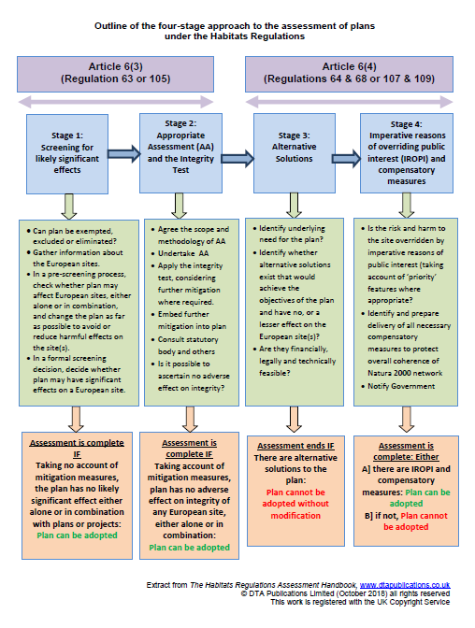
Figure 5: Outline of the Four Stage Approach to the Assessment of Plans under the Habitats Regulations (taken from the DTA handbook).

4.4.1 Stage 1: HRA Screening
The screening stage identifies if any significant effects are likely because any policies or projects will have an impact on a Habitats Site. Table 4 identifies the different categories assigned to each policy in the plan: Category A identifies those policies or projects that are considered to have No Negative Effect. Category B identifies those policies or projects that will have No Likely Significant Effect. Category C identifies those policies or projects that might have Likely Significant Effect upon a Habitats Site either alone or in combination with other plans or projects. Section 4.5 considers each policy or projects and the results of the screening exercise recorded.
Table 4: Screening categorisation
Category A: No negative effect
Policies or projects that will not be likely to have any negative effect on a Habitats site.
Category B: No Likely Significant Effect
Policies or projects that could have an effect but would not be likely to have a significant negative effect on a Habitats site alone or in combination. This conclusion could only be reached if the effects, even in combination and taking the precautionary principle into account, are considered trivial.
Category C: Likely Significant Effect
Policies or projects which are predicted to have a likely significant effect on a Habitats Site either alone or in combination with other plans and projects.

4.4.2 Potential impacts of Fulbourn Neighbourhood Plan on Habitats Sites
There are a wide range of potential impacts on Habitats Sites that could arise from development plans. These can be summarised as -
- Land take by developments;
- Impact on protected species found within but which travel outside the protected sites may be relevant where development could result in effects on qualifying interest species within the Habitats site, for example through the loss of feeding grounds for an identified species.
- Increased disturbance, for example from recreational use resulting from new housing development and / or improved access due to transport infrastructure projects;
- Changes in water availability, or water quality as a result of development and increased demands for waste water treatment, and changes in groundwater regimes due to increased impermeable areas;
- Changes in atmospheric pollution levels due to increased traffic, waste management facilities etc. Pollution discharges from developments such as industrial developments, quarries and waste management facilities.
In line with the SA Scoping Report for South Cambridgeshire’s Local Plan, each policy will be assessed against the criteria in the table below.
Table 5: Assessment of potential impacts
Nature of potential impact | How the Fulbourn Neighbourhood Plan (alone or in combination with other plans and projects) could affect a Habitats site | Why these effects are not considered significant
Land take by development | The Fulbourn Neighbourhood Plan area is outside the boundaries of the Habitats Sites within scope of this HRA. | N/A
Impact on protected species outside the protected sites | The Fulbourn Neighbourhood Plan area lies outside the 4km Impact Risk Zone (IRZ) for Devils Dyke and outside the IRZ 5km for Wicken Fen Ramsar site which is a component of Fenland SAC. | N/A
Recreational pressure and disturbance | There is public access to Eversden and Wimpole Woods SAC. | The Fulbourn Neighbourhood Plan area is 14km from Eversden and Wimpole Woods SAC so beyond the 10km distance that Natural England consider, in the absence of evidence that visitors are likely to travel to these sites for recreation.  The site is carefully managed by the landowners to avoid impacts from recreational pressure and disturbance
Water quantity and quality | Although water quality is an issue of concern for Wicken Fen Ramsar site (and thereby Fenland SAC), Fulbourn Neighbourhood Plan area lies outside the 5km Impact Risk Zone, so it is considered that there is no pathway for water quantity or quality impacts. | N/A.
Changes in pollution levels | The Fulbourn Neighbourhood Plan area lies outside the IRZ of the wetland SSSIs within scope of this HRA, so it is considered that there is no pathway for pollution impacts. | N/A

4.5 Results from HRA Screening of Neighbourhood Plan Policies
Each of the policies in the Fulbourn Neighbourhood Plan was screened to identify whether they would have any impact on a Habitats Site.
Table 4: Assessment of potential impacts
Policy Number | Policy Wording | Will Policy have Likely Significant Effects on the Habitats Sites? | Recommendations
Policy FUL/01 – Respect for Local Character and Local Setting | Development opportunities in Fulbourn will be conceived and designed in a way that respects and enhances the character and setting of the village and its surrounding through application of the guidance and design principles of the Fulbourn Village Design Guide (SPD 2020). | No, Category A | No specific recommendations
Policy FUL/02 – Protected Setting of Fulbourn | 1. The setting and special character of Fulbourn, surrounded by the Cambridge Green Belt, will be protected from urban encroachment to preserve its quality of discrete and individual village set among fields and woodland retaining a clear visual and physical separation from the outer developed boundary of the urban area of Cambridge and from neighbouring villages.  2. Important views across open fields from the Gog Magog Hills and from all other approach roads shall be protected, with land retained for agricultural use or as natural open space or woodland (Fig. 5), to ensure that the setting of Fulbourn as a village within the countryside is preserved.  3. The pattern of fields penetrating the built area of the village and outside the Village Framework Boundary will be protected from development and urbanisation to retain this key feature of the village setting. This important relationship will be protected through:  a. Designation of Important Countryside Frontages, in accordance with Policy NH/13 of the South Cambridgeshire Local Plan.  b. Identification of sensitive fields with a strong visual relationship between the village edge and the open countryside that contribute to the views from inside the village over rural landscape. | No, Category A | No specific recommendations
Policy FUL/03 – Development in the Green Belt and Outside the Development Framework | 1. Development proposals outside the Development Framework of the village should clearly demonstrate that they do not compromise the rural setting of the village and its visual and physical separation from Cambridge or other nearby settlements. Development within the Green Belt will only be permitted in exceptional cases in accordance with the NPPF.  2. Any development outside the Development Framework will also be required to demonstrate that:  a. The village character and integrity (Policy FUL/06) is respected and enhanced.  b. The richness of trees and tree belts surrounding the village are maintained, where building rooflines are consistently below the crowns of existing trees or the expected height of new ones 10 years from planting.  c. Street night light pollution is limited, with clearly perceptible lower lighting levels than usual for built areas and avoidance of floodlit spaces (including sport facilities), especially at the fringes of the village, within the Green Belt or in proximity of biodiversity networks.  d. Outward views from the edge of the development and across the site towards the open countryside are preserved and enhanced, especially of views towards the Windmill or other local landmarks.  e. Abundant additional tree planting using suitable native species and generous provision of natural open space within the site.  f. Natural buffers and hedgerow planting are provided along all site edge roads and prominent ‘gateway’ buildings are avoided. | No, Category A | No specific recommendations
Policy FUL/04 – Protection and Enhancement of Natural Features | 1. New development of any size shall incorporate measures to protect, enhance and extend existing natural features and demonstrate that consideration has been given to:  a. Development form and design which respects and enhances local natural features.  b. Creation of opportunities for positive biodiversity gain through species rich planting, including some larger native species trees and shrubs as part of the site.  c. Enhancement and retention of habitat connectivity and provision of wildlife friendly hedges/fences to allow corridors for small animals.  d. Protection of existing mature trees and succession planting, where space allows, with the species of local and indigenous trees which are larger at maturity and can therefore enrich and strengthen current tree presence.  e. Enhancement of the village natural features and biodiversity net gain with indigenous street trees of appropriate large species and avoiding out of character ornamental trees.  f. Incorporation of integral boxes for birds (such as swifts and sparrows) in all buildings, and bat boxes, where appropriate.  2. New developments of 10 units or more shall demonstrate, in addition, that provision is made for:  a. The preservation of important elements of existing biodiversity, including mature trees and hedgerows, and safeguarding or establishing suitable green networks for wildlife, which link to the wider existing green infrastructure (see Fig. 7).  b. The creation of natural and semi-natural greenspace in accordance to the definition of Natural England (ENRR526 Accessible Natural Greenspace).  c. The assessment of current site biodiversity and provision of at least 10% net gain in biodiversity value on site. Where this cannot be accommodated on site, to identify alternative sustainable mitigation measures at an agreed location within the Parish boundaries as appropriate.  d. Ensuring that the drainage patterns of the area are not compromised, considering the context of a changing climate, and no off site impacts are generated to the water flow and quality of the springs, streams and ditches around the Parish that feed into the Fulbourn Fen Nature Reserve (SSSI), the Wilbraham River system and Wilbraham Fen (SSSI) on the northern parish boundary.  e. Ensuring sustainable long-term maintenance for the site for wildlife benefit, amenity and social value, as appropriate. | No, Category A | No specific recommendations
Policy FUL/05 –Additional Protected Green Spaces within the Village | 1. In addition to the sites already identified in the South Cambridgeshire Local Plan (2018), the following sites make significant contribution to the village and are designated as follows:  a. Additional Local Green Space according to the criteria of the NPPF, where no development should take place at his location except in exceptional circumstances:  • Pound Green, containing the village war memorial and making a significant contribution to a stronger village character, identity and amenity and providing habitat opportunities for wildlife.  b. Additional Protected Village Amenity Areas according to the criteria of Policy NH/11 of the Local Plan. Development will not be permitted within or adjacent to these areas if it would have an adverse impact on the character, amenity, tranquillity or well-being of village residents. These include:  • Saint Vigor’s Road Green Space  • The Swifts Green Space  • The Haven Green Space  • Caraway Road/Bird Farm Road Green Space  • Cherry Orchard Green Space  • Huntsmill Green Space | No, Category A | No specific recommendations
Policy FUL/06 – Securing Village Character | 1. New development proposals within the Fulbourn Neighbourhood Plan area should have regard to the integrity of the historical and agricultural and rural character of the area. Development proposals will be supported where they conserve or enhance the visual qualities and essential characteristics of Fulbourn within its landscape.  2. New development, including infill and house alterations, will be expected to respect and positively contribute to the essential character of Fulbourn, by demonstrating a creative and contemporary response to the character of:  a. Local street and lane layout – see also Policy FUL/07.  b. Local architectural and building heights, form and features – see also Policy FUL /08.  c. Type and style of tree planting and hedgerow species within the village in both street verges and private gardens.  d. Soft edges to the built-up area, with diverse built frontages set in landscape. | No, Category A | No specific recommendations
Policy FUL/07 – Street and Lane Layout | 1. The existing streets and lanes of Fulbourn shall retain their essential character, green aspect, scale, width and alignment.  2. New development proposals that include alterations to existing streets, roads, lanes, pedestrian passages and spaces or new street layouts will be expected to demonstrate respect for local characteristics. In particular detailed design of new street layouts should:  a. Adopt the characteristics of the village streets and lanes, including the prevailing proportions of road to green verges.  b. Create street networks as a natural extension of the village with informal interconnected streets, lanes and spaces, avoiding rigid and regular grids.  c. Align streets and public spaces so that open views from within the village towards countryside and local landmarks are retained and enhanced.  d. Minimise the use of associated signage, lighting and other road hardware.  3. The High Street provides a key social and commercial function for the village and any development in or adjacent to it will be expected to make a positive contribution to its character, scale, attractiveness and vibrancy. | No, Category A | No specific recommendations
Policy FUL/08 – Building and Landscape Design | 1. New buildings, including infill, extensions and housing alterations, will be designed to make a positive contribution to the character of the village and demonstrate they respond they respond in particular to the following design criteria:  a. Building heights should be lower than the crown of surrounding trees to retain the concept of a ‘village among trees’, indicatively corresponding to a maximum height from ground to ridge of 8.5m or less, a typical 2-storey building.  b. Overall height of any proposed 2.5-storey building shall be similar to that of a typical 2-storey building. Such a building shall be defined by having an upper floor plan significantly smaller than the one below (first floor above ground level) with daylight provided by a roof window or dormer which is fully within the tiled roof area.  c. Buildings should be informally aligned and avoid forming rigid and regular perimeter blocks.  d. A variety of building types should be provided, designed with coherent scale, massing and elegant simplicity, avoiding complex patterns of different materials, contrasting colours and styles that have no architectural links with the village.  e. Parking spaces and garages should make minimal visual impact; storage for refuse and recycling bins and cycles, together with other infrastructure such as meter boxes shall be integrated into the design within enclosures, and not visible from the street.  f. Local and contemporary features, materials and detailing should be used, and main road frontages should include tall trees, hedges and boundary walls typical of Fulbourn.  2. New development proposals shall contribute to the richness of the village’s existing landscape in accordance to Policy FUL/04. In particular:  a. Trees and native shrubs should be used to frame views and create a transition (‘soft edge’) between the village and the open countryside.  b. Any green buffer between new development and the existing built-up areas of the village should be laid out to respect privacy while not isolating the new community.  c. Sustainable drainage systems (SUDS) should form part of the landscape, taking inspiration from traditional ditches and watercourses and contributing to the biodiversity of the site through appropriate dense planting and long-term maintenance. | No, Category A | No specific recommendations
Policy FUL/09 - Housing Design Quality | 1. All residential development proposals shall contribute positively to the quality and character of Fulbourn (see Policy FUL/06 to FUL/08), and as set out in the Fulbourn Village Design Guide (SPD 2020), South Cambridgeshire District Council’s Design Guide and any documents that supersede or complement these.  2. For modifications or extensions to existing dwellings, design proposals will need to clearly demonstrate that the following criteria are met:  a. Building and site boundaries are sensitively treated to avoid over-development and adverse impact on the character of the area and its street scene.  b. Where the existing building is of high quality or holds significant architectural or historic interest, proposed extensions must not dominate the original building and context.  c. A contemporary design has been considered for an extension that adds quality and interest to the original building. Designers should seek creative solutions to providing natural light, ventilation, summer shading and winter solar gain.  d. A choice of high-quality materials which reflect the existing building or, where appropriate, the context of the wider village area.  3. For newly built single dwellings or schemes of up to 9 houses, including infill and windfall sites, self-build or co-housing, this means demonstrating that:  a. The proposals are in scale with neighbouring developments.  b. The proposals are generally in keeping with the design context or provide an opportunity to strengthen village design quality and provide a positive precedent for future development.  4. For proposals that result in the development of new housing schemes of 10 dwellings or more, it is also necessary:  a. To demonstrate that the proposed development will contribute to sustainable development through a submitted Building for a Healthy Life assessment or other appraisal system agreed with the local Parish Council.  b. To ‘design in’ opportunities for safe outdoor play in playgrounds and on the streets notwithstanding compliance with Local Plan Policy SC/7 (Outdoor Play Space, Informal Open Space and New Developments).  c. To incorporate appropriate energy generation technology (solar PV, solar thermal, heat pumps, etc.) and demonstrate how contributions towards becoming energy neutral are maximised in the scheme.  5. All proposals are expected to:  a. Observe high standards of energy efficiency and use of renewables.  b. Adopt rainwater storage and grey water technology.  c. Respond to the needs of residents to manage their waste, access their cycles, park their cars and report their utility usage.  d. To adopt design and layout strategies which prioritise walking and cycling, create permeable, connected, safe communities with links to amenities and facilities and to other residential areas.  e. To ‘design in’ active facades where front doors and habitable rooms overlook the street, thus also providing enhanced safety through informal observation by ‘eyes on the street’.  f. To give careful consideration of car parking so that it does not dominate the street.  g. To ensure creative use of landscaping, building design and planting that enhances the public realm, creates biodiversity and increases amenity.  h. To use opportunities to provide public art that will reinforce a sense of place and community. | No, Category A | No specific recommendations
Policy FUL/10 - Housing Development and Local Need | 1. New housing development proposals of 10 or more units will be expected to take account of and demonstrate that they respond to identified local need, by providing:  a. Housing mix including at least a 5% share of small units designed to cater for the needs of an ageing population, built to accessible and adaptable dwellings M4(2) standard rounding to the nearest whole property.  b. At least 40% of the houses should be affordable according to Local Plan Policy H/10, including a suitable proportion of low-income houses for sale and rent and for people with disability.  c. Net density (as defined in the Local Plan) shall not exceed 30 dwellings per hectare (dph) in any particular part of the development, unless it can be demonstrated that higher densities are appropriate through a design-led approach respecting the character of the locality and the scale of development and are in accordance with other policies of this plan.  Any developers’ obligations to provide social and community infrastructure should be directed in preference towards increasing and strengthening the facilities and amenities of the village as a whole and to support community integration, in response to the requirements set out by Fulbourn Parish Council. | No, Category A | No specific recommendations
Policy FUL/11 - Ida Darwin and Teversham Road Sites | 1. In addition to the requirements of other policies of the Neighbourhood Plan, redevelopment of the Ida Darwin Site shall respond positively to the following criteria:  a. Visual separation from Capital Park shall be provided by a green wedge to be retained and enhanced through planting and buffers. This area will be established in perpetuity as a natural area, with trees and high biodiversity value, with minimal low-level lighting only along the southern boundary pedestrian/cycle path.  b. The design and layout of the development should reflect its location by retaining the prevailing openness of the Green Belt, including the balance of green space and built form in which open natural space visually prevails, and maintaining its character of buildings in parkland.  c. Particular attention shall be made to preserving and enhancing long-distance views across open countryside and to the retention of views across the site, particularly out towards the Windmill to the south.  d. Orientation and integration (functionally and visually) of the new residential area with the village, rather than self-containment or merging with the fringe of Cambridge, is expected, including pedestrian routes, signage and visual coherence.  e. Pedestrian and cycle connections along Fulbourn Old Drift linking Fulbourn village with the Beechwoods Estate and the bus transport hub at the Tesco Superstore should form part of the redevelopment plans to provide an opportunity to connect the Beechwoods Estate with the village and its facilities.  f. A clear approach to reducing the need to travel by private vehicle through the provision of infrastructure that supports low carbon mobility.  2. Any development of land at the proposed Teversham Road site, south of the railway line, shall ensure that:  a. There is no degradation of the natural wetland ecosystem associated with the natural spring at Poor Well, the chalk stream and associated wetlands.  b. There is an effective and sustainable drainage scheme for this low-lying site in perpetuity, including future-proofing for the challenge of the escalating climate emergency.  c. The vistas to the surrounding countryside from Poor Well are retained reflecting the existence of a natural wildlife corridor that extends from Poor Well on Cow Lane northwards to Fulbourn Fen, the Wilbraham River and Little Wilbraham Fen, including provision to conserve and enhance the existing flora and fauna.  d. Design and layout of the site should be integrated into the pattern of streets and lanes of the village, at least for pedestrians and cyclists, so as to avoid becoming an isolated housing estate. | No, Category A | No specific recommendations
Policy FUL/12 – Rural Exception Sites | 1. The development of rural exception sites will only be supported if all the relevant criteria in Policy FUL/09 are met and it can be demonstrated that the site proposal:  a. Addresses a recognised local need which is not and cannot be satisfied elsewhere.  b. Prioritises access to housing by local residents.  c. Secures 100% affordable homes in perpetuity. d. Does not compromise the views, rural setting and biodiversity protected by Policies FUL/01-04 | No, Category A | No specific recommendations
Policy FUL/13 – Employment Development in General | 1. Within the village Framework Boundary, planning applications for business uses which meet the criteria set out in Policies E/12 of the South Cambridgeshire Local Plan 2018 will be supported, especially if new employment opportunities available to village residents are created and there is a demonstrable reduction in the need to travel.  2. All employment development will need to demonstrate in a Transport Statement that:  a. Car parking and transportation to serve the business can be provided without loss of character, visual amenity and safety. Developments will also be expected to demonstrate that the proposed changes will not materially increase the traffic load on the village roads.  b. The requirements and operation of van and heavy vehicles has been fully explored and permitted only subject to implementation of adequate mitigation measures.  c. Development requiring heavy vehicle movements will only be acceptable if heavy vehicle movement takes place at the village periphery or with direct access to the road network outside of the village boundary.  d. All employment development must clearly show its commitment to the adoption of sustainable travel measures. | No, Category A | No specific recommendations
Policy FUL/14 – Large Employment Sites | 1. Any proposed development, re-development or extensions to existing business premises at Capital Park or the Peterhouse Extension site should be compliant with the Fulbourn Village Design Guide as well as the relevant policies of the South Cambridgeshire Local Plan.  2. Measures to support ambitious sustainable travel in line with accepted best practice at the time of the application will be required. These should be clearly set out in a Transport Assessment with clear responsibilities for monitoring and management. | No, Category A | No specific recommendations
Policy FUL/15 – Rural and Edge of Village Employment | 1. Employment and employment diversification in rural areas (Green Belt) is supported as long as Policy E/13 of the South Cambridgeshire Local Plan 2018 is respected and there is no increase in volume and heavy vehicle movement through the existing communities.  a. Employment developments or extensions requiring routine heavy vehicle movements will only be supported if they have direct access to the road network outside of the village boundary.  b. Adequate planted edges to screen the car parking will be required. | No, Category A | No specific recommendations
Policy FUL/16 – Valued Community Assets | 1. Proposals that result in the loss of valued community assets such as meeting rooms, public houses, places of worship and recreation and sports facilities will be resisted unless there is clear evidence that the asset is no longer required, or an alternative, suitable and enhanced facility is provided at an accessible location within the village and with the support of the local community. | No, Category A | No specific recommendations
Policy FUL/17 – Recreational and Healthcare Facilities | 1. Where development of large sites is required to make financial and / or direct contribution to community facilities, contribution towards the expansion and strengthening of the existing facilities should be considered in preference to creation of new ones.  2. Expansion of the current Recreation Ground to meet current standards by the National Playing Fields Association and provide additional outdoor pitch space is strongly preferred to the creation of alternative facilities elsewhere.  a. The field adjacent to the Recreation Ground is designated for the required expansion (see Fig. 9)  b. Expansion of outdoor facilities is to be prioritised over provision of additional indoor ones.  Alternative facilities at other locations, and as part of new development, should clearly demonstrate that they are offering synergy with the existing ones and that they are provided and designed to strengthen the community of Fulbourn as a whole.  3. The provision of a new multi-purpose healthcare, social and life-style support centre to replace the existing Health Centre is strongly encouraged and should be prioritised above the provision of other community facilities.  a. Redevelopment and intensification of the current site for this purpose would be welcomed, because of its accessible location. Alternative locations should be equally easily accessible.  There will be an expectation of collaborative working with the current GP practice. | No, Category A | No specific recommendations
Policy FUL/18 – Sustainable Mobility | 1. Within the village, where appropriate, development should:  a. Clearly demonstrate a clear order of priority given to road users as follows: pedestrians, cycling and horse riding, public transport, innovative mobility, shared transport, private transport.  b. Design streets for safe pedestrian use, including by wheelchair / electric chair.  c. Ensure that existing pedestrian / cyclist access is not reduced and if any changes are required to road configuration then the opportunity shall be used to enhance pedestrian and cycling access.  d. Integrate with the existing network of shortcuts, footpaths, cycleway and bridleways, linking, where applicable, into the network serving the wider Parish Area.  e. Positively contribute to the upgrade and maintenance of the existing networks and contribute to improved bus provision, including additional high-quality and safe bus waiting areas.  2. Adoption of sustainable mobility measures and integration with Cambridge sustainable mobility efforts are supported. | No, Category A | No specific recommendations
Policy FUL/19 – Safe Streets | 1. The character of the streets shall comply with the Village Design Guide (SPD 2020)  2. Roads, footpaths and lighting should use material with low environmental impact and offer easy long-term maintenance. | No, Category A | No specific recommendations

4.5.1 Recommendations
There are no specific recommendations to deliver for the policies in this draft Neighbourhood Plan as they have all been assigned to Category A. There is therefore no need to amend the policy text as they are not predicted to have a Likely Significant Effect on any Habitats site.
The in-combination effects from other plans and projects are considered in the following Section.

4.6 Other Plans and Projects: In-combination Effects
The plans and projects listed below and their HRAs have been carried out by South Cambridgeshire District Council or other organisations and none have been found to have a likely significant effect on the Habitats sites within scope of this assessment.
The Water Cycle Strategy (WCS) for Major Growth Sites in and Around Cambridge is not in itself a relevant plan or project under the Habitats Regulations but was prepared to support the delivery of the existing development strategy. Whilst it does not provide an assessment of new proposals for the Local Plan, its findings are relevant to support the assessment of this plan. It focused on issues related to the water supply, surface drainage and wastewater sewerage associated with potential development sites, and also concluded no likely significant effects, and that protected sites could be screened out of further assessment.
In the context of this HRA, the other relevant plans to be considered (i.e. those that have also triggered a requirement for HRA) are listed below in combination with Fulbourn Neighbourhood Plan HRA.
Table 6: Other plans or projects considered for in combination effects
Statutory Body | Title of HRA or Project | Findings of HRA or Project | Potential for in combination effects
South Cambridgeshire District Council | Northstowe Area Action Plan HRA (April 2007) | “It can be objectively concluded that the Northstowe Area Action Plan is not likely to have any significant effects on any Natura 2000 or Ramsar sites. There is therefore no requirement to proceed to the next stage of an Appropriate Assessment.” | It is considered that in combination likely significant effects are not predicted.
South Cambridgeshire District Council | Cambridge Southern Fringe Area Action Plan HRA (May 2007) | “This AAP was subject to an HRA and found not to impact on a Natura site or a Ramsar site.” | It is considered that in combination likely significant effects are not predicted.
South Cambridgeshire District Council | Cambridge East Area Action Plan HRA (May 2007) | “It can be objectively concluded that the Cambridge East Area Action Plan is not likely to have any significant effects on any Natura 2000 or Ramsar sites. There is therefore no requirement to proceed to the next stage of an Appropriate Assessment.” | It is considered that in combination likely significant effects are not predicted.
South Cambridgeshire District Council | North West Cambridge Area Action Plan HRA (August 2007) | “It has been objectively concluded that the North West Cambridge Area Action Plan – Preferred Options Draft - is not likely to have any significant effects on any Natura 2000 or Ramsar sites. It is therefore concluded that there is no requirement to proceed to the next stage of an Appropriate Assessment.” | It is considered that in combination likely significant effects are not predicted.
South Cambridgeshire District Council | Habitat Regulations Assessment: Chapter 20 of South Cambs Local Plan SA Scoping Report (June 2012) and including the Draft Final Sustainability Report (2014) and Sustainability Appraisal Addendum (2015) | “The Local Plan for the district was subject to an HRA screening and found to have no likely significant impact on a Natura site or a Ramsar site.” | It is considered that in combination likely significant effects are not predicted.
South Cambridgeshire District Council | Waterbeach New Town SPD HRA screening report (2018) | “The overall conclusion of this screening assessment is that the draft Waterbeach New Town SPD is unlikely to have any significant effects on the Natura 2000 and Ramsar sites identified alone or in combination with other plans or projects.” | It is considered that in combination likely significant effects are not predicted.
South Cambridgeshire District Council | Bourn Airfield New Village SPD SEA / HRA Screening Report (June 2019) | “The HRA element of this Screening Report indicates that the draft Bourn Airfield New Village SPD is not predicted to have likely significant effects on Eversden and Wimpole Woods SAC, either alone or in combination with other plans and projects.” | It is considered that in combination likely significant effects are not predicted.
South Cambridgeshire District Council | Greater Cambridge Local Plan Habitats Regulations Assessment Issues and Options Scoping Report (Dec 2019) | “This Scoping document has been produced to provide guidance and parameters for developing the GCLP in the context of European sites and as a reference point for stakeholders wishing to comment on the document.” | N/A
South Cambridgeshire District Council and Cambridge City Council | North East Cambridge Area Action Plan HRA Report (July 2020) | RE: Air Quality, Water Quality, Water Quantity, and Recreation - “In accordance with the precautionary principle, a conclusion of no AEoI cannot be reached.” | It is considered that in combination likely significant effects are not predicted as all Fulbourn Neighbourhood Plan policies have been assigned to Category A.

References
- Northstowe Area Action Plan HRA (April 2007)
- South Cambridgeshire District Council Cambridge Southern Fringe Area Action Plan HRA (May 2007)
- Cambridge East Area Action Plan HRA (May 2007)
- North West Cambridge Area Action Plan HRA (August 2007)
- South Cambridgeshire District Council Biodiversity Supplementary Planning Document (adopted July 2009)
- Bourn Airfield New Village SPD SEA / HRA Screening Report (June 2019)
- Waterbeach New Town SPD HRA screening report (2018)
- South Cambridgeshire District Council South Cambridgeshire Local Plan (September 2018)
- Greater Cambridge Local Plan Habitats Regulations Assessment Issues and Options Scoping Report (Dec 2019)
- North East Cambridge Area Action Plan HRA Report (July 2020)
- Fulbourn Neighbourhood Plan 2019 to 2031 (Pre-Submission Draft, 18th July 2020)
- Natural England Conservation objectives for European Sites: East of England Website
- Tydlesley, D., and Chapman, C., (2013) The Habitats Regulations Assessment Handbook, (January 2020) edition UK: DTA Publications Limited

Conclusions

5.1 Strategic Environmental Assessment (SEA)
The Neighbourhood Plan has been prepared for town and country planning purposes and sets a framework for future development consent. The policies of the Neighbourhood Plan can be considered to determine the use of small areas at local level commensurate with their status in determining local planning applications.
The Plan does not allocate any land for development purposes and does not include any content that could give rise to significant negative effects on the environment, or any social or economic tenets of sustainability.
The Fulbourn Neighbourhood Plan can therefore be screened out for its requirement of Strategic Environmental Assessment in line with the requirements of Directive 2001/42/EC.

5.2 Habitats Regulations Assessment (HRA)
Subject to Natural England’s review, this HRA screening report indicates that the Fulbourn Neighbourhood Plan is not predicted to have likely significant effects on any Habitats site, either alone or in combination with other plans and projects. The requirement for the Plan to undertake further assessment under the Conservation of Habitats and Regulations 2017 (as amended) is therefore screened out.

Appendix 1

The Fulbourn Neighbourhood Plan area
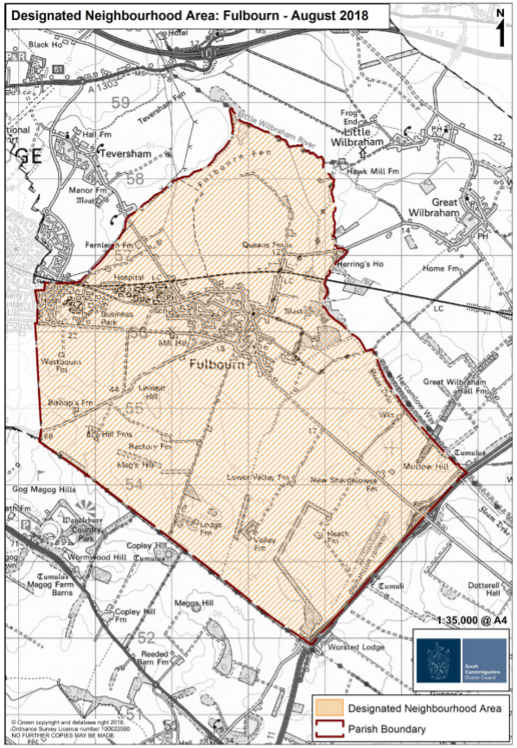
Source: South Cambs District Council, 2018

Appendix 2

The Plan Area and Locations of the Habitats sites within 20 km
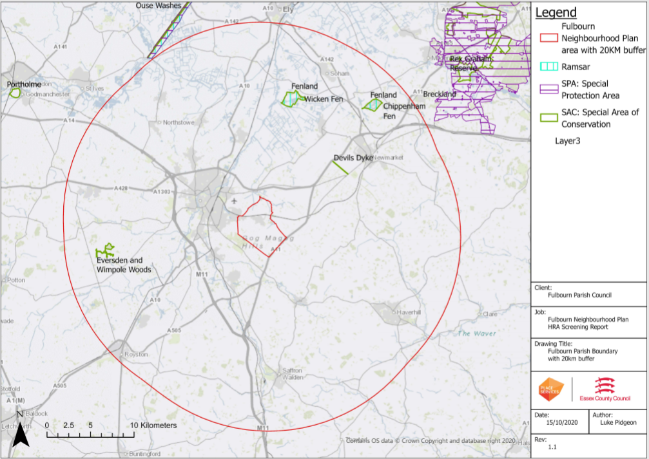
Source: Place Services, 2020

Place Services
Essex County Council
County Hall, Chelmsford, Essex CM1 1QH

T: +44 (0)333 013 6840
E: enquiries@placeservices.co.uk

www.placeservices.co.uk

October 2020

Appendix 2: Consultation Responses from the Statutory Environmental Bodies

Historic England
6 November 2020

Thank you for inviting Historic England to comment on this consultation. As the Government’s adviser on the historic environment Historic England is keen to ensure that the protection of the historic environment is fully taken into account at all stages and levels of the local planning process. Therefore we welcome this opportunity to review the Screening Report for this plan. For the purposes of this consultation, Historic England will confine its advice to the question, “Is it (the Fulbourn Neighbourhood Plan) likely to have a significant effect on the historic environment?”. Our comments are based on the information supplied with the Screening Opinion.

The Screening Report indicates that the Council considers that the plan will not have any significant effects on the historic environment. We note that the plan does not propose to allocate any sites for development.

On the basis of the information supplied, and in the context of the criteria set out in Schedule 1 of the Environmental Assessment Regulations [Annex II of ‘SEA’ Directive], Historic England concurs with the Council that the preparation of a Strategic Environmental Assessment is not required.

The views of the other two statutory consultation bodies should be taken into account before the overall decision on the need for an SEA is made.

I should be pleased if you can send a copy of the determination as required by REG 11 of the Environmental Assessment of Plans and Programmes Regulations 2004.

We should like to stress that this opinion is based on the information provided by you with your correspondence. To avoid any doubt, this does not reflect our obligation to provide further advice on later stages of the SEA process and, potentially, object to specific proposals which may subsequently arise (either as a result of this consultation or in later versions of the plan) where we consider that, despite the SEA, these would have an adverse effect upon the environment.

Historic England strongly advises that the conservation and archaeological staff of the relevant local authorities are closely involved throughout the preparation of the plan and its assessment. They are best placed to advise on; local historic environment issues and priorities, including access to data held in the Historic Environment Record (HER), how the allocation, policy or proposal can be tailored to minimise potential adverse impacts on the historic environment; the nature and design of any required mitigation measures; and opportunities for securing wider benefits for the future conservation and management of heritage assets.
Yours sincerely
Edward James – Historic Places Advisor, East of England

Natural England
3 November 2020

Thank you for your consultation on the above dated 26 October 2020 which was received by Natural England on 26 October 2020

Natural England is a non-departmental public body. Our statutory purpose is to ensure that the natural environment is conserved, enhanced, and managed for the benefit of present and future generations, thereby contributing to sustainable development.

Screening Request: Strategic Environmental Assessment
It is our advice, on the basis of the material supplied with the consultation, that, in so far as our strategic environmental interests (including but not limited to statutory designated sites, landscapes and protected species, geology and soils) are concerned, that there are unlikely to be significant environmental effects from the proposed plan.
Neighbourhood Plan

Guidance on the assessment of Neighbourhood Plans, in light of the Environmental Assessment of Plans and Programmes Regulations 2004 (as amended), is contained within the National Planning Practice Guidance. The guidance highlights three triggers that may require the production of an SEA, for instance where:
- a neighbourhood plan allocates sites for development
- the neighbourhood area contains sensitive natural or heritage assets that may be affected by the proposals in the plan
- the neighbourhood plan may have significant environmental effects that have not already been considered and dealt with through a sustainability appraisal of the Local Plan.

We have checked our records and based on the information provided, we can confirm that in our view the proposals contained within the plan will not have significant effects on sensitive sites that Natural England has a statutory duty to protect.

We are not aware of significant populations of protected species which are likely to be affected by the policies / proposals within the plan. It remains the case, however, that the responsible authority should provide information supporting this screening decision, sufficient to assess whether protected species are likely to be affected.

Notwithstanding this advice, Natural England does not routinely maintain locally specific data on all potential environmental assets. As a result the responsible authority should raise environmental issues that we have not identified on local or national biodiversity action plan species and/or habitats, local wildlife sites or local landscape character, with its own ecological and/or landscape advisers, local record centre, recording society or wildlife body on the local landscape and biodiversity receptors that may be affected by this plan, before determining whether an SA/SEA is necessary.

Please note that Natural England reserves the right to provide further comments on the environmental assessment of the plan beyond this SEA/SA screening stage, should the responsible authority seek our views on the scoping or environmental report stages. This includes any third party appeal against any screening decision you may make.

Habitats Regulations Assessment (HRA) Screening
Natural England agrees with the report’s conclusions that the Fulbourn Neighbourhood Plan would not be likely to result in a significant effect on any European Site, either alone or in combination and therefore no further assessment work would be required.

Yours sincerely

Danielle Priestner
Consultations Team

Environment Agency

28 October 2020
Thank you for your consultation.
Environment Agency position.

Due to resource pressures we are no longer able to provide you with comprehensive bespoke advice on pre application enquiries, neighbourhood plans, screening and scoping opinions etc.

Notwithstanding the above I attach a copy of the Agency’s ‘Planning Application Guidance’ (PAG) document for the applicant’s assistance.

Note to applicant;
Key environmental issues associated with this site will include floodrisk, investigation and remediation plans of any contaminated land, protection of controlled waters, investigation of any historic landfills in the vicinity, and full details of proposed site drainage (surface and foul water including pollution prevention measures). Information regarding these issues is available at www.gov.uk

Anglian Water Services Ltd. should be consulted by the Local Planning Authority and be requested to demonstrate that the sewerage and sewage disposal systems serving the development have sufficient capacity to accommodate the additional flows, generated as a result of the development, without causing pollution or flooding. If there is not capacity in either of the sewers, the Agency must be reconsulted with alternative methods of disposal.

Please note that the views expressed in this letter by the Environment Agency do not represent our final view in relation to any future planning application(s) made in relation to this submission. We reserve the right to change our position in relation to any such application.
Yours faithfully

Mr. T.G. Waddams
Planning Liaison

Known fully as The Environmental Assessment of Plans and Programmes Regulations 2004.
Known fully as Directive 2001/42/EC of the European Parliament and of the Council of 27 June 2001 on the assessment of the effects of certain plans and programmes on the environment.
a spatial dataset that describes the geographic extent and location of Natural Environment and Rural Communities Act (2006) Section 41 habitats of principal importance.

