CUSTOMER NOTICE
While queueing for the till please keep 2 metres
between yourself & the
person in front of you.
We aim to serve you as soon as possible.

Please use contactless payment if you can

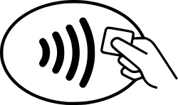
Contactless payment is now available for purchases up to £45

