Hand Washing

Washing your hands properly takes about as long as singing “Happy Birthday” twice, using the images below.
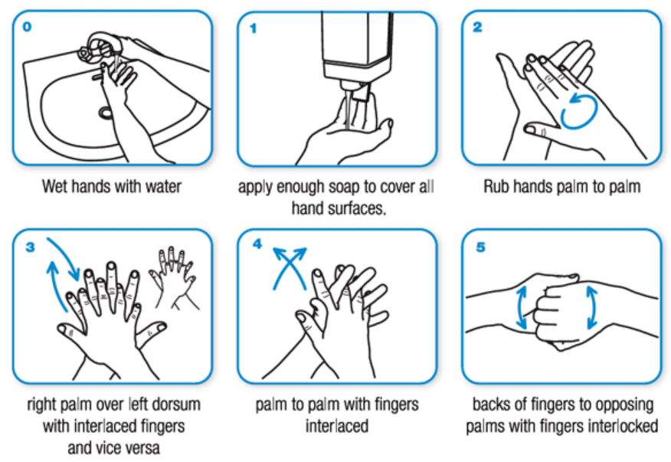

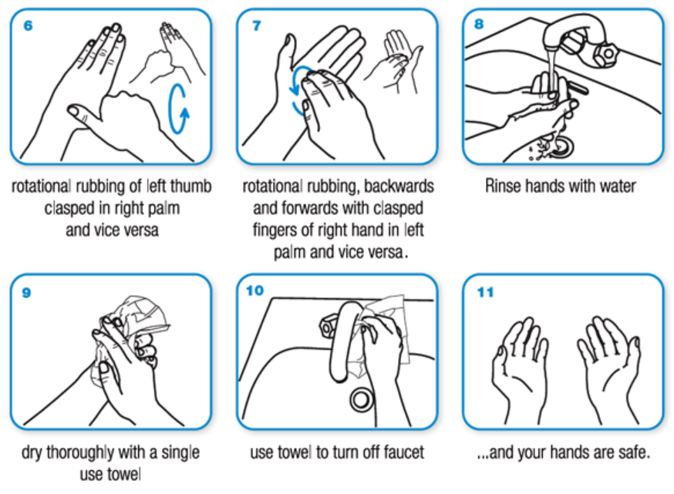

Taken from: World Health Organisation - https://www.who.int/gpsc/clean_hands_protection/en/

