Hi Alison,

Apologies, full points of clarification below.

During Tuesdays Transport Roundtable session the Inspector asked questions relating to Cambridge Science Park, are we able to pass on the following points of clarification to the Inspector please:

- Cambridge Science Park (CSP) is subject to a S106 dated 20th December 2019 between South Cambridgeshire District Council, Cambridge City Council, Cambridgeshire County Council and Trinity College Cambridge. (Planning Reference: S/4629/18/FL)
- The S106 limits car parking on CSP to 7,498 car parking spaces.
- The S106 covenants Trinity College Cambridge as the owner to use ‘reasonable endeavours’ to reduce the car parking to 6,977 spaces by the 20th December 2029.
- The NECAAP is at an early stage of development and the Trip Budget and parking assumptions are yet to be tested through Examination in Public.
- Trinity College and CSP are continuing to engage with the NECAAP team that are developing the strategy.
- Trinity College and CSP are supportive of the approach that would see continued investment in sustainable travel for the area.
- There are outstanding concerns regarding the Trip Budget derivation and allocation and potential to reduce car parking across CSP below that set out in the s106.

Are you able to confirm if you can pass on these comments submitted on behalf of Trinity College Cambridge, the freehold owners of Cambridge Science Park. We will be in attendance on Friday and can pass a printed copy of these points of clarification if required?

Kind regards Emma

Emma Woods Director 07765 475936
emma.woods@sphere25.co.uk

From: Skinner, Helen <HELEN.SKINNER@planninginspectorate.gov.uk> On Behalf Of Dyson, Alison
Sent: Friday, June 2, 2023 2:30 PM
To: Katie Hutchings <katie.hutchings@sphere25.co.uk>; Dyson, Alison
<ALISON.DYSON@planninginspectorate.gov.uk>
Cc: Maddie Wild <maddie.wild@sphere25.co.uk>; Emma Woods <emma.woods@sphere25.co.uk>
Subject: RE: Land North Of Cambridge North Station (Appeal ref. APP/W0530/W/23/3315611) Dear Katie,

It will be up to the Inspector to decide if any members of the public can attend the visit. Arrangements will be made at the inquiry, so I’d suggest you attend the inquiry, or contact the council after the opening day to see if they can provide you with any further information.

Please note no discussion on the case can take place during the site visit. Kind regards
Helen

Helen Skinner | Inquiries & Major Casework Team Leader
The Planning Inspectorate
Major Casework, Third Floor, Temple Quay House, 2 The Square, Temple Quay, Bristol, BS1 6PN helen.skinner@planninginspectorate.gov.uk | 0303 444 5531 https://www.gov.uk/government/organisations/planning-inspectorate | @PINSgov

From: Katie Hutchings <katie.hutchings@sphere25.co.uk>
Sent: 02 June 2023 13:39
To: Dyson, Alison <ALISON.DYSON@planninginspectorate.gov.uk>
Cc: Maddie Wild <maddie.wild@sphere25.co.uk>; Emma Woods <emma.woods@sphere25.co.uk>
Subject: Land North Of Cambridge North Station (Appeal ref. APP/W0530/W/23/3315611) Dear Alison,
I hope you are well.

I email regarding the above-referenced appeal.

I note from the draft timetable (dated 01 June) that Thursday 08th June is scheduled to comprise a site visit. Please can you advise if the public is able to attend this? If so, please can you provide the details?
Many thanks for your assistance. Kind regards

Katie

Katie Hutchings Planner
07354 900295
katie.hutchings@sphere25.co.uk

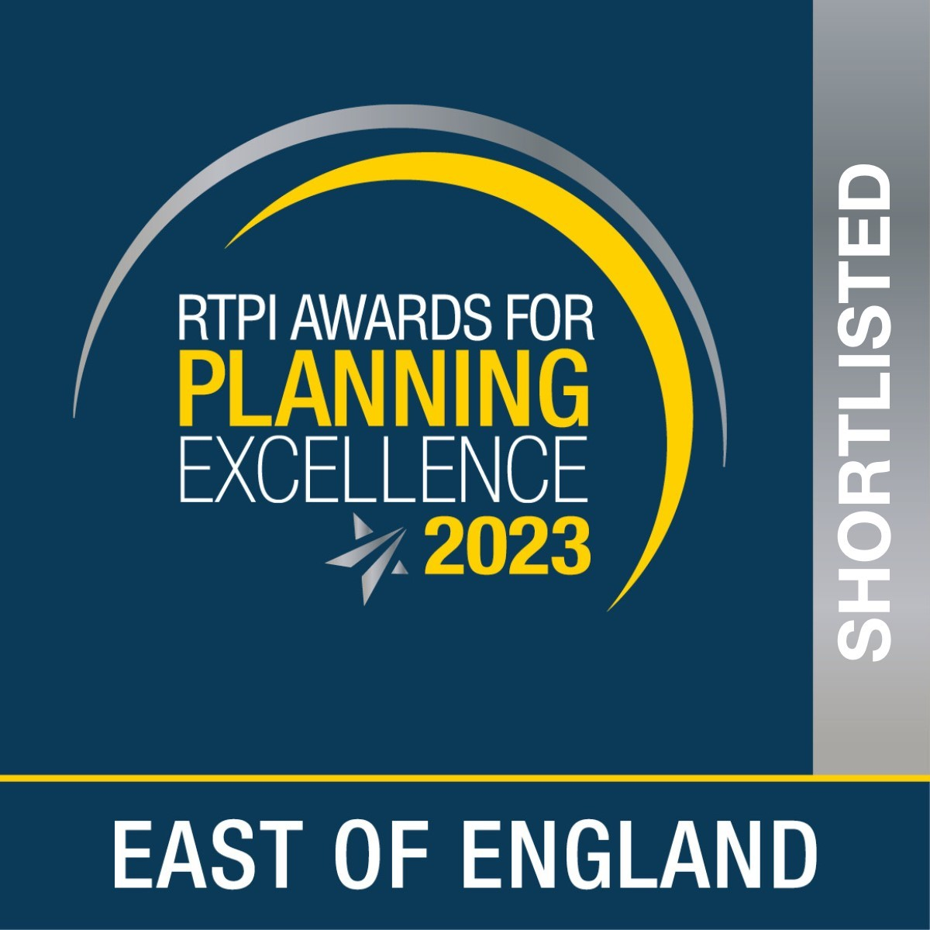
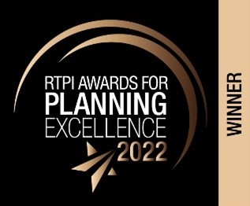

RTPI Awards for Small Planning Consultancy of the Year (2023) - shortlisted

RTPI Awards for Planning Excellence London (2022) – Winner RTPI Awards for Planning Excellence National (2022) – Winner

This message is intended solely for the addressee and may contain confidential information. If you have received this message in error, please send it back to us, and immediately and permanently delete it. Do not use, copy or disclose the information contained in this message or in any attachment. Any files attached to this email will have been checked by us with virus detection software before transmission. You should carry out your own virus checks before opening any attachment. We accept no liability for any loss or damage of any kind which may be caused by software viruses.

Please take a moment to review the Planning Inspectorate's Privacy Notice which can be accessed by clicking this link.

Please note that the contents of this email and any attachments are privileged and/or confidential and intended solely for the use of the intended recipient. If you are not the intended recipient of this email and its attachments, you must take no action based upon them, nor must you copy or show them to anyone. Please contact the sender if you believe you have received this email in error and then delete this email from your system.

Recipients should note that e-mail traffic on Planning Inspectorate systems is subject to monitoring, recording and auditing to secure the effective operation of the system and for other lawful purposes. The Planning Inspectorate has taken steps to keep this e-mail and any attachments free from viruses. It accepts no liability for any loss or damage caused as a result of any virus being passed on. It is the responsibility of the recipient to perform all necessary checks.

The statements expressed in this e-mail are personal and do not necessarily reflect the opinions or policies of the Inspectorate.

DPC:76616c646f72

To help protect you r priv acy, Microsoft Office prevented automatic download of this picture from the Internet. Environmental advice image with text saying please consider the environment before printing this email

