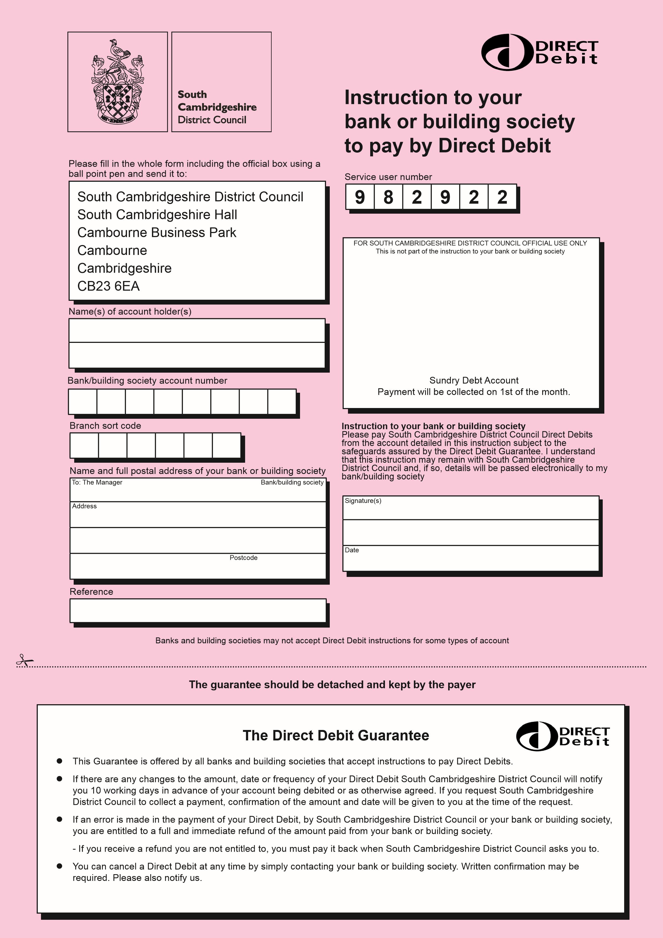
Name
Address
260
 | Direct Debit - Sundry Debt Account Your Questions Answered
Q | Can I cancel a Direct Debit Instruction?
A | Yes. Instructions can be cancelled by writing to your Bank or Building Society. Please send a copy of your letter to South Cambridgeshire District Council.
Q | What sort of account do I need to use Direct Debits?
A | Most current accounts at Banks and Building Societies can be used to make Direct Debit payments. Some special deposit accounts now allow them too. Just ask your branch.
Q | Can any organisation collect money by Direct Debit?
A | No. Banks and Building Society only permit organisations with known integrity and sound financial and administrative capabilities to collect money by Direct Debit.
Q | Will I still receive bills?
A | Yes, but they will only be for information and to check against your Bank or Building Society statement.  